Isle of Portland, Dorset, England
A rugged limestone peninsula jutting into the English Channel, Portland pairs a working harbour with striking Jurassic Coast scenery — Henry VIII's coastal castle, a white-and-red-banded lighthouse at the island's tip, and a short shuttle to Weymouth's sandy Georgian seafront.
⚓ Docked — Portland Harbour · 🕒 Typical call: 8–10 hrs · 💷 Currency: GBP (£) · 🗣️ Language: English
✍️ MY DAY IN PORT (FILL IN)
Ship / Date
In port | arrive ______ · all aboard ______
Booked excursion
Notes / meeting point
GETTING ASHORE
- Docking: Outer Coaling Pier or Deep Water Berth, Portland Harbour — all ships dock; no tender
- Walk to centre: Not permitted on foot; free port shuttle to Weymouth (~5 miles) and Portland Castle
- Best For: Jurassic Coast scenery, history lovers, coastal walks, rock climbing
- Don't Miss: Portland Bill Lighthouse and the view over the Portland Race
GETTING AROUND
- 🚕 Taxi: £25–£30 — Taxis from Portland Port to Weymouth town centre run approximately £25–£30 (10–15 min). Pre-booking is strongly recommen
- 📱 Rideshare: ✅ Uber
TOP THINGS TO DO
- Portland Bill Lighthouse — Walk or take a local bus to the southern tip of the island and climb the white tower with its broad red band for sweeping views…
- Portland Castle — One of Henry VIII's best-preserved coastal artillery forts, built in 1539–40 to guard Portland Harbour against French and Spanish…
- Jurassic Coast — Lulworth Cove & Durdle Door — The headline full-day excursion from Portland: a coach run (45 min each way) to Lulworth Cove's perfect horseshoe bay and the…
- Corfe Castle & Swanage — A dramatic 11th-century Norman keep perched on a conical hill — one of England's great castle ruins, partially slighted by…
- Weymouth Town & Seafront — The free port shuttle drops you in the heart of Weymouth, a classic English seaside resort with a long sandy beach, a lively…
BEST WALKS
- Portland Bill Loop: 4 miles round-trip | Easy–moderate | 2 hrs — From the shuttle stop at Portland Castle, take a local bus or taxi to Easton, then walk the South…
- Weymouth Harbour & Beach Stroll: 1–2 miles | Easy | 45 min — From the shuttle drop-off in Weymouth town centre, walk along the old harbour past the colourful…
cruiseports.org/isle-of-portland · Confirm terminal & all-aboard time with your ship

Isle of Portland, Dorset, England — Port Map
Red = walkable sights · Amber = excursions farther out · P = cruise terminal
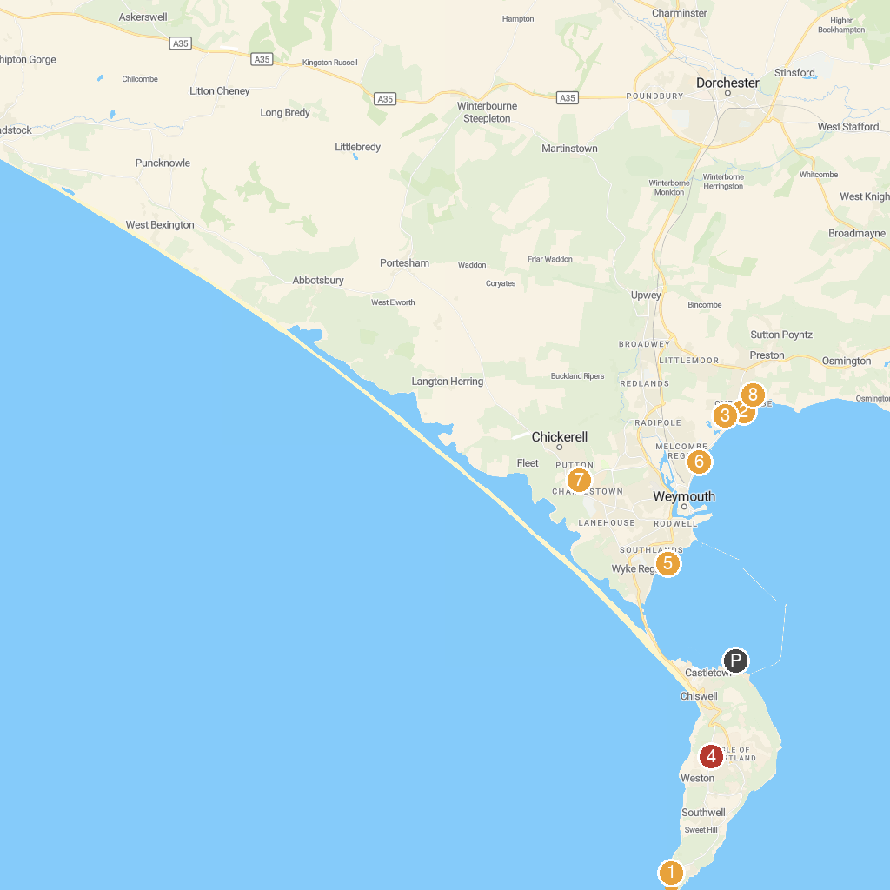
MAP KEY
1. Pulpit Rock | 5. Sandsfoot Castle
2. Air-time Beach Shop | 6. Greenhill Gardens
3. RSPB Lodmoor | 7. Bennetts Water Gardens
4. St George's Church | 8. Jordan Hill Roman Temple
P. Cruise port / terminal
Map © MapTiler © OpenStreetMap contributors · cruiseports.org

