Isle of Pines, New Caledonia, France
Towering columnar pines meet blindingly white sand and turquoise lagoons — the Isle of Pines is one of the Pacific's most striking cruise calls. Most of the island's best moments are free.
⚓ Tender port (no pier) · 🕒 Typical call: 7-9 hrs · 💵 XPF (CFP Franc) — bring cash, no ATMs near pier · 🗣️ French / Kanak (Kwényï) · 🌿 UNESCO-listed lagoon
✍️ MY DAY IN PORT (FILL IN)
Ship / Date
In port | arrive ______ · all aboard ______
Booked excursion
Notes / meeting point
GETTING ASHORE
- Docking: Tender to Kuto Bay jetty (~10–15 min ride)
- Walk to center: Kuto Beach is right at the tender pier; Kanumera Bay 5 min walk
- Best For: Snorkeling, beaches, natural pool, colonial history
- Don't Miss: Piscine Naturelle (natural pool) at Oro Bay — bring reef shoes
GETTING AROUND
- 🚕 Taxi: ~555 XPF base + 123 XPF/km (~USD 5–12) — Taxis wait at the Kuto Beach jetty. The main village of Vao is roughly 8 minutes away; agree on fare before departing as
- 📱 Rideshare: ❌ not available
TOP THINGS TO DO
- Piscine Naturelle (Natural Pool) — A coral-rimmed natural swimming pool at Oro Bay on the far (northeast) side of the island, teeming with tropical fish.
- Kanumera Bay & the Sacred Rock — A 5-minute walk from the tender pier brings you to this horseshoe bay dominated by the giant Kanumera Rock — a Kanak sacred site.
- French Penal Colony Ruins — A 20-minute inland walk from Kuto Beach leads to the overgrown ruins of a 19th-century French colonial prison, where Communards…
- Pic N'Ga Hike — The island's highest point (262 m) rewards a steep 1-hour climb with a 360° panorama of the reef, bays, and columnar pines.
- Queen Hortense's Cave — A large limestone cavern where the local Kanak queen hid during a 19th-century tribal war.
BEST WALKS
- Kuto Beach to Kanumera Bay: 0.5 km · 5 min · Easy · Free — Walk across the narrow sandy isthmus from the tender jetty at Kuto Beach to the gorgeous Kanumera…
- Kuto Bay to Penal Colony Ruins: 1.5 km · 20 min · Easy–moderate · Free — Follow the main road inland from the tender pier to the atmospheric ruins of the 19th-century…
WEATHER · DAYLIGHT · MONEY
Month | High °F | Low °F | Rainy days
May | 75 | 71 | 13
Jul | 72 | 67 | 9
Sep | 72 | 67 | 11
Daylight: May 6:15AM–5:17PM · Jul 6:30AM–5:22PM · Sep 5:47AM–5:43PM
cruiseports.org/isle-of-pines · Confirm terminal & all-aboard time with your ship

Isle of Pines, New Caledonia, France — Port Map
Red = walkable sights · Amber = excursions farther out · P = cruise terminal
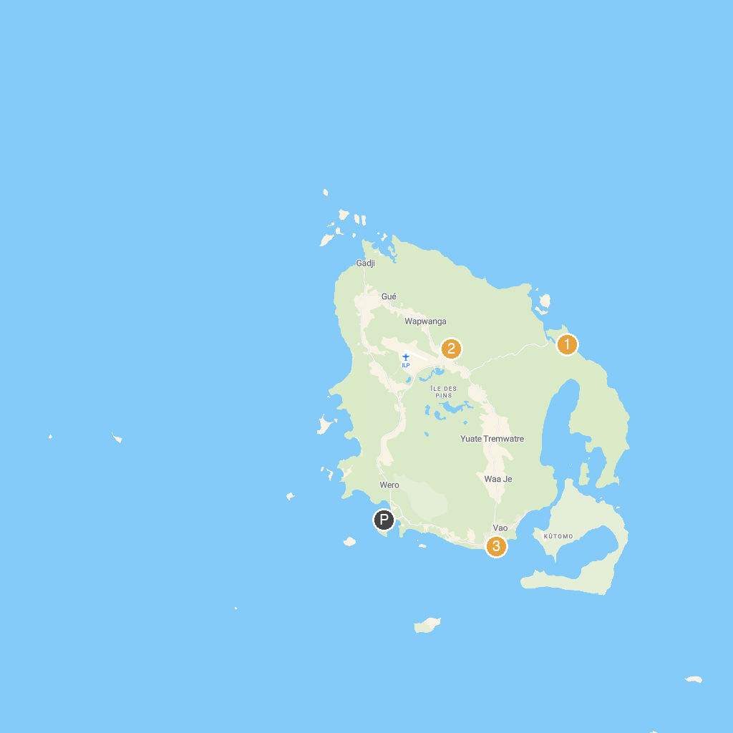
MAP KEY
1. Piscine Naturelle d’Oro | 3. Saint Maurice
2. Grotte de la Reine Hortense
P. Cruise port / terminal
Map © MapTiler © OpenStreetMap contributors · cruiseports.org

