Isle of Noss, Shetland, Scotland
A roaring, teeming wall of seabirds on sheer sandstone cliffs — Isle of Noss is a National Nature Reserve with no shops, no restaurants, and absolutely no equal for raw wildlife drama in British waters.
⚓ Anchor / Zodiac landing (expedition ships) · 🕒 Typical call: 4-6 hrs · 💷 Currency: British Pound (GBP) · 🗣️ Language: English · 🐦 Prime season: May–July
✍️ MY DAY IN PORT (FILL IN)
Ship / Date
In port | arrive ______ · all aboard ______
Booked excursion
Notes / meeting point
GETTING ASHORE
- Docking: No pier — expedition ships anchor; Zodiac landing at Gungstie jetty (weather permitting)
- Walk to cliffs: ~1.5 mi / 2.4 km from Gungstie landing to Noup of Noss clifftop
- Best For: Seabird photography, gannet colonies, wildlife boat tours, remote Shetland scenery
- Don't Miss: The Noup of Noss — 181m sandstone cliffs with 25,000+ breeding gannet pairs
GETTING AROUND
- 🚕 Taxi: Varies by distance — Local taxi firms (e.g. Shetland Taxi Services) serve Lerwick and can transfer passengers to the Bressay ferry terminal o
- 📱 Rideshare: ❌ not available
TOP THINGS TO DO
- Zodiac Cliff Cruise — Cruise the base of the Noup of Noss in an inflatable Zodiac — 181m of sheer sandstone packed with 25,000 gannet pairs…
- Noss Circular Walk — From the Gungstie landing, hike the circuit of the island: up through bonxie (Great Skua) nesting grounds to the clifftop, along…
- Seabirds & Seals Boat Tour (from Lerwick) — Depart Victoria Pier, Lerwick on a local wildlife tour boat that circles Bressay and Noss.
- Bressay & Noss Ferry Day — Independent option: Lerwick–Bressay car ferry (7 min), walk or taxi across Bressay (3 miles), then the small NatureScot…
BEST WALKS
- Noss Circular Walk: ~5 mi | 2.5-3 hrs | Moderate-strenuous | Start: Gungstie jetty — From the landing at Gungstie, head east past seal haul-outs, climb through the bonxie nesting…
- Gungstie Shore Walk (short): 0.5 mi | 15-20 mins | Easy | Start: Gungstie jetty — A short walk from the landing to the seal haul-out rocks and the warden's cottage.
WEATHER · DAYLIGHT · MONEY
Month | High °F | Low °F | Rainy days
May | 50 | 44 | 14
Jul | 57 | 52 | 17
Sep | 55 | 50 | 16
Daylight: May 4:25AM–9:37PM · Jul 4:07AM–10:11PM · Sep 6:32AM–7:24PM
cruiseports.org/isle-of-noss · Confirm terminal & all-aboard time with your ship

Isle of Noss, Shetland, Scotland — Port Map
Red = walkable sights · Amber = excursions farther out · P = cruise terminal
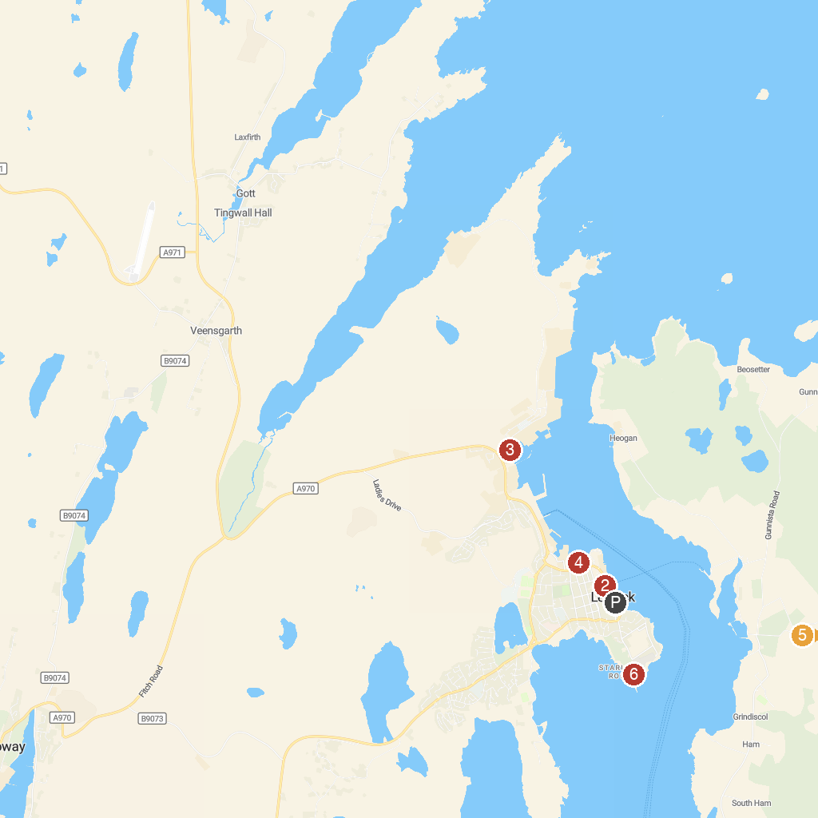
MAP KEY
1. Seabirds-and-Seals - THE ORIGINAL & NO.1 NOSS BOAT - EST 1992 | 5. Shetland Museum & Archives
2. Fort Charlotte | 6. Noss National Nature Reserve
3. Shetland Textile Museum | 7. The Knab
4. Scalloway Castle | 8. Carol's Ponies
P. Cruise port / terminal
Map © MapTiler © OpenStreetMap contributors · cruiseports.org

