Isle of Muck, Inner Hebrides, Scotland
The smallest of the Small Isles, Muck is a working croft island with barely 30 residents, turquoise bays, Highland ponies, and big skies — a genuine off-grid Hebridean escape only expedition ships can reach.
⚓ Tender only (no pier) · 🕒 Typical call: 4–6 hrs · 💷 Currency: GBP (British Pounds) · 🗣️ Language: English (Scots Gaelic heritage) · 🚶 Entirely walkable — no cars
✍️ MY DAY IN PORT (FILL IN)
Ship / Date
In port | arrive ______ · all aboard ______
Booked excursion
Notes / meeting point
GETTING ASHORE
- Docking: Tender to Port Mòr slipway
- Walk to village: 2 min from slipway (Port Mòr)
- Best For: Wildlife, peaceful beaches, off-grid Hebrides
- Don't Miss: Gallanach Beach & Beinn Airein summit views
GETTING AROUND
- 📱 Rideshare: ❌ not available
TOP THINGS TO DO
- Beinn Airein Summit Hike — Climb Muck's highest point (137 m / 449 ft) for 360° views of Eigg, Rum, Canna, Skye, and the Ardnamurchan Peninsula.
- Seal & Porpoise Watching — Grey seals haul out on the rocks near Port Mòr.
- Gallanach Beach — A crescent of white shell sand with improbably turquoise water on the north coast.
- Community Hall History Display & Craft Shop — The Community Hall near the pier often hosts a small display of island photos and genealogy records.
BEST WALKS
- Port Mòr to Gallanach Beach: 2.5 km return · 40 min · Easy — Follow the single paved road north from the slipway to the island's finest beach.
- Beinn Airein Summit Loop: ~4 km · 2 hrs · Moderate — From Port Mòr, take the track west then climb the grassy slopes of Beinn Airein.
WEATHER · DAYLIGHT · MONEY
Month | High °F | Low °F | Rainy days
May | 57 | 47 | 14
Jul | 64 | 55 | 17
Sep | 61 | 52 | 14
Daylight: May 5:16AM–9:23PM · Jul 5:05AM–9:51PM · Sep 6:56AM–7:38PM
cruiseports.org/isle-of-muck · Confirm terminal & all-aboard time with your ship

Isle of Muck, Inner Hebrides, Scotland — Port Map
Red = walkable sights · Amber = excursions farther out · P = cruise terminal
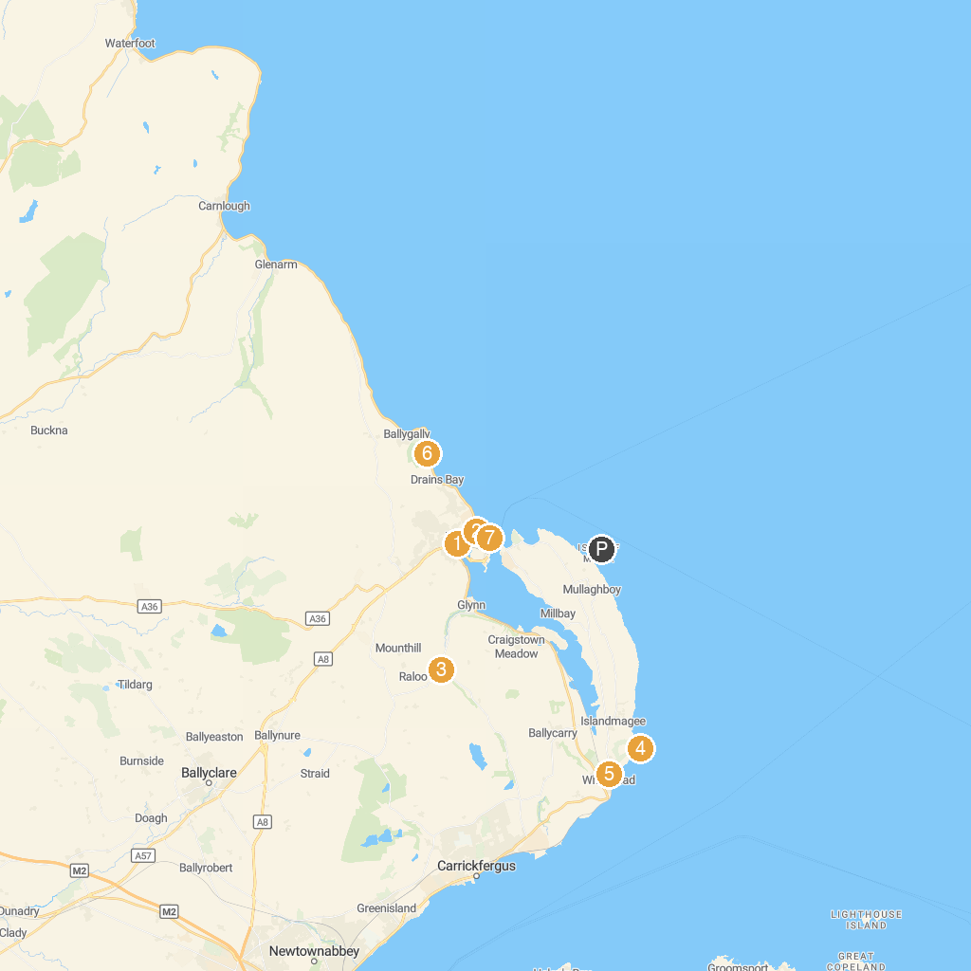
MAP KEY
1. Larne Museum & Arts Centre | 5. Whitehead Railway Museum
2. Larne Town Park | 6. Carnfunnock Country Park
3. National Trust - Gleno | 7. Oakfield Glen and Bashfordsland Wood
4. Blackhead Lighthouse | 8. Chaine Memorial Tower
P. Cruise port / terminal
Map © MapTiler © OpenStreetMap contributors · cruiseports.org

