Isle of Man, British Isles, United Kingdom
A UNESCO Biosphere Reserve in the Irish Sea, the Isle of Man packs Viking heritage, Victorian steam railways, and a working medieval castle into one compact, endlessly fascinating shore day.
⚓ Tender (most ships anchor in Douglas Bay) · 🕒 Typical call: 8–10 hrs · 💷 Manx Pound / British Pound (GBP) · 🗣️ English (Manx Gaelic on signs) · 🏝️ UNESCO Biosphere Reserve
✍️ MY DAY IN PORT (FILL IN)
Ship / Date
In port | arrive ______ · all aboard ______
Booked excursion
Notes / meeting point
GETTING ASHORE
- Docking: Tender to Douglas Sea Terminal; tender ride ~10–15 min. Expedition ships may berth at Victoria Pier or King Edward Pier.
- Walk to center: 5 min flat walk from Sea Terminal to Duke Street shops; Douglas Promenade starts at the terminal.
- Best For: Vintage railways, medieval castles, scenic tram rides, and local Manx seafood.
- Don't Miss: Great Laxey Wheel by electric tram, or Castle Rushen by steam railway to Castletown.
GETTING AROUND
- 🚕 Taxi: £5–£10 — Metered taxis queue directly outside the terminal. Government-regulated fares; base rate ~£3.80 plus ~£1.93/mile. Short
- 📱 Rideshare: ❌ not available
TOP THINGS TO DO
- Great Laxey Wheel & Snaefell Summit — Ride the Manx Electric Railway north to Laxey to see Lady Isabella — the world's largest working waterwheel (1854).
- Castle Rushen by Steam Train — Vintage steam locomotives on the 1873–1874 narrow-gauge line run south to Castletown, the island's former capital.
- Peel Castle & Manx Kippers — Bus across the island to Peel for its atmospheric ruined castle on St Patrick's Isle — plus the town's historic kipper-smoking…
- Manx Museum (Free) & Douglas Promenade — The island's national museum is world-class and free.
- TT Mountain Course Drive — The Isle of Man TT is the world's most dangerous motorcycle race.
BEST WALKS
- Douglas Promenade & Horse Trams: 2 miles flat | 45–60 min | Easy — Walk the full length of the Victorian promenade from the Sea Terminal to Derby Castle at the north…
- Douglas Head & Camera Obscura: 1.5 miles | 30–40 min | Moderate (uphill) — Cross the swing bridge south of the harbor and climb to Douglas Head for panoramic views over…
- Castletown Town Walk: 0.5 miles | 20 min | Easy — After arriving by steam train, explore Castletown's compact historic core: Castle Rushen, the old…
WEATHER · DAYLIGHT · MONEY
Month | High °F | Low °F | Rainy days
May | 55 | 47 | 12
Jul | 63 | 55 | 15
Sep | 60 | 53 | 14
Daylight: May 5:14AM–9:14PM · Jul 5:04AM–9:43PM · Sep 6:51AM–7:35PM
cruiseports.org/isle-of-man · Confirm terminal & all-aboard time with your ship

Isle of Man, British Isles, United Kingdom — Port Map
Red = walkable sights · Amber = excursions farther out · P = cruise terminal
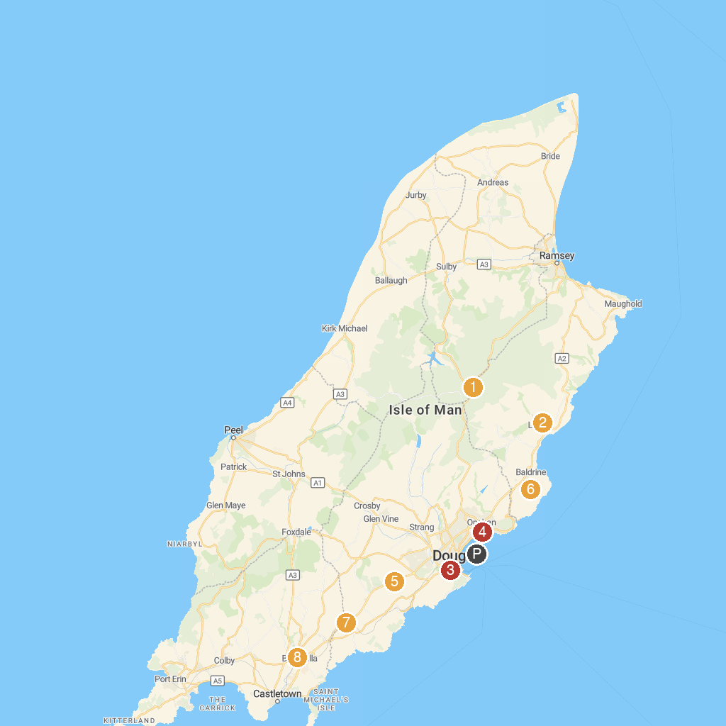
MAP KEY
1. The Bungalow | 5. Home of Rest for Old Horses
2. King Orry's Grave (North site) | 6. Ballannette Nature Reserve
3. Isle of Man Steam Railway | 7. Murray's Motorcycle Museum
4. Onchan Park | 8. Rushen Abbey
P. Cruise port / terminal
Map © MapTiler © OpenStreetMap contributors · cruiseports.org

