Isle of Jura, Inner Hebrides, Scotland
One road, 200 residents, 6,000 red deer, and a single-malt whisky that defines the island. The Isle of Jura is as remote as Scottish islands get — and all the better for it.
⚓ Tender (no cruise pier) · 🕒 Typical call: 6–8 hrs · 💷 Currency: GBP · 🗣️ Language: English · 🦌 Deer outnumber people 30:1
✍️ MY DAY IN PORT (FILL IN)
Ship / Date
In port | arrive ______ · all aboard ______
Booked excursion
Notes / meeting point
GETTING ASHORE
- Docking: Tender into Craighouse distillery pier
- Walk to village: 5 min from tender landing to Craighouse centre
- Best For: Whisky lovers, hillwalkers, wildlife & solitude
- Don't Miss: Jura Distillery tour & the Paps of Jura views
GETTING AROUND
- 🚕 Taxi: Varies — contact for quote — Jura Island Tours (Alex: 01496 820314 / 07884 024777) and other local drivers offer taxi and guided island tours by car.
- 📱 Rideshare: ❌ not available
TOP THINGS TO DO
- Jura Distillery Tour & Tasting — Founded in 1810 and revived in 1963, Jura Distillery produces a sweet, lightly peated single malt unlike its heavily smoky Islay…
- Paps of Jura Walk — Three dramatic quartzite peaks — Beinn an Òir, Beinn Shiantaidh, and Beinn a' Chaolais — dominate the island skyline.
- Corryvreckan Whirlpool RIB Tour — The Gulf of Corryvreckan between Jura and Scarba is home to one of the world's most powerful tidal whirlpools — audible from…
- Corran Sands Beach Walk — Just 4km north of Craighouse, Corran Sands is considered Jura's finest beach — a wide sweep of white shell sand backed by views…
- Craighouse Village & Keils Cemetery — A self-guided loop from the pier to the Jura Distillery, along the shoreline, and back via the ancient Keils burial ground takes…
BEST WALKS
- Craighouse Harbour & Keils Cemetery Loop: 3.2 mi / 5.2 km • 1.5 hrs • Easy — From the pier, walk through the village past the distillery, follow the shoreline south to the…
- Craighouse to Corran Sands: 5 mi / 8 km round trip • 2.5–3 hrs • Easy–Moderate — Head north out of Craighouse along the A846 and the track to Corran Sands — Jura's most beautiful…
- Paps of Jura — Beinn an Òir Summit: ~8 mi / 13 km • 5–7 hrs • Strenuous — Scotland's most iconic island hillwalk.
WEATHER · DAYLIGHT · MONEY
Month | High °F | Low °F | Rainy days
May | 55 | 47 | 14
Jul | 61 | 54 | 18
Sep | 59 | 53 | 17
Daylight: May 5:11AM–9:28PM · Jul 4:59AM–10:00PM · Sep 6:55AM–7:42PM
cruiseports.org/isle-of-jura · Confirm terminal & all-aboard time with your ship

Isle of Jura, Inner Hebrides, Scotland — Port Map
Red = walkable sights · Amber = excursions farther out · P = cruise terminal
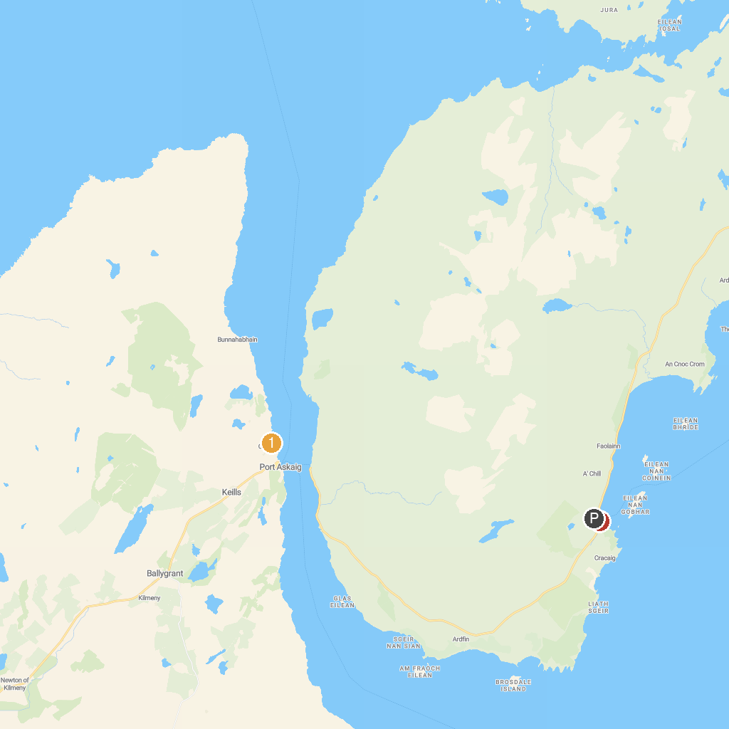
MAP KEY
1. Caol Ila Distillery | 3. Isle of Jura Distillery Co
2. Finlaggan Trust
P. Cruise port / terminal
Map © MapTiler © OpenStreetMap contributors · cruiseports.org

