Isle of Iona, Inner Hebrides, Scotland
A car-free island the size of a small village, Iona holds the graves of medieval kings, the roots of Celtic Christianity, and beaches that glow turquoise on a clear Hebridean day.
⚓ Tender only (no cruise pier) · 🕒 Typical call: 5–7 hrs · 💷 Currency: British Pound (GBP) · 🗣️ Language: English (Scottish Gaelic signs)
✍️ MY DAY IN PORT (FILL IN)
Ship / Date
In port | arrive ______ · all aboard ______
Booked excursion
Notes / meeting point
GETTING ASHORE
- Docking: Tender to Baile Mòr slipway — no cruise pier on island
- Walk to Abbey: ~12–15 min from the landing slipway (0.5 mi, flat road)
- Best For: History, pilgrimage, scenic walks, unspoiled beaches
- Don't Miss: Iona Abbey & Museum, Reilig Odhráin (kings' graveyard), North End beaches
GETTING AROUND
- 🚕 Taxi: Varies (by arrangement) — Iona Taxi is the island's sole licensed taxi service, useful for those with limited mobility or heavy luggage. Advance b
- 📱 Rideshare: ❌ not available
TOP THINGS TO DO
- Iona Abbey & Museum — The spiritual heart of Scotland, founded by St.
- Reilig Odhráin & St. Oran's Chapel — Adjacent to the Abbey, this is the graveyard of 48 medieval Scottish kings — including Macbeth and Duncan — as well as Norse and…
- North End Beach Walk — Walk north along the island's single track road to Tràigh Bhàn nam Monach — a sweep of brilliant white shell sand with…
- St. Columba's Bay (South End) — A pebble beach at the island's southern tip where St.
- Iona Heritage Centre — A compact community museum in the old Thomas Telford-designed manse, covering crofting, fishing, the local marble quarry, and the…
BEST WALKS
- Slipway to Iona Abbey: 0.5 mi | ~15 min | Easy | Paved — Follow the single paved road north from the Baile Mòr slipway, passing the Nunnery ruins and…
- Abbey to North Beach: 1.5 mi one way | ~35 min | Easy–Moderate | Mostly track — Continue north past the Abbey along the island's western track to reach the white-sand beach at the…
WEATHER · DAYLIGHT · MONEY
Month | High °F | Low °F | Rainy days
May | 54 | 47 | 17
Jul | 60 | 54 | 20
Sep | 58 | 53 | 19
Daylight: May 5:11AM–9:34PM · Jul 4:59AM–10:03PM · Sep 6:57AM–7:42PM
cruiseports.org/isle-of-iona · Confirm terminal & all-aboard time with your ship

Isle of Iona, Inner Hebrides, Scotland — Port Map
Red = walkable sights · Amber = excursions farther out · P = cruise terminal
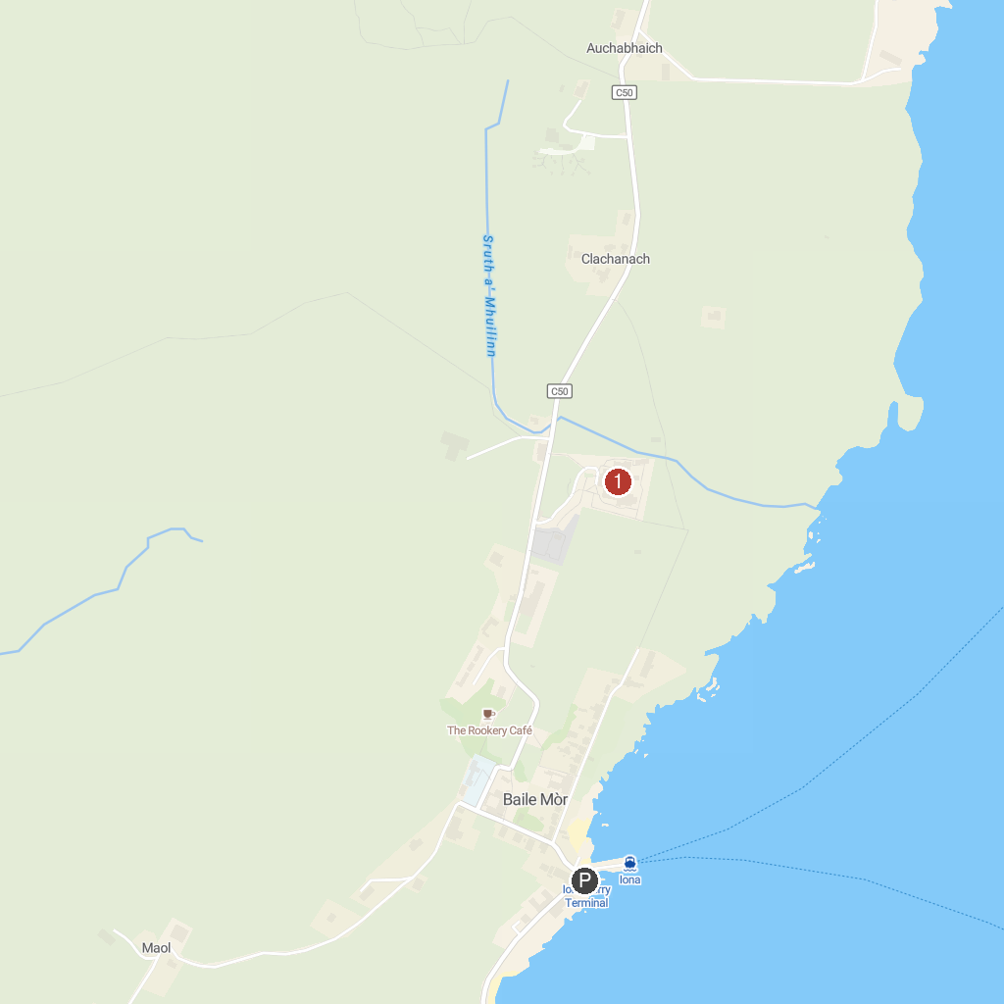
MAP KEY
1. Staffa National Nature Reserve - Fingal's Cave (National Trust for Scotland) | 2. Iona Abbey and Nunnery
P. Cruise port / terminal
Map © MapTiler © OpenStreetMap contributors · cruiseports.org

