Isle of Colonsay, Inner Hebrides, Scotland
One of Scotland's last truly unhurried islands — 135 residents, no traffic lights, and some of Europe's finest Atlantic beaches. Colonsay rewards slow explorers with dramatic coastal walks, a centuries-old priory, local gin, and a silence you'll remember.
⚓ Tender (no cruise pier) · 🕒 Typical call: 5–8 hrs · 💷 Currency: British Pound (GBP) · 🗣️ Language: English (Gaelic spoken by some) · 🚲 Best explored by bike
✍️ MY DAY IN PORT (FILL IN)
Ship / Date
In port | arrive ______ · all aboard ______
Booked excursion
Notes / meeting point
GETTING ASHORE
- Docking: Tender to Scalasaig Pier — no deep-water berth for cruise ships
- Walk to village: 5 min flat from pier to Scalasaig general store and café
- Best For: Wild beaches, coastal walks, birdwatching, distillery visits
- Don't Miss: Kiloran Bay — one of Scotland's finest white-sand beaches, 3.5 miles from pier
GETTING AROUND
- 📱 Rideshare: ❌ not available
TOP THINGS TO DO
- Kiloran Bay & Coastal Walk — Cycle or shuttle 3.5 miles to Kiloran Bay, widely regarded as one of Scotland's finest beaches — a wide crescent of golden sand…
- Oronsay Priory (Tidal Island) — At low tide, walk the sandy Strand causeway to Oronsay — a separate island with the ruins of a 14th-century Augustinian priory, a…
- Colonsay Brewery & Wild Island Gin — Colonsay Beverages produces Wild Island Botanic Gin and runs the Colonsay Brewery — the smallest island in the world with its own…
- Colonsay House Gardens — About 1.5 miles (a 30-minute walk) north of the pier, these historic woodland gardens hold one of Scotland's finest hybrid…
- Birdwatching & Wildlife Walk — Colonsay is home to 150+ bird species including the rare corncrake, red-billed chough, and golden eagle.
BEST WALKS
- Scalasaig Village Stroll: 30 min | Easy | All flat — From the pier, walk past the Colonsay Pantry café, up to the general store and post office, then…
- Colonsay House & Gardens Walk: 1.5–2 hrs | Easy | ~3 miles round trip — Head north from Scalasaig along the main road through open farmland to Colonsay House and its…
WEATHER · DAYLIGHT · MONEY
Month | High °F | Low °F | Rainy days
May | 52 | 48 | 15
Jul | 58 | 55 | 17
Sep | 58 | 55 | 18
Daylight: May 5:11AM–9:31PM · Jul 4:59AM–10:00PM · Sep 6:56AM–7:41PM
cruiseports.org/isle-of-colonsay · Confirm terminal & all-aboard time with your ship

Isle of Colonsay, Inner Hebrides, Scotland — Port Map
Red = walkable sights · Amber = excursions farther out · P = cruise terminal
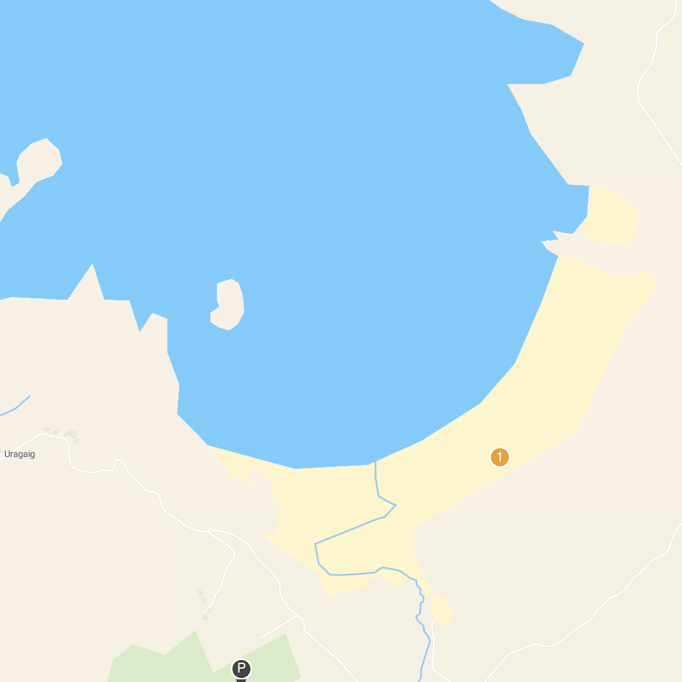
MAP KEY
1. Caol Ila Distillery | 3. RSPB Loch Gruinart, Islay
2. Finlaggan Trust | 4. Kiloran Bay
P. Cruise port / terminal
Map © MapTiler © OpenStreetMap contributors · cruiseports.org

