Isle of Barra, Outer Hebrides, Scotland
A pocket-sized Hebridean gem where scheduled flights land on a tidal beach, a medieval castle floats in the bay, and the scallops are hand-dived this morning. Barra is small, remote, and utterly unforgettable.
⚓ Tender (no pier) · 🕒 Typical call: 6–8 hrs · 💷 GBP (British Pounds) · 🗣️ English & Scottish Gaelic
✍️ MY DAY IN PORT (FILL IN)
Ship / Date
In port | arrive ______ · all aboard ______
Booked excursion
Notes / meeting point
GETTING ASHORE
- Docking: Tender to Castlebay pontoon — ships anchor in the bay
- Walk to centre: 0 min — tender drops at Castlebay village
- Best For: Scenic Hebridean landscapes, Gaelic culture, fresh seafood
- Don't Miss: Kisimul Castle & watching a plane land on Traigh Mhòr beach
GETTING AROUND
- 🚕 Taxi: £10–£25 — A handful of local taxis serve the island, including Asty's Taxi, Barra Taxi, Campbells, and Dan's Taxis & Tours. Book a
TOP THINGS TO DO
- Kisimul Castle Boat Trip — A short boat ride from the Castlebay jetty lands you on the rocky islet where the Clan MacNeil's medieval fortress rises straight…
- Traigh Mhòr Beach Airport — The only scheduled airport in the world where planes land on a beach.
- Vatersay Island & Twin Beaches — Cross the short causeway to Vatersay and walk the double crescent of white-sand beaches — Bagh Bhatarsaigh — with turquoise…
- Dualchas Heritage Centre — Castlebay's small but excellent museum covers the social history, fishing heritage, and Gaelic culture of Barra and Vatersay…
- Heaval Hill Hike & Our Lady of the Sea — A steep grassy climb from Castlebay to Barra's highest point (383 m) passes a striking white marble statue of the Madonna and…
BEST WALKS
- Castlebay Harbour Loop: 1–1.5 km · Easy · 20–30 min — From the tender pontoon, walk along the waterfront past the CalMac terminal, up to St Brendan's…
- Castlebay to Vatersay Causeway: ~8 km return · Moderate · Allow 2+ hrs — Walk or cycle the main road south from Castlebay across the Vatersay causeway to the twin Atlantic…
WEATHER · DAYLIGHT · MONEY
Month | High °F | Low °F | Rainy days
May | 51 | 48 | 13
Jul | 57 | 55 | 15
Sep | 57 | 55 | 17
Daylight: May 5:11AM–9:42PM · Jul 4:59AM–10:11PM · Sep 7:01AM–7:47PM
cruiseports.org/isle-of-barra · Confirm terminal & all-aboard time with your ship

Isle of Barra, Outer Hebrides, Scotland — Port Map
Red = walkable sights · Amber = excursions farther out · P = cruise terminal
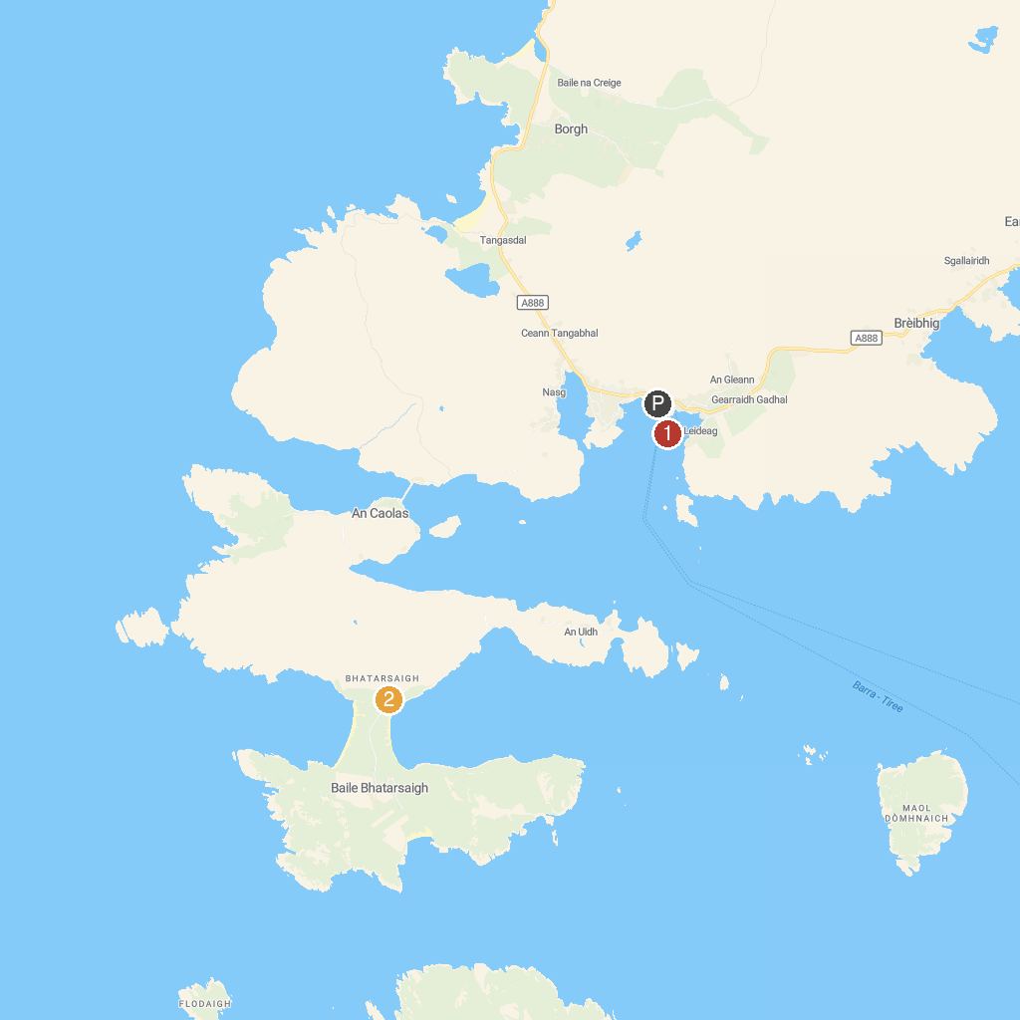
MAP KEY
1. Kisimul Castle | 2. The Hebridean Way Start Point
P. Cruise port / terminal
Map © MapTiler © OpenStreetMap contributors · cruiseports.org

