Isle of Arran, Scotland, United Kingdom
Known as 'Scotland in Miniature,' Arran packs Highland peaks, medieval castles, whisky distilleries, and seal-watched beaches into a single island day. Most cruise ships tender into Brodick Bay — and the reward is worth every minute.
⚓ Tender (Brodick Bay) · 🕒 Typical call: 6-8 hrs · 💷 Currency: British Pounds (GBP) · 🗣️ Language: English
✍️ MY DAY IN PORT (FILL IN)
Ship / Date
In port | arrive ______ · all aboard ______
Booked excursion
Notes / meeting point
GETTING ASHORE
- Docking: Tender — ships anchor in Brodick Bay; tender to Brodick Ferry Terminal pontoon
- Walk to Centre: 5-10 min flat walk from tender pontoon to Brodick village shops & cafes
- Best For: Scenic walks, whisky distillery tours, Brodick Castle, prehistoric standing stones
- Don't Miss: Arran Cheese Shop and a dram of Arran Single Malt before re-boarding
GETTING AROUND
- 🚕 Taxi: £4–£6 to Brodick center — Several small taxi firms serve the island (Arran Taxi, ARC Private Hire, etc.). Pre-booking is strongly recommended as m
- 📱 Rideshare: ❌ not available
TOP THINGS TO DO
- Brodick Castle & Country Park — A dramatic red-sandstone baronial castle (National Trust for Scotland) packed with antiques and art, surrounded by rhododendron…
- Arran Single Malt Distillery Tour (Lochranza) — The Isle of Arran Distillery in the scenic north produces award-winning unpeated single malt whisky.
- Machrie Moor Standing Stones — Six Neolithic and Bronze Age stone circles on an atmospheric moorland plateau — one of Scotland's most important prehistoric sites.
- Kildonan Beach & Seal Colony — A sandy south-coast beach famous for its resident harbour seals, which can almost always be spotted basking on offshore rocks.
- Goatfell Summit Hike — Arran's highest peak at 874m (2,867ft) offers panoramic views across the Firth of Clyde to the Scottish mainland — and as far as…
BEST WALKS
- Fisherman's Walk: Brodick to Brodick Castle: 2 miles one way · Flat · ~40-50 min · Free — The best walk from the tender pontoon.
- Glen Rosa Valley Walk: 2-4 miles · Easy to moderate · 1.5-2.5 hrs — A classic Scottish glaciated glen walk starting about 30 minutes on foot from Brodick village.
WEATHER · DAYLIGHT · MONEY
Month | High °F | Low °F | Rainy days
May | 55 | 47 | 15
Jul | 61 | 55 | 17
Sep | 59 | 53 | 16
Daylight: May 5:10AM–9:25PM · Jul 4:58AM–9:53PM · Sep 6:53AM–7:37PM
cruiseports.org/isle-of-arran · Confirm terminal & all-aboard time with your ship

Isle of Arran, Scotland, United Kingdom — Port Map
Red = walkable sights · Amber = excursions farther out · P = cruise terminal
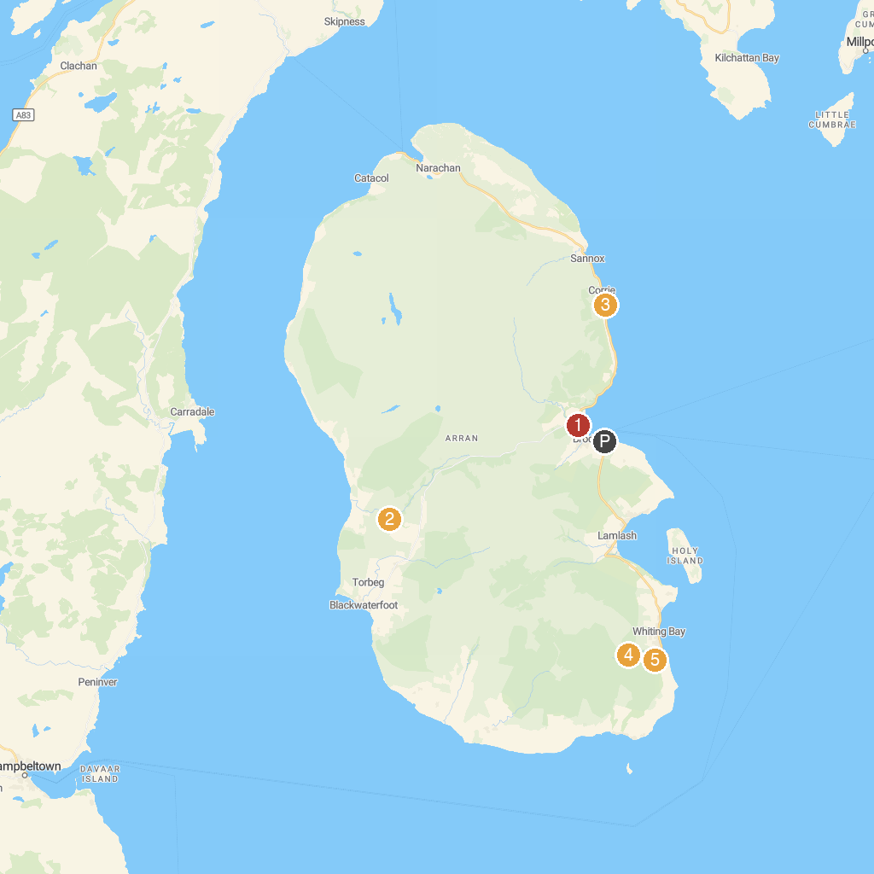
MAP KEY
1. Rosaburn Ducks | 4. Eas a’ Chrannaig
2. Machrie Moor Standing Stones | 5. Giants’ Graves
3. Sheep Harbour Cleats
P. Cruise port / terminal
Map © MapTiler © OpenStreetMap contributors · cruiseports.org

