Isla Mujeres, Quintana Roo, Mexico
A laid-back island of turquoise shallows and colorful streets just 8 miles from Cancún — best explored by golf cart with the whole island in a single port day.
⚓ Tender (small ships anchor offshore) · 🕒 Typical call: 6-8 hrs · 💵 USD widely accepted / MXN preferred · 🗣️ Spanish (English widely spoken in tourist areas) · 🏖️ Beach destination
✍️ MY DAY IN PORT (FILL IN)
Ship / Date
In port | arrive ______ · all aboard ______
Booked excursion
Notes / meeting point
GETTING ASHORE
- Docking: Tender to Terminal Marítima (downtown). Large ships use as excursion from Cozumel/Cancún; small luxury ships anchor offshore.
- Walk to Center: 0 min — ferry terminal opens directly into El Centro
- Best For: Playa Norte beach, golf cart island tour, MUSA underwater museum, whale shark swims (Jun–Sep)
- Don't Miss: Pescado Tikin Xic (Mayan grilled fish) at Playa Lancheros, and the Sea Walls murals in town
GETTING AROUND
- 🚕 Taxi: $3–$10 USD per ride — Fixed-zone fares apply; confirm price before boarding. Short downtown trips ~$3 USD; full island (north to south) ~$7–10
- 📱 Rideshare: ✅ Uber
TOP THINGS TO DO
- Playa Norte Beach Day — Frequently ranked among the world's best beaches — crushed-coral white sand, waist-deep turquoise water for 100 yards, and a row…
- Golf Cart Island Tour — Rent a golf cart and drive the full perimeter of the island: downtown murals, the Malecón sea wall, Playa Lancheros, and dramatic…
- Whale Shark Swim (Seasonal) — Between June and mid-September, boat excursions head offshore to swim alongside massive, harmless whale sharks — one of the…
- MUSA Underwater Museum — Over 500 life-sized sculptures installed on the seabed, designed to act as artificial reefs.
- Punta Sur & Temple of Ixchel — The southern tip of the island — also the easternmost point of Mexico — holds cliff-edge views, a sculpture park, and ruins of a…
BEST WALKS
- Terminal to Playa Norte: 10 min • 0.5 mi • flat and paved — Walk north from the ferry terminal along Avenida Hidalgo (pedestrian-only cobblestone street) past…
- El Centro to the Malecón: 15 min stroll • paved sea wall — From downtown, walk east to the Malecón — a paved seawall path along the windward side of the…
WEATHER · DAYLIGHT · MONEY
Month | High °F | Low °F | Rainy days
May | 83 | 79 | 12
Jul | 85 | 81 | 9
Sep | 85 | 80 | 19
Daylight: May 6:08AM–7:17PM · Jul 6:14AM–7:31PM · Sep 6:34AM–6:49PM
cruiseports.org/isla-mujeres-mexico · Confirm terminal & all-aboard time with your ship

Isla Mujeres, Quintana Roo, Mexico — Port Map
Red = walkable sights · Amber = excursions farther out · P = cruise terminal
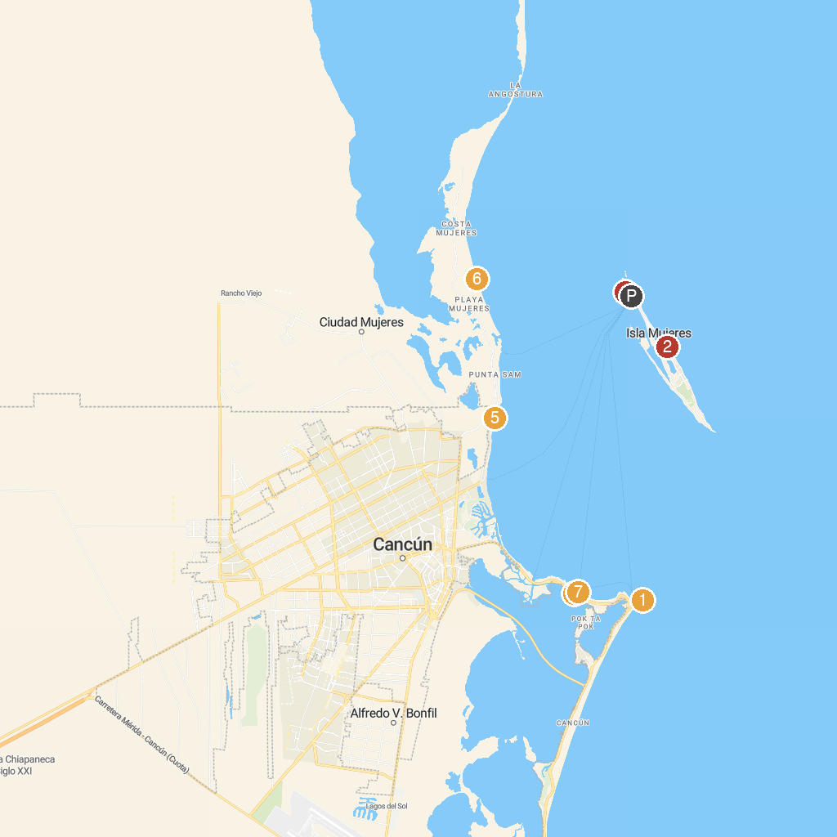
MAP KEY
1. Delphinus Punta Cancún | 5. Total Snorkel Cancun
2. Chapel of Guadalupe, Isla Mujeres | 6. Delphinus Playa Mujeres
3. DC Explorer Snorkeling in Isla Mujeres and swim with Whale sharks | 7. Experiencias Cancun
4. Columbus Romantic Dinner Cancun
P. Cruise port / terminal
Map © MapTiler © OpenStreetMap contributors · cruiseports.org

