Ishinomaki, Miyagi, Japan
The self-proclaimed Manga Kingdom of Japan, Ishinomaki pairs the whimsical world of Kamen Rider and Cyborg 009 with one of the most moving stories of resilience in modern history — and some of the freshest seafood in the Pacific.
⚓ Pier (Oote or Nakajima Wharf) · 🕒 Typical call: 8-10 hrs · 💴 Japanese Yen (JPY) · 🗣️ Japanese (limited English) · 🚌 Free shuttle to city center
✍️ MY DAY IN PORT (FILL IN)
Ship / Date
In port | arrive ______ · all aboard ______
Booked excursion
Notes / meeting point
GETTING ASHORE
- Docking: Pier — Oote Wharf or Nakajima Wharf (industrial port, 4-5 km from center)
- Walk to center: Not walkable from pier — free shuttle or taxi required
- Best For: Manga fans, tsunami memorial visits, fresh oysters and seafood
- Don't Miss: Ishinomori Manga Museum, Manga Road, Hiyori-yama Park views
GETTING AROUND
- 🚕 Taxi: ¥1,800–¥2,200 (~$11–14) per taxi — Taxis wait at the pier on cruise days. The 4–5 km ride to Ishinomaki Station takes about 10–15 minutes. Price is per cab
- 📱 Rideshare: ✅ Uber
TOP THINGS TO DO
- Ishinomori Manga Museum — The spaceship-shaped museum on Kyukitakami River celebrates the work of Shotaro Ishinomori — creator of Kamen Rider, Cyborg 009…
- Tsunami Memorial Sites — Visit Kadonowaki Elementary School — preserved largely as found after the 2011 tsunami — and the Minamihama Tsunami Memorial Park…
- San Juan Bautista Museum — The Sant Juan Kan museum tells the story of the 17th-century galleon built near Ishinomaki under Date Masamune, which carried…
- Hiyori-yama Park — Climb the hill where Ishinomaki Castle once stood for panoramic views over the Kitakami River estuary and the rebuilt city.
- Tashirojima (Cat Island) — A short ferry ride from Ishinomaki brings you to this small island famous for its thriving feral cat population and the Manga…
BEST WALKS
- Manga Road to the Museum: ~1 km one-way · 20-30 min · Flat — Walk from Ishinomaki Station along the character-statue-lined Manga Road to the Ishinomori Manga…
- Hiyori-yama Park Viewpoint: 20 min from station · Moderate hill · Great views — From the city center, head south up the hill to Hiyori-yama Park for sweeping views over the…
WEATHER · DAYLIGHT · MONEY
Month | High °F | Low °F | Rainy days
May | 66 | 53 | 10
Jul | 78 | 69 | 14
Sep | 75 | 66 | 12
Daylight: May 4:23AM–6:38PM · Jul 4:23AM–6:58PM · Sep 5:16AM–5:43PM
cruiseports.org/ishinomaki · Confirm terminal & all-aboard time with your ship

Ishinomaki, Miyagi, Japan — Port Map
Red = walkable sights · Amber = excursions farther out · P = cruise terminal
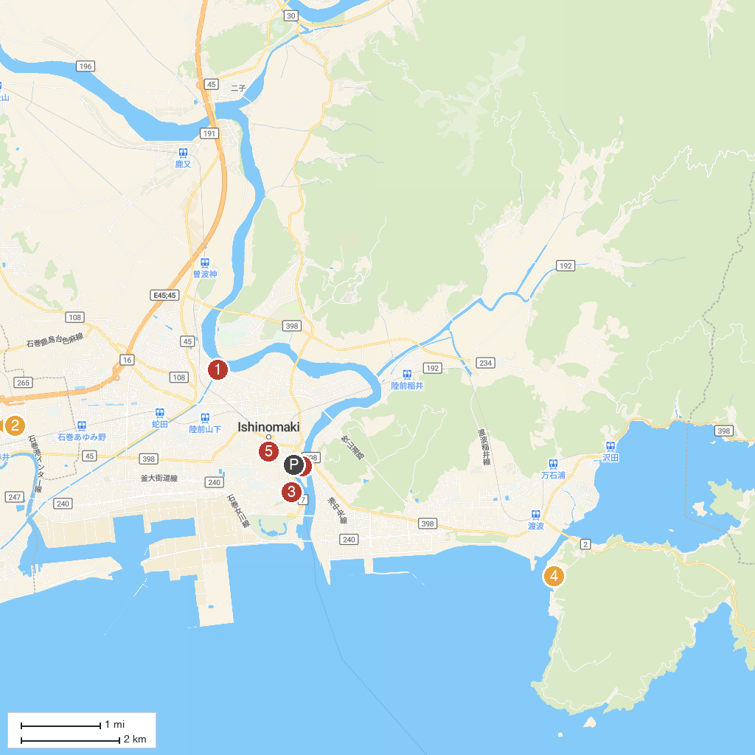
MAP KEY
1. Ishii lock | 4. Miyagi Sant Juan Bautista Museum
2. Takaginomori Sports Park | 5. Hagurosan Toya Shrine
3. Kashimamiko Shrine | 6. Nakaze Park
P. Cruise port / terminal
Map © MapTiler © OpenStreetMap contributors · cruiseports.org

