Ischia, Gulf of Naples, Italy
Italy's volcanic green island in the Gulf of Naples offers thermal hot springs, a medieval castle on the sea, and sandy beaches without Capri's crowds. This is where real Italians come to heal.
⚓ Tender (large ships) / Pier (small ships) · 🕒 Typical call: 7-10 hrs · 💶 Currency: Euro (€) · 🗣️ Language: Italian
✍️ MY DAY IN PORT (FILL IN)
Ship / Date
In port | arrive ______ · all aboard ______
Booked excursion
Notes / meeting point
GETTING ASHORE
- Docking: Small ships dock at Ischia Porto pier; larger vessels anchor and tender ashore
- Walk to center: 2 min to Ischia Porto town; 30 min walk to Aragonese Castle
- Best For: Thermal spa days, castle history, sandy beaches, authentic Italian food
- Don't Miss: Castello Aragonese and a glass of Rucolino, the island's wild-arugula digestif
GETTING AROUND
- 🚕 Taxi: €6–€55 — Taxis are readily available at Ischia Porto. Fares are fixed by zone: ~€6–7 to the town center, €25 to Casamicciola, €37
- 🚌 Hop-on hop-off: ✅
TOP THINGS TO DO
- Castello Aragonese — Ischia's defining landmark: a medieval fortress perched on a volcanic rock islet, connected to the island by a 220-meter stone…
- Poseidon or Negombo Thermal Gardens — Ischia's famous volcanic thermal parks feature dozens of open-air pools at different temperatures, private beaches, and optional…
- La Mortella Botanical Gardens — Created by Susana Walton (wife of British composer William Walton), La Mortella in Forio is one of Europe's finest private gardens.
- Sorgenti di Sorgeto Hot Springs — A wild volcanic cove on the south coast where scalding-hot thermal water bubbles up from the seabed, creating natural hot tubs at…
- Borgo Sant'Angelo Village — A car-free fishing village on the island's southern tip: pastel houses stacked up a volcanic promontory, boutiques, seafood…
BEST WALKS
- Porto to Aragonese Castle Waterfront Walk: 3 km round trip · Flat · 60-70 min — From the harbor, follow the Riva Destra (right bank) east through Ischia Porto's restaurant strip…
- Via Roma Shopping & Town Stroll: 1 km loop · Flat · 20-30 min — A quick orientation walk through the heart of Ischia Porto's shopping street.
WEATHER · DAYLIGHT · MONEY
Month | High °F | Low °F | Rainy days
May | 70 | 61 | 8
Jul | 84 | 75 | 2
Sep | 79 | 70 | 8
Daylight: May 5:47AM–8:14PM · Jul 5:46AM–8:33PM · Sep 6:45AM–7:12PM
cruiseports.org/ischia-island · Confirm terminal & all-aboard time with your ship

Ischia, Gulf of Naples, Italy — Port Map
Red = walkable sights · Amber = excursions farther out · P = cruise terminal
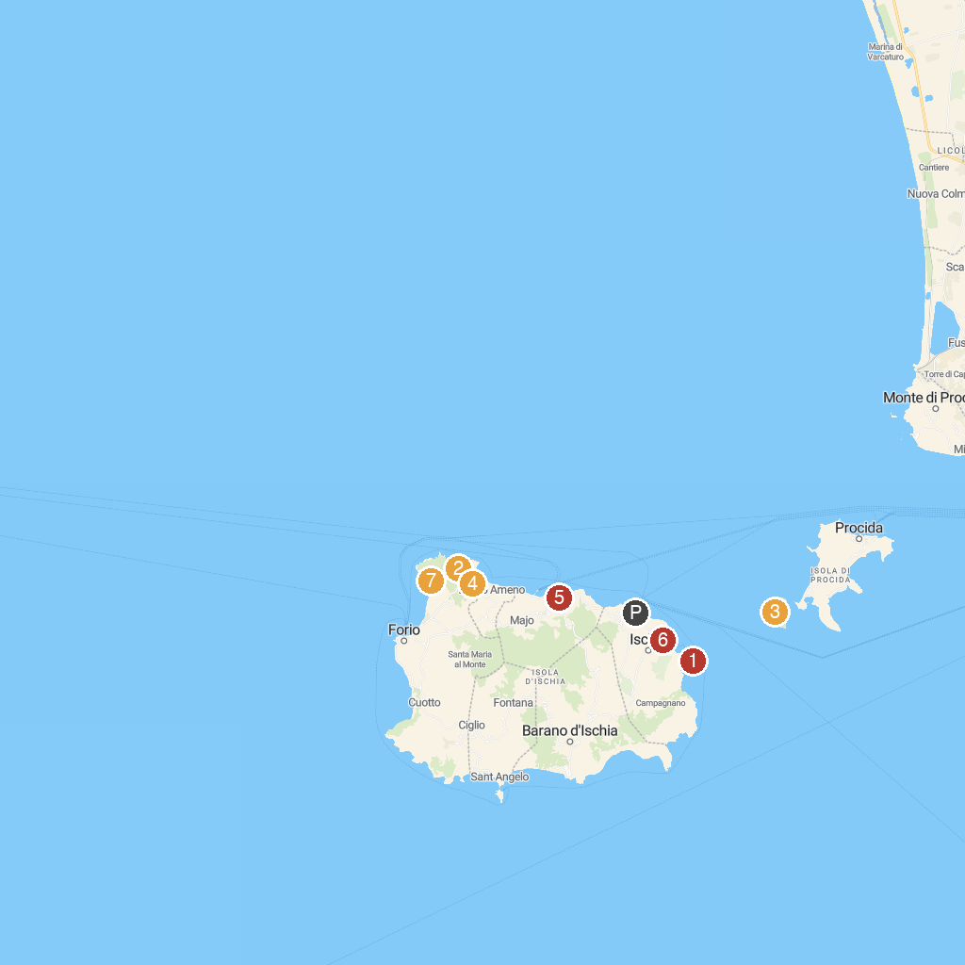
MAP KEY
1. Aragonese Castle | 5. Archaeological Museum of Pithecusa
2. Negombo | 6. St. Gabriel of the Passionist Fathers
3. Stufe di Nerone | 7. Pineta Mirtina
4. Riserva Naturale Statale Isola di Vivara | 8. Belvedere Di Zaro
P. Cruise port / terminal
Map © MapTiler © OpenStreetMap contributors · cruiseports.org

