Ísafjörður
Wooden old town · Dynjandi falls · Vigur puffins · Arctic fox country
⚓ Docked at main pier (centre) · 🕒 Typical call: 7–9 hrs · 💵 Icelandic Króna (ISK) · cards widely accepted · 🗣️ Icelandic · English universally spoken
✍️ MY DAY IN PORT (FILL IN)
Ship / Date
In port | arrive ______ · all aboard ______
Booked excursion
Notes / meeting point
GETTING ASHORE
- Docking: Central town pier, town centre
- To centre: Walk off the gangway — 2 min
- Best For: Fjords · Wildlife · History
- Don't Miss: Dynjandi waterfall · Vigur island
GETTING AROUND
- 🚕 Taxi: ISK 730 base + ~ISK 351/km — A small number of local taxis serve Ísafjörður. Book in advance (call +354 456-3518) — supply is very limited, especiall
- 📱 Rideshare: ❌ not available
- 🚌 Hop-on hop-off: ✅ West Travel Iceland
TOP THINGS TO DO
- Dynjandi Waterfall — Often called the jewel of the Westfjords, Dynjandi fans out like a bridal veil over 100 metres before tumbling through six…
- Vigur Island Puffin Tour — A short boat ride from Ísafjörður lands you on tiny Vigur island, home to thousands of Atlantic puffins, eider ducks, and Arctic…
- Súðavík Arctic Fox Centre — The Melrakkasetur (Arctic Fox Centre) in nearby Súðavík is dedicated to Iceland's only native land mammal.
- Westfjords Heritage Museum (Byggðasafn Vestfjarða) — Housed in four restored 18th-century timber warehouses — among the oldest buildings in Iceland — the Heritage Museum brings…
BEST WALKS
- Old Town Wooden Quarter: ~1.5 km · 45 min · easy — Wander the grid of preserved 18th- and 19th-century timber houses clustered on the harbour spit.
- Naustahvilft (The Troll Seat) Hike: ~4 km return · 2–2.5 hrs · moderate — A well-marked trail climbs steeply from the edge of town to a natural rock amphitheatre carved into…
- Bolungarvík Coastal Drive & Walk: ~30 min drive + 1 hr walk · easy — The neighbouring town of Bolungarvík, 15 km along the fjord, has its own open-air maritime museum…
WEATHER · DAYLIGHT · MONEY
Month | High °F | Low °F | Rainy days
May | 42 | 34 | 14
Jul | 54 | 45 | 14
Sep | 48 | 40 | 19
Daylight: Sep 6:53AM–7:59PM
cruiseports.org/isafjordur · Confirm terminal & all-aboard time with your ship

Ísafjörður — Port Map
Red = walkable sights · Amber = excursions farther out · P = cruise terminal
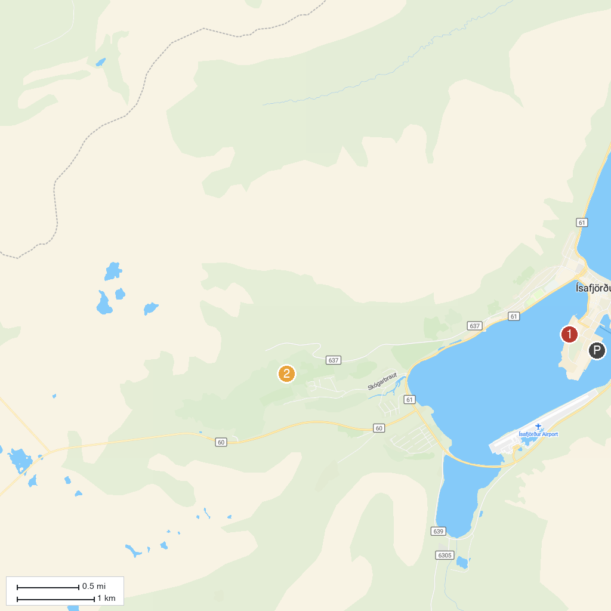
MAP KEY
1. Westfjord History Museum | 3. Valagil Waterfall
2. Bunárfoss
P. Cruise port / terminal
Map © MapTiler © OpenStreetMap contributors · cruiseports.org

