Puerto Villamil, Isabela Island, Ecuador
The largest and wildest of the Galapagos Islands, Isabela is a place where white-sand streets meet volcanic giants — and Galapagos penguins swim past your Zodiac.
⚓ Tender (no pier) · 🕒 Typical call: 6-8 hrs · 💵 USD · 🗣️ Spanish · 🦎 Wildlife-rich
✍️ MY DAY IN PORT (FILL IN)
Ship / Date
In port | arrive ______ · all aboard ______
Booked excursion
Notes / meeting point
GETTING ASHORE
- Docking: Tender only — ships anchor in the bay; Zodiacs ferry passengers to Muelle El Embarcadero pier
- Walk to center: 10–15 min walk (0.8 mi / 1.2 km) from the pier along boardwalk and sandy road; pickup trucks available ($2–3)
- Best For: Wildlife encounters, snorkeling, giant tortoises, volcanic hiking, and desert-island beaches
- Don't Miss: Concha de Perla snorkeling lagoon (free, 2 min from pier) and Arnaldo Tupiza Tortoise Breeding Center
GETTING AROUND
- 🚕 Taxi: $1–$2 per person — White pickup trucks serve as taxis around town. Fares are per person and very cheap; drivers prefer a full vehicle. Note
- 📱 Rideshare: ❌ not available
TOP THINGS TO DO
- Concha de Perla Snorkeling — A crystal-clear natural mangrove lagoon just two minutes from the pier — free to enter and arguably the best self-guided snorkel…
- Arnaldo Tupiza Giant Tortoise Breeding Center — Walk the flamingo estuary boardwalk to this conservation facility where you can see giant tortoises at every life stage — from…
- Los Túneles Snorkeling (The Tunnels) — Ancient lava flows have formed underwater arches and bridges teeming with white-tip reef sharks, giant manta rays, seahorses, and…
- Las Tintoreras Islet — A short 10-minute boat ride from the pier leads to this rocky islet where white-tip reef sharks rest in a narrow lava crevice.
- Sierra Negra Volcano Hike — A challenging 10-mile round-trip hike to one of the world's largest volcanic calderas.
BEST WALKS
- Pier to Town & Flamingo Estuary: 2.5 miles round-trip · 1-1.5 hrs · Easy · Free — Walk from the pier past Concha de Perla snorkeling lagoon (worth the 2-minute detour), through town…
- Bike to the Wall of Tears: 7 miles round-trip · 2-3 hrs · Easy cycling · Bike rental ~$15 — Rent a bicycle in town and follow the sandy road west past Playa Grande beach, through dry forest…
WEATHER · DAYLIGHT · MONEY
Month | High °F | Low °F | Rainy days
May | 80 | 73 | 23
Jul | 75 | 70 | 18
Sep | 73 | 68 | 13
Daylight: May 5:58AM–6:02PM · Jul 6:08AM–6:11PM · Sep 5:56AM–6:01PM
cruiseports.org/isabela-island · Confirm terminal & all-aboard time with your ship

Puerto Villamil, Isabela Island, Ecuador — Port Map
Red = walkable sights · Amber = excursions farther out · P = cruise terminal
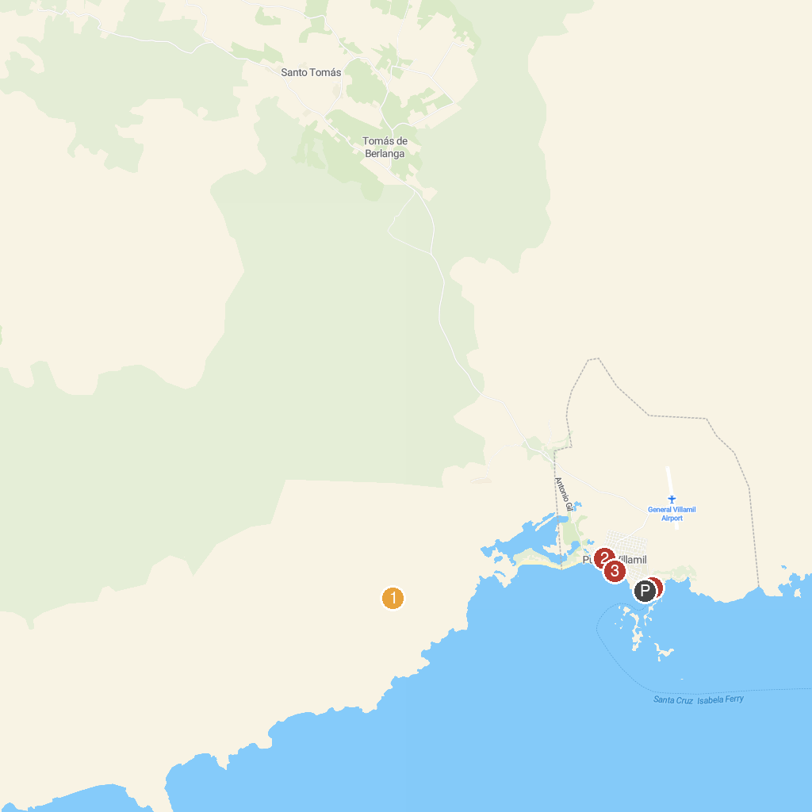
MAP KEY
1. Wall of Tears | 3. Malecon Puerto Villamil
2. Poza de los Flamingos | 4. Pearl Shell
P. Cruise port / terminal
Map © MapTiler © OpenStreetMap contributors · cruiseports.org

