Iron Gate, Danube Gorge, Serbia/Romania
Where the Danube carves through the Carpathians in a spectacular 134 km gorge, passing Roman inscriptions, a medieval fortress, and Europe's largest rock sculpture — all viewed from the sundeck or explored on shore.
⚓ Pontoon pier (river cruise) · 🕒 Typical call: scenic transit + 4-6 hrs ashore · 💵 Serbian Dinar / Romanian Leu (€ widely accepted) · 🗣️ Serbian / Romanian
✍️ MY DAY IN PORT (FILL IN)
Ship / Date
In port | arrive ______ · all aboard ______
Booked excursion
Notes / meeting point
GETTING ASHORE
- Docking: Floating pontoon in Donji Milanovac — direct walkoff, no tender
- Walk to center: 5 min to Donji Milanovac town; Golubac Fortress 1 km from pier if stopped there
- Best For: Scenic gorge cruising, Roman history, ancient archaeology
- Don't Miss: Decebalus rock carving (from ship) and Lepenski Vir Mesolithic site
GETTING AROUND
- 🚕 Taxi: €5–€15 local trips — Local taxis available at both Donji Milanovac (Serbia) and Orșova/Drobeta-Turnu Severin (Romania). Small-town distances
TOP THINGS TO DO
- Decebalus Rock Sculpture (from ship) — At 55 m, the giant stone portrait of Dacian king Decebalus carved into the gorge cliff is the tallest rock sculpture in Europe.
- Lepenski Vir Archaeological Site — One of Europe's most important prehistoric sites, dating to 9500–6000 BC.
- Golubac Fortress — A breathtaking 14th-century fortification with ten towers stepping down the cliff face into the Danube.
- Đerdap National Park Hike — Serbia's largest national park flanks the gorge with dense forest, limestone cliffs, and viewpoints over the narrowest stretch of…
- Iron Gate Dam Lock Transit — A genuine engineering marvel: the ship enters a double-lock chamber and rises or drops 30 m as massive gates open before you.
BEST WALKS
- Donji Milanovac Waterfront Stroll: 1 km • 15 min • Flat — Walk the riverside promenade from the ship's pontoon through the town center, passing a small park…
WEATHER · DAYLIGHT · MONEY
Month | High °F | Low °F | Rainy days
May | 71 | 54 | 13
Jul | 84 | 66 | 8
Sep | 75 | 59 | 7
Daylight: May 5:04AM–7:52PM · Jul 5:01AM–8:13PM · Sep 6:10AM–6:41PM
cruiseports.org/iron-gate · Confirm terminal & all-aboard time with your ship

Iron Gate, Danube Gorge, Serbia/Romania — Port Map
Red = walkable sights · Amber = excursions farther out · P = cruise terminal
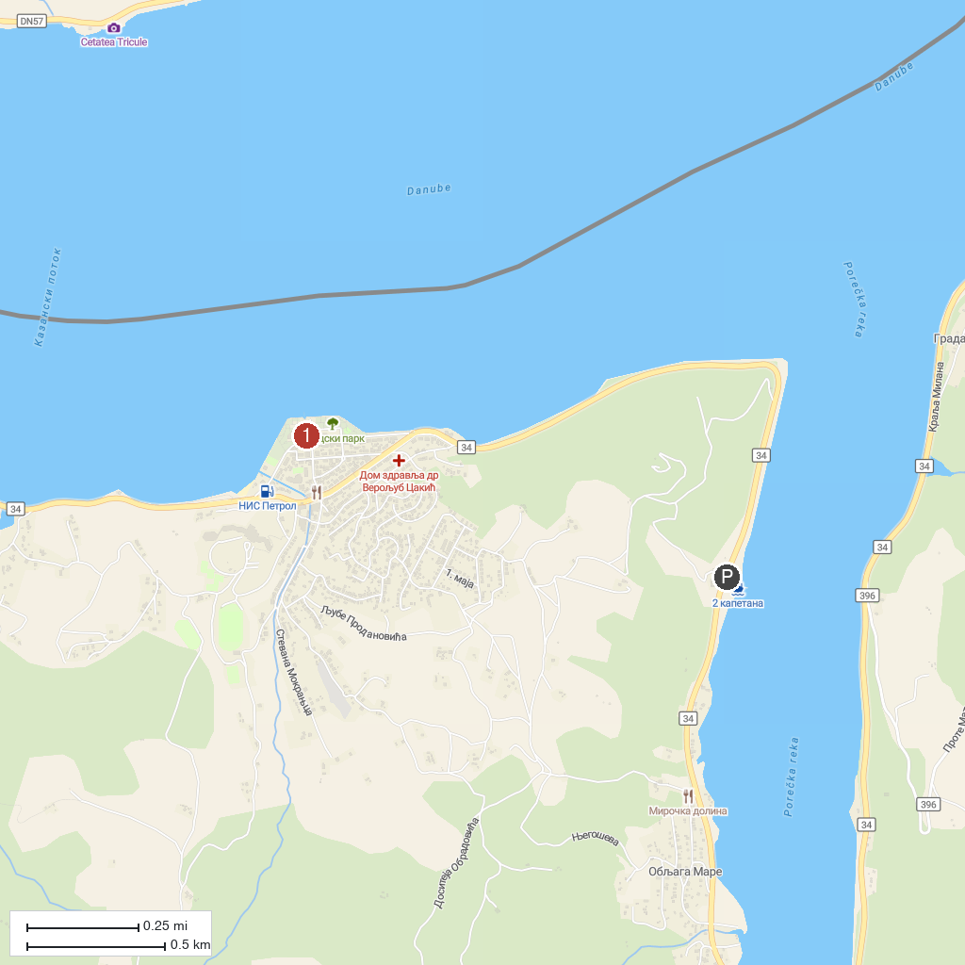
MAP KEY
1. Tourist Info Center Donji Milanovac | 3. Boljetin river canyon
2. 2 Kapetana, krstarenje Dunavom u Đerdapu
P. Cruise port / terminal
Map © MapTiler © OpenStreetMap contributors · cruiseports.org

