Iquitos, Loreto, Peru
The world's largest city unreachable by road, Iquitos sits deep in the Peruvian Amazon — a place of rubber-boom mansions, floating neighborhoods, and encounters with wildlife found nowhere else on Earth.
⚓ Docked at ENAPU Pier (anchor/tender possible at high water) · 🕒 Typical call: 8–12 hrs (often embark/disembark port) · 💵 Peruvian Sol (PEN) — cash only for most things · 🗣️ Spanish (Castellano)
✍️ MY DAY IN PORT (FILL IN)
Ship / Date
In port | arrive ______ · all aboard ______
Booked excursion
Notes / meeting point
GETTING ASHORE
- Docking: ENAPU river pier ~4 km north of center; smaller riverboats use private wharves. Zodiac/tender transfers used by expedition ships and at high water.
- Walk to center: Do not walk — port area is industrial. Mototaxi to Plaza de Armas: 10–15 min, ~5–8 Soles ($1.50–2).
- Best For: Amazon wildlife, rubber-boom history, Amazonian cuisine, river excursions
- Don't Miss: Baby manatees at CREA, floating restaurant Al Frío y Al Fuego, the Iron House on the Plaza de Armas
GETTING AROUND
- 🚕 Taxi: S/2–3 within city; ~S/20 from dock to center — Three-wheeled motorcycle taxis are the defining transport of Iquitos and the most affordable option. Agree on fare befor
- 📱 Rideshare: ❌ not available
TOP THINGS TO DO
- CREA Amazon Manatee Rescue Center — Hand-feed orphaned baby Amazonian manatees at this rescue and rehabilitation center.
- Pilpintuwasi Butterfly Farm & Animal Orphanage — Take a mototaxi to Bellavista Nanay, then a 20-minute peke-peke boat to Padre Cocha village.
- Monkey Island (Isla de los Monos) — A family-run sanctuary 30–40 minutes downriver where rescued monkeys roam free in the canopy.
- Rubber Boom Walking Tour — Walk the Malecón Tarapacá and surrounding streets with a guide to see the crumbling Portuguese-tiled mansions built by rubber…
- Belén Market & Floating District — The city's sprawling riverside market sells Amazonian fish (giant paiche), exotic jungle fruits, and medicinal plants down the…
BEST WALKS
- Plaza de Armas to Malecón Tarapacá: Easy · ~15 min · riverside views — From the main plaza, walk one block west to the Malecón Tarapacá riverfront promenade.
- Bellavista Nanay Waterfront: Easy · ~20 min walk · local river atmosphere — Head to the Bellavista Nanay neighbourhood on the Nanay River.
WEATHER · DAYLIGHT · MONEY
Month | High °F | Low °F | Rainy days
May | 84 | 74 | 26
Jul | 84 | 73 | 22
Sep | 88 | 75 | 19
Daylight: May 5:51AM–5:47PM · Jul 6:01AM–5:56PM · Sep 5:45AM–5:50PM
cruiseports.org/iquitos · Confirm terminal & all-aboard time with your ship

Iquitos, Loreto, Peru — Port Map
Red = walkable sights · Amber = excursions farther out · P = cruise terminal
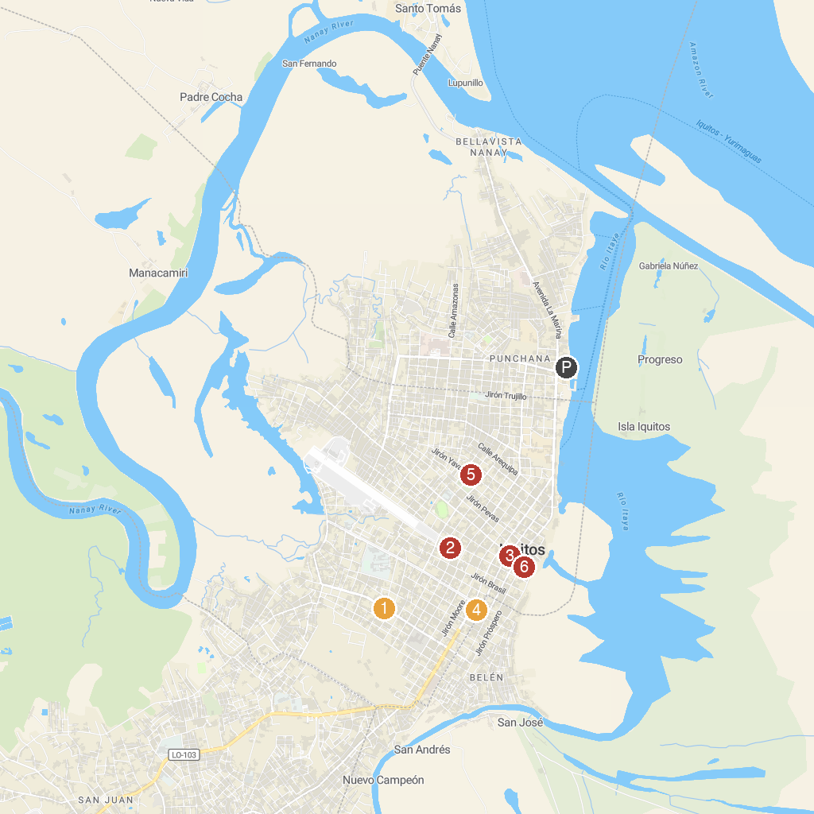
MAP KEY
1. Cerro Palmeras | 4. Plaza 28 De Julio
2. Plaza Sargento Lores | 5. Mi Museo Iquitos
3. CRISAP-UNAP | 6. Casa de Fierro
P. Cruise port / terminal
Map © MapTiler © OpenStreetMap contributors · cruiseports.org

