Invergordon, Easter Ross, Scotland
A small town with massive ambitions — Invergordon plants you 5 minutes from the High Street and an hour from some of the most dramatic scenery in Europe. Loch Ness, ancient castles, and legendary whisky all await.
⚓ Pier (docked) · 🕒 Typical call: 8-10 hrs · 💷 Currency: GBP (£) · 🗣️ Language: English
✍️ MY DAY IN PORT (FILL IN)
Ship / Date
In port | arrive ______ · all aboard ______
Booked excursion
Notes / meeting point
GETTING ASHORE
- Docking: Deep-water pier — ships berth directly, no tender
- Walk to town: 5-10 min to High Street (~400 m flat walk)
- Best For: Highland day trips: Loch Ness, castles, whisky distilleries
- Don't Miss: Mural Trail in town; Glenmorangie Distillery just 15 min away
GETTING AROUND
- 🚕 Taxi: £50–£70/hr (4-hr min) — Local taxi companies (e.g. Scotland Taxi Tours, Highland Taxis) meet ships at the pier. Rates are ~£50/hr for 4-seater,
- 📱 Rideshare: ❌ not available
TOP THINGS TO DO
- Loch Ness & Urquhart Castle — The dark, deep loch that holds Scotland's greatest mystery.
- Culloden Battlefield & Clava Cairns — The moorland where the Jacobite rising ended in 1746.
- Dunrobin Castle & Falconry — One of Britain's oldest continually inhabited houses, styled like a French château with spectacular gardens overlooking the North…
- Glenmorangie Distillery Tour & Tasting — One of Scotland's most celebrated single malts is distilled in Tain, just 15 minutes north of the port.
- Cawdor Castle & Gardens — A beautifully preserved 14th/15th-century castle still lived in by the Cawdor family, with Shakespeare's Macbeth connections and…
BEST WALKS
- Invergordon Mural Trail: 1-2 hrs · Easy · Free — Numerous large professionally painted murals cover the sides of buildings throughout town…
- Saltburn Woodland & Shore Walk: 1.5-2 hrs · Easy · Free — Head east along the Cromarty Firth shoreline to the village of Saltburn.
WEATHER · DAYLIGHT · MONEY
Month | High °F | Low °F | Rainy days
May | 56 | 44 | 14
Jul | 64 | 53 | 17
Sep | 60 | 50 | 13
Daylight: May 4:54AM–9:33PM · Jul 4:40AM–10:03PM · Sep 6:47AM–7:34PM
cruiseports.org/invergordon · Confirm terminal & all-aboard time with your ship

Invergordon, Easter Ross, Scotland — Port Map
Red = walkable sights · Amber = excursions farther out · P = cruise terminal
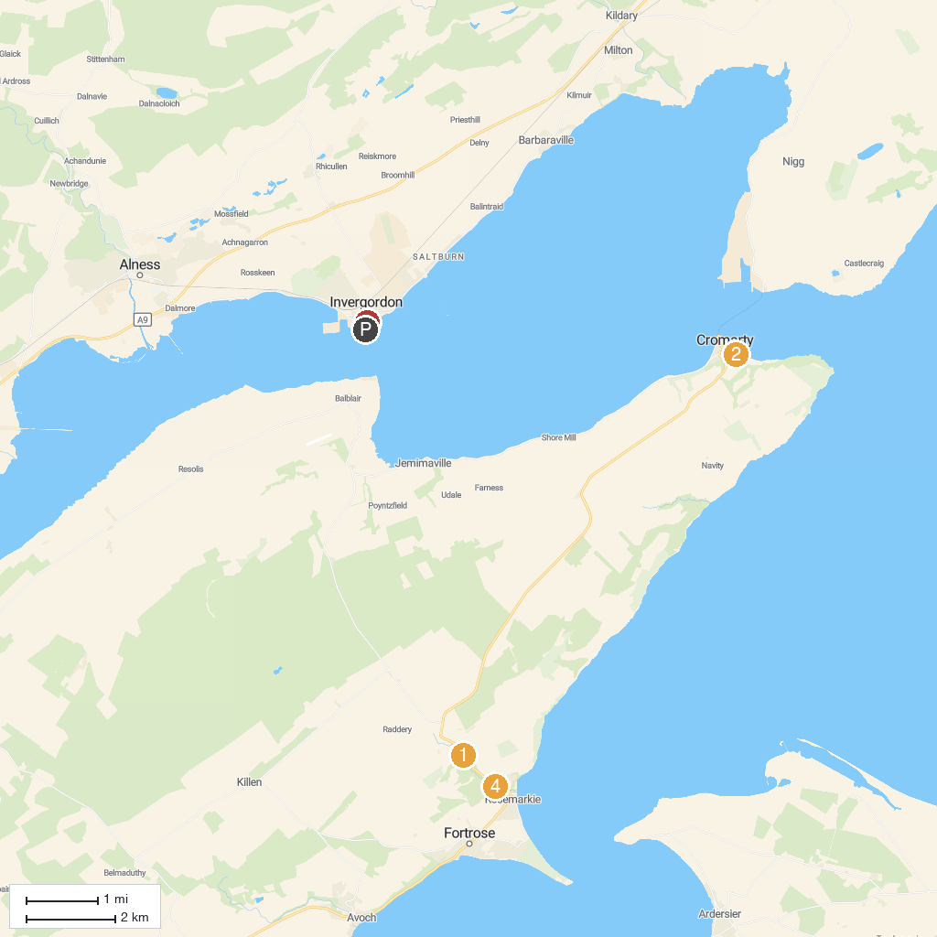
MAP KEY
1. Fairy Glen Falls | 4. Hugh Miller's Birthplace Cottage and Museum (National Trust for Scotland)
2. Fort George | 5. Invergordon Tours
3. Chanonry Lighthouse | 6. RSPB Fairy Glen
P. Cruise port / terminal
Map © MapTiler © OpenStreetMap contributors · cruiseports.org

