Inside Passage, Southeast Alaska, USA
A thousand miles of protected waterway threading through ancient rainforest, tidewater glaciers, and some of the richest wildlife habitat on earth — no port stop required.
⚓ Scenic Cruising Day (no port stop) · 🕒 Full day at sea — 8-12 hrs of scenery · 💵 USD (no going ashore) · 🗣️ English · 🦅 World-class wildlife viewing
✍️ MY DAY IN PORT (FILL IN)
Ship / Date
In port | arrive ______ · all aboard ______
Booked excursion
Notes / meeting point
GETTING ASHORE
- Docking: Scenic cruising — no port call, ship sails through
- Route Length: ~1,000 miles, Vancouver Island to Skagway
- Best For: Wildlife, glaciers, dramatic fjord scenery
- Don't Miss: Whale spouts at dawn; misty fjords at dusk
GETTING AROUND
TOP THINGS TO DO
- Whale & Wildlife Watch from Deck — Humpback whales, orca, Dall's porpoise, Steller sea lions, and harbor seals are regularly spotted from the ship's open decks.
- Glacier & Fjord Scenery — Many Inside Passage itineraries include a slow pass through Tracy Arm Fjord or Endicott Arm, where sheer granite walls rise 3,000…
- Onboard Naturalist Program — National Park Service rangers and ship naturalists give lectures on Southeast Alaska ecology, Tlingit culture, glacier science…
- Tongass National Forest Backdrop — The world's largest temperate rainforest lines both sides of the passage.
WEATHER · DAYLIGHT · MONEY
Month | High °F | Low °F | Rainy days
May | 54 | 41 | 14
Jul | 64 | 54 | 18
Sep | 57 | 47 | 21
Daylight: May 4:30AM–9:18PM · Jul 4:17AM–9:48PM · Sep 6:28AM–7:15PM
cruiseports.org/inside-passage · Confirm terminal & all-aboard time with your ship

Inside Passage, Southeast Alaska, USA — Port Map
Red = walkable sights · Amber = excursions farther out · P = cruise terminal
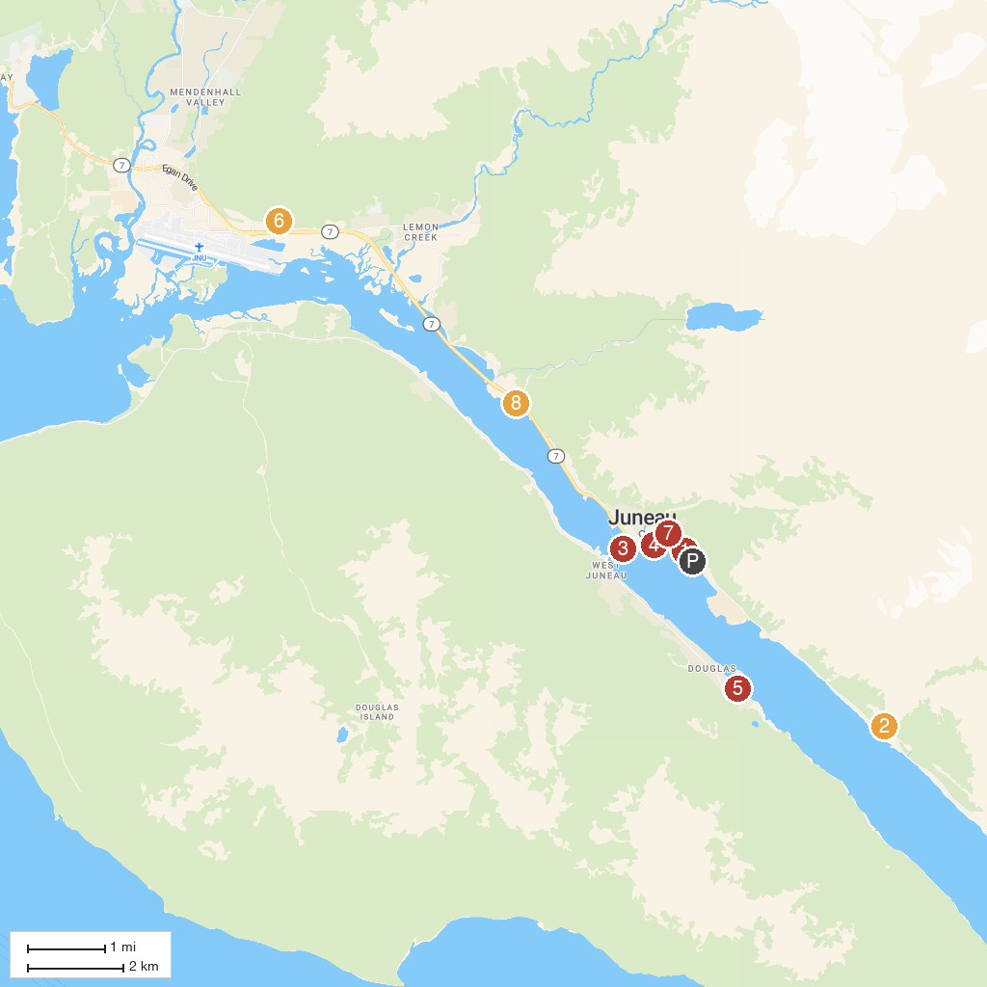
MAP KEY
1. Liquid Alaska Tours | 5. Savikko Park
2. AJ Mine Gastineau Mill Tours | 6. Glacier Gardens Rainforest Adventure
3. The Whale Project | 7. Alaska State Capitol
4. Alaska State Museum | 8. DIPAC Macaulay Salmon Hatchery
P. Cruise port / terminal
Map © MapTiler © OpenStreetMap contributors · cruiseports.org

