Ilulissat, Avannaata, Greenland
The world's most productive glacier calves day and night into a UNESCO fjord jammed with cathedral-sized icebergs — and it's right at the edge of town. Ilulissat delivers Arctic drama unlike anywhere else on a cruise map.
⚓ Tender port (no cruise pier) · 🕒 Typical call: 6-9 hrs · 💵 Danish Krone (DKK) — cards accepted everywhere · 🗣️ Greenlandic & Danish · ❄️ UNESCO World Heritage Icefjord
✍️ MY DAY IN PORT (FILL IN)
Ship / Date
In port | arrive ______ · all aboard ______
Booked excursion
Notes / meeting point
GETTING ASHORE
- Docking: Tender only — ships anchor in Disko Bay; ice conditions can delay or cancel tenders
- Walk to center: ~0.5 km (5-10 min) uphill from tender landing — town is compact
- Best For: Icefjord boardwalk hike, iceberg boat tours, Arctic wildlife, photography
- Don't Miss: The Sermermiut boardwalk to the Icefjord edge — free and unmissable
GETTING AROUND
- 🚕 Taxi: 130–150 DKK (~–22 USD) — Metered taxis operate in Ilulissat (base ~29.5 DKK + 20 DKK/km). Call Ilulissat Taxi (+299 94 44 44) or Radio Taxi (+299
- 📱 Rideshare: ❌ not available
TOP THINGS TO DO
- Sermermiut Boardwalk & Icefjord — Walk the free wooden boardwalk through the ancient Sermermiut Inuit settlement valley to the edge of the UNESCO Icefjord.
- Iceberg Boat Tour in Disko Bay — Sail right up to the towering ice giants calved from Sermeq Kujalleq.
- Ilulissat Icefjord Centre — Award-winning museum and visitor centre designed to melt into the Arctic landscape.
- Knud Rasmussen Museum — Birthplace of the great Arctic explorer, now a museum dedicated to his polar expeditions and Inuit culture.
- Helicopter Flightseeing over the Glacier — A splurge that delivers: helicopter tours fly over the mouth of the Icefjord and approach the face of Sermeq Kujalleq (Jakobshavn…
BEST WALKS
- Harbor to Icefjord Centre & Sermermiut: 4 km round trip | 1.5-2 hrs | Moderate (hilly start, easy boardwalk) — From the harbor, walk uphill into town, passing Zion's Church, then continue to the Icefjord Centre…
- Town Center Loop: 2 km | 45 min | Easy — A short loop taking in the main square, the Knud Rasmussen Museum, colorful Greenlandic houses, and…
WEATHER · DAYLIGHT · MONEY
Month | High °F | Low °F | Rainy days
May | 37 | 26 | 6
Jul | 56 | 43 | 6
Sep | 40 | 30 | 8
Daylight: Sep 7:40AM–8:56PM
cruiseports.org/ilulissat · Confirm terminal & all-aboard time with your ship

Ilulissat, Avannaata, Greenland — Port Map
Red = walkable sights · Amber = excursions farther out · P = cruise terminal
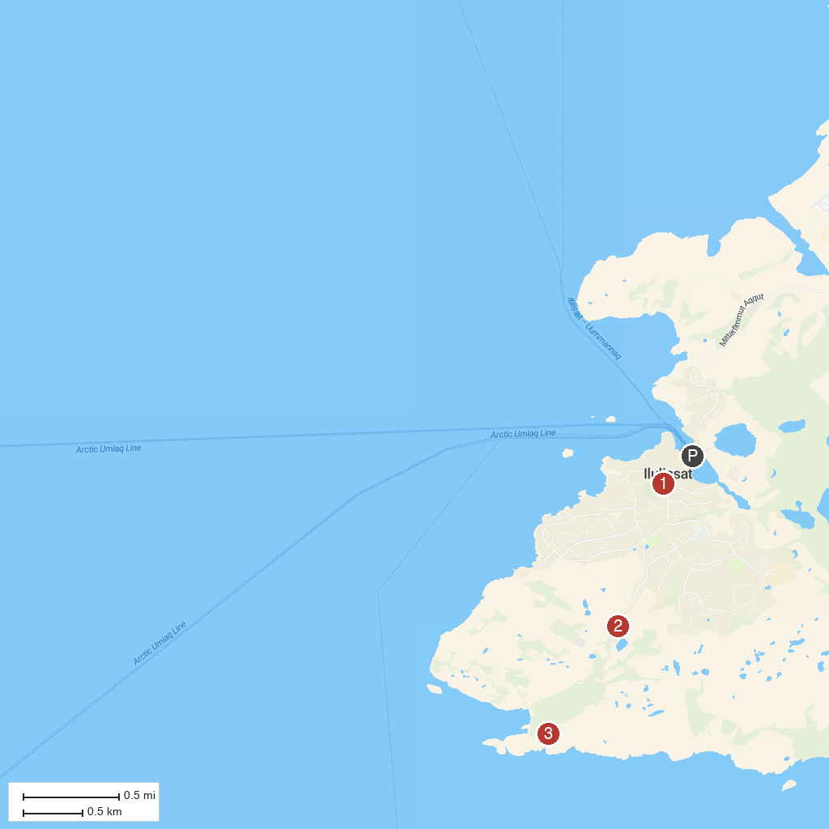
MAP KEY
1. World of Greenland | 3. Ilulissat Isfjord
2. Ilulissat Isfjordscenter
P. Cruise port / terminal
Map © MapTiler © OpenStreetMap contributors · cruiseports.org

