Ilhéus, Bahia, Brazil
The 'Cacao Capital of Brazil' blends colonial grandeur with Bahian soul — crack open a raw cacao pod, sip the pulp, and pull up a chair at the bar that inspired a novel.
⚓ Pier (Porto do Malhado) · 🕒 Typical call: 7-9 hrs · 💵 Brazilian Real (BRL) · 🗣️ Portuguese · 🍫 Cacao & chocolate
✍️ MY DAY IN PORT (FILL IN)
Ship / Date
In port | arrive ______ · all aboard ______
Booked excursion
Notes / meeting point
GETTING ASHORE
- Docking: Pier — Porto do Malhado, ~2 km north of historic center
- Walk to center: Not recommended (industrial zone); taxi or shuttle ~10 min
- Best For: History lovers, foodies, chocolate fans, beach seekers
- Don't Miss: Cacao farm tour + fresh cacao pulp juice
GETTING AROUND
- 🚕 Taxi: R$25–35 — Taxis wait at the port gate for the ~2–3 km ride to the historic center. Agree on fare before departing or ask for the m
- 📱 Rideshare: ✅ Uber, 99
TOP THINGS TO DO
- Cacao Farm & Chocolate Experience — The signature Ilhéus excursion.
- Jorge Amado Historic Center Walk — Follow in the footsteps of Brazil's most beloved novelist — visit the Casa de Cultura Jorge Amado, grab a kibe at the legendary…
- Praia dos Milionários Beach Day — Bahia's 'Millionaires' Beach' is 7 km south of center — wide golden sands, warm Atlantic waters, and excellent beach cabanas…
- Bahian Cuisine & Tasting Tour — Dive into Bahia's African-influenced kitchen: moqueca baiana (coconut fish stew), acarajé street fritters, fresh cacao juice, and…
- Cururupe River & Kayaking — 12 km south, the Cururupe River meets the sea in a dramatic tidal estuary.
BEST WALKS
- Historic Center: Amado's Ilhéus: 1.5 km · 30–45 min · Easy — Start at the São Sebastião Cathedral on the waterfront, walk to Casa de Cultura Jorge Amado for a…
- Praia do Cristo & Waterfront: 1 km · 20 min · Easy — Stroll south from the historic center to Praia do Cristo, where a small Christ statue overlooks the…
WEATHER · DAYLIGHT · MONEY
Month | High °F | Low °F | Rainy days
May | 81 | 71 | 20
Jul | 78 | 68 | 22
Sep | 80 | 70 | 18
Daylight: May 5:49AM–5:15PM · Jul 6:02AM–5:21PM · Sep 5:31AM–5:31PM
cruiseports.org/ilheus · Confirm terminal & all-aboard time with your ship

Ilhéus, Bahia, Brazil — Port Map
Red = walkable sights · Amber = excursions farther out · P = cruise terminal
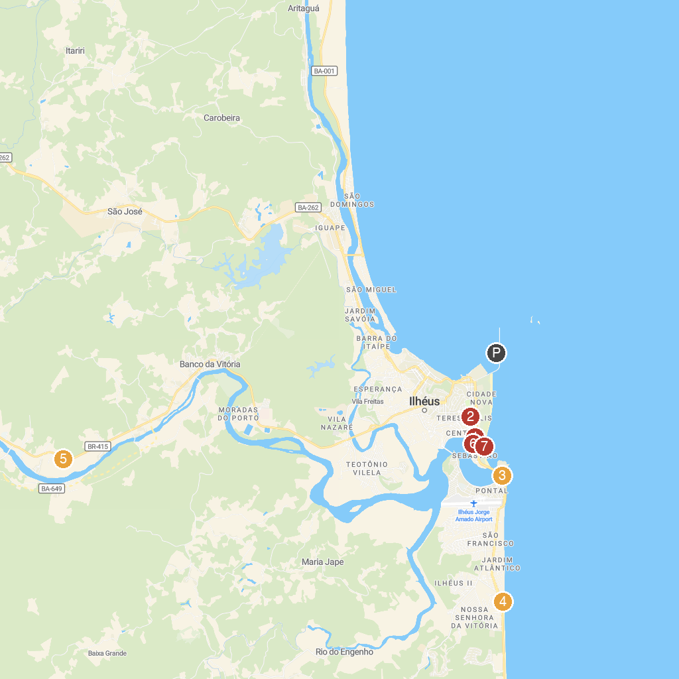
MAP KEY
1. San Sebastian Cathedral | 5. Fazenda Yrere
2. Mirante da Piedade | 6. Cannon Lookout
3. MARAMATA | 7. Praia da Avenida
4. Praia Do Sul -Ilhéus, BA
P. Cruise port / terminal
Map © MapTiler © OpenStreetMap contributors · cruiseports.org

