Ikaria Island, Aegean, Greece
One of the world's five Blue Zones, Ikaria moves to its own rhythm — wild thermal springs bubbling into the sea, clifftop monasteries, and locals who genuinely forget to die.
⚓ Pier (Agios Kirykos) · 🕒 Typical call: 6-8 hrs · 💶 Euro (EUR) · 🗣️ Greek
✍️ MY DAY IN PORT (FILL IN)
Ship / Date
In port | arrive ______ · all aboard ______
Booked excursion
Notes / meeting point
GETTING ASHORE
- Docking: Pier at Agios Kirykos (capital); some calls use Evdilos (north coast)
- Walk to center: 2–5 min from pier to Agios Kirykos harbor square
- Best For: Hot springs, off-the-beaten-path beaches, Blue Zone culture
- Don't Miss: Free thermal springs at Lefkada rocks (2 km from port)
GETTING AROUND
- 🚕 Taxi: €5–€10 — Taxis are available at the port. Meter starts at €1.20 with a minimum fare of €3.40 plus a €1.07 port surcharge. Short r
- 📱 Rideshare: ❌ not available
TOP THINGS TO DO
- Thermal Springs at Therma — Soak in the municipal radioactive hot springs at the village of Therma, just 2 km east of the port.
- Seychelles Beach Hike — Ikaria's most dramatic beach — white limestone cliffs, electric-blue water, and smooth white pebbles created by a road-blasting…
- Drakano Tower (Ancient Watchtower) — The remains of a 4th-century BC military watchtower on Ikaria's eastern tip, overlooking Samos and the open Aegean.
- Afianes Winery & Pramnios Wine — Taste Pramnios wine — the same wine praised by Homer — at a mountain winery that ferments in clay amphorae buried underground.
- Theoktistis Monastery — A tiny chapel built entirely under a massive hollow boulder — one of Ikaria's most striking sights.
BEST WALKS
- Harbor to Lefkada Thermal Rocks: 2 km each way | Easy flat road | ~25 min each way — Walk west along the coast road from the harbor to the Lefkada thermal springs, where hot mineral…
- Agios Kirykos Town Wander: 1-2 km loop | Very easy | ~30-40 min — Explore the amphitheater-like streets of the capital: the harbor monument to Icarus, the…
WEATHER · DAYLIGHT · MONEY
Month | High °F | Low °F | Rainy days
May | 73 | 62 | 3
Jul | 84 | 74 | 0
Sep | 79 | 71 | 2
Daylight: May 6:05AM–8:17PM · Jul 6:05AM–8:35PM · Sep 6:57AM–7:22PM
cruiseports.org/ikaria-island · Confirm terminal & all-aboard time with your ship

Ikaria Island, Aegean, Greece — Port Map
Red = walkable sights · Amber = excursions farther out · P = cruise terminal
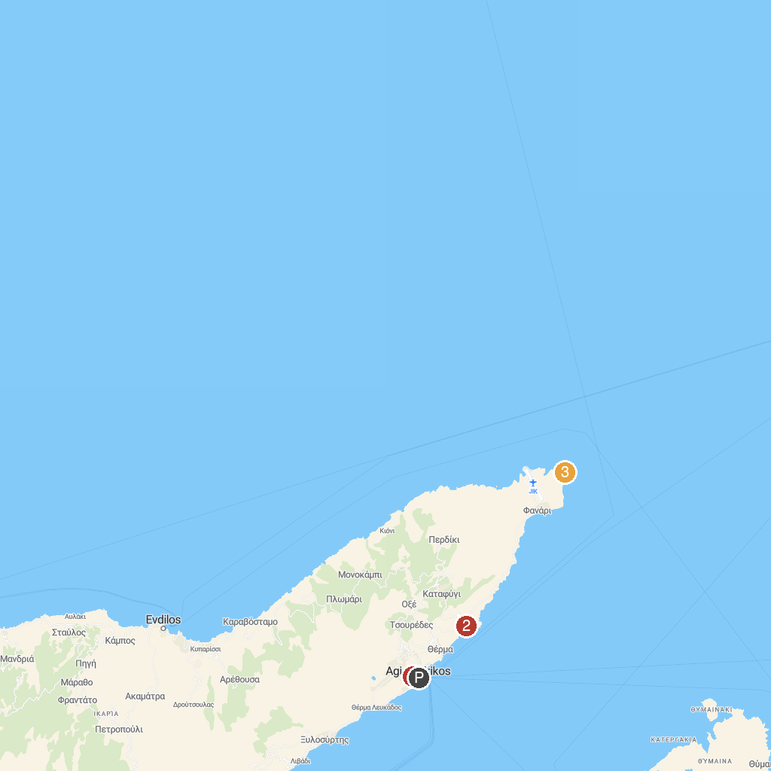
MAP KEY
1. Archaeological Museum of Agios Kirykos | 3. Tower of Drakano
2. Nealia Beach
P. Cruise port / terminal
Map © MapTiler © OpenStreetMap contributors · cruiseports.org

