IJmuiden, Netherlands
The North Sea Gateway
Cruise Terminal · North Sea Coast · Industrial Port · Amsterdam Gateway
✍️ MY DAY IN PORT (FILL IN)
Ship / Date
In port | arrive ______ · all aboard ______
Booked excursion
Notes / meeting point
GETTING ASHORE
- Currency: Euro (€)
- Language: Dutch
- Time Zone: CET (UTC+1)
- Transport: Tender or Shuttle to Amsterdam
GETTING AROUND
- 🚕 Taxi: €80–€125 — Licensed metered taxis wait outside the terminal for the ~30–45 min ride to Amsterdam city center. Sedans typically run
- 📱 Rideshare: ✅ Uber, Bolt
- 🚌 Hop-on hop-off: ✅
TOP THINGS TO DO
- Amsterdam City Highlights — A guided tour of the canals, the Rijksmuseum, and the Anne Frank House.
- IJmuiden Lighthouses & Dunes — Visit the historic High and Low Lighthouses and walk the scenic dunes along the North Sea coast.
- North Sea Canal Cruise — A scenic boat trip from IJmuiden into the heart of Amsterdam, passing through the locks.
- Zaanse Schans Windmill Village — Explore the traditional windmills and craft workshops of this open-air museum.
BEST WALKS
- Coastal Promenade Walk: Easy — A flat, scenic walk along the beach and dunes, perfect for fresh sea air.
- Port & Canal Exploration: Moderate — A walk from the terminal to the local shops and cafes in the center of IJmuiden.
- Amsterdam Canal Walk: Moderate — A self-guided walk through the Jordaan district and the historic center of Amsterdam.
WEATHER · DAYLIGHT · MONEY
Month | High °F | Low °F | Rainy days
May | 60 | 49 | 10
Jul | 69 | 59 | 13
Sep | 66 | 56 | 11
Daylight: May 5:45AM–9:31PM · Jul 5:37AM–9:56PM · Sep 7:16AM–7:55PM
cruiseports.org/ijmuiden · Confirm terminal & all-aboard time with your ship

IJmuiden, Netherlands — Port Map
Red = walkable sights · Amber = excursions farther out · P = cruise terminal
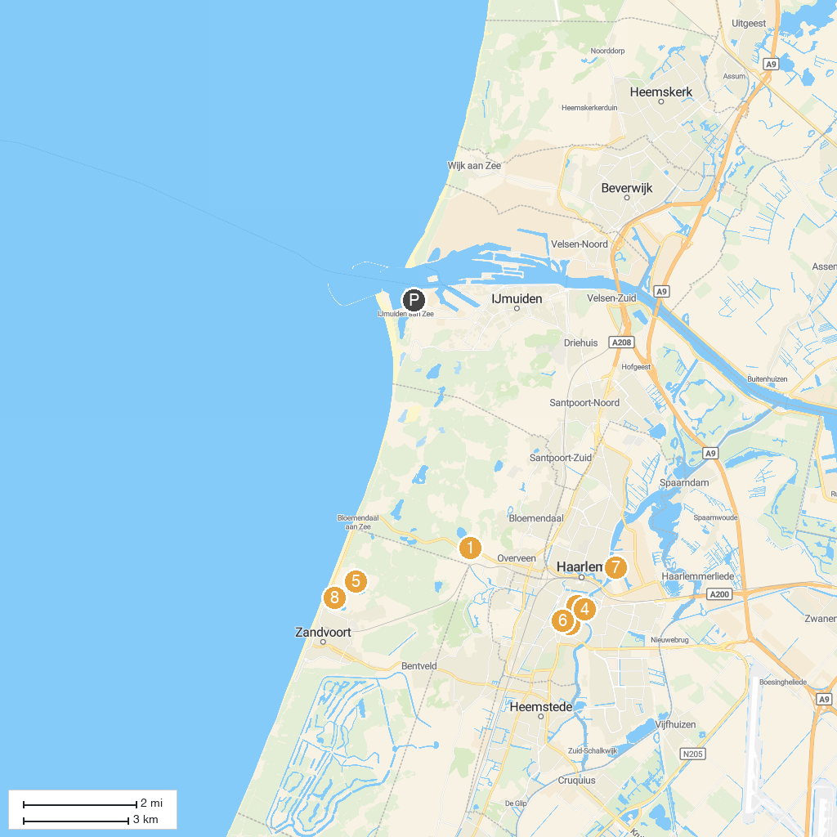
MAP KEY
1. Nationaal Park Zuid-Kennemerland | 5. MASCOT Circuit Zandvoort
2. The St. Bavo Church in Haarlem | 6. Proveniershuis
3. Frans Hals Museum | 7. Barrel Organ Museum Haarlem
4. Teylers Museum | 8. BMW Driving Experience
P. Cruise port / terminal
Map © MapTiler © OpenStreetMap contributors · cruiseports.org

