Ibiza, Balearic Islands, Spain
The White Island delivers a striking double life — ancient Phoenician ramparts and UNESCO cobblestone streets by day, legendary beach clubs and sunset bars by night. Most cruise passengers arrive for the history and leave wishing they had more time.
⚓ Pier (Es Botafoc — most ships) · 🕒 Typical call: 8-12 hrs (some overnight) · 💶 Euro (€) · 🗣️ Spanish / Catalan (English widely spoken) · 🏖️ Beaches within 20 min of port
✍️ MY DAY IN PORT (FILL IN)
Ship / Date
In port | arrive ______ · all aboard ______
Booked excursion
Notes / meeting point
GETTING ASHORE
- Docking: Pier at Es Botafoc (Botafoc Pier), ~3 km from Ibiza Town center
- Walk to center: ~40 min on flat waterfront path; most passengers use water taxi (€3-4) or shuttle
- Best For: UNESCO history, beaches, Balearic food, nightlife (overnights)
- Don't Miss: Dalt Vila ramparts at sunset — free views rival anything paid on the island
GETTING AROUND
- 🚕 Taxi: €8–€12 — Taxis queue at the port exit; the ride to Ibiza Town takes 5–7 minutes. A €2 port-pickup supplement applies. Also bookab
- 📱 Rideshare: ✅ Uber
TOP THINGS TO DO
- Dalt Vila & the Phoenician Necropolis — Ibiza's UNESCO-listed fortified old town is the unmissable centerpiece.
- Talamanca Beach — The closest good beach to the cruise pier — a 20-minute walk or 5-minute taxi from Es Botafoc.
- Es Vedrà & the Southwest Coast — The dramatic 400m limestone rock off the southwest coast is Ibiza's most iconic natural landmark — mythologized as a magnetic…
- Las Dalias Hippie Market (Saturdays) — One of the Balearics' most famous open-air markets, running every Saturday in Sant Carles de Peralta (San Carlos), about 25 km…
- Balearic Food & Tapas in the Old Town — The La Marina neighborhood at the foot of Dalt Vila is dense with restaurants serving traditional dishes: bullit de peix (fish…
BEST WALKS
- Old Port to Dalt Vila Cathedral: 1.5 km | 45-60 min | Moderate (steep, cobbled) — Start at the Old Port monument, enter Dalt Vila through the Portal de ses Taules, and wind uphill…
- Marina to Talamanca Beach: 1.8 km | 20 min | Easy (flat) — Walk north along the marina promenade from the Aquabus stop past the superyachts to the sandy…
WEATHER · DAYLIGHT · MONEY
Month | High °F | Low °F | Rainy days
May | 74 | 61 | 4
Jul | 87 | 74 | 1
Sep | 82 | 71 | 7
Daylight: May 6:41AM–8:59PM · Jul 6:41AM–9:18PM · Sep 7:36AM–8:02PM
cruiseports.org/ibiza · Confirm terminal & all-aboard time with your ship

Ibiza, Balearic Islands, Spain — Port Map
Red = walkable sights · Amber = excursions farther out · P = cruise terminal
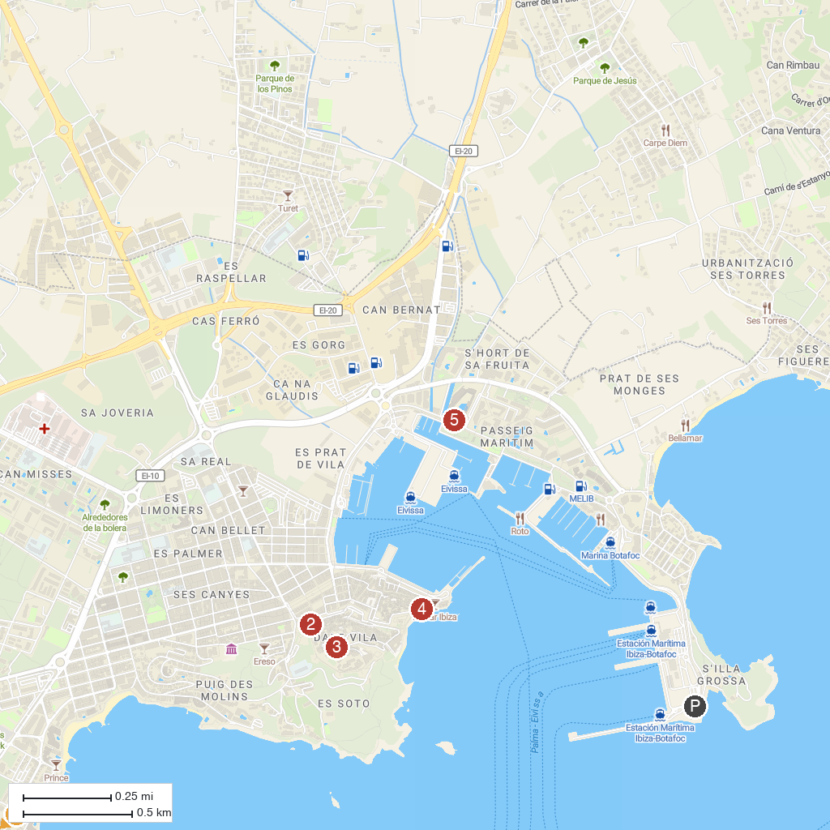
MAP KEY
1. Gran Piruleto Park Ibiza | 5. Ibiza Casino
2. Baluarte de San Pedro | 6. Slingshot Ibiza
3. Museu Puget | 7. Faro de Cuevas Blancas
4. Casa Broner Museum | 8. Santa Maria dels Cubells
P. Cruise port / terminal
Map © MapTiler © OpenStreetMap contributors · cruiseports.org

