Hydra Island, Saronic Gulf, Greece
No cars. No motorbikes. No noise except church bells, donkey hooves, and waves. Hydra is the rare Greek island that bans all motor vehicles — and it's glorious.
⚓ Tender (no pier) · 🕒 Typical call: 6-8 hrs · 💶 Euro (€) · 🗣️ Greek / English widely spoken · 🚗 Car-free island
✍️ MY DAY IN PORT (FILL IN)
Ship / Date
In port | arrive ______ · all aboard ______
Booked excursion
Notes / meeting point
GETTING ASHORE
- Docking: Tender — ships anchor offshore; 5-10 min tender ride to harbor
- Walk to center: Immediate — tender drops you on the harbor promenade
- Best For: Walking, swimming off rocky ledges, Greek history, photography
- Don't Miss: Amygdalota almond cookies from Tsagaris, Hydronetta rock-platform swim
GETTING AROUND
- 🚕 Taxi: €19–€27 per trip — Small motorboats depart from the east corner of the harbor to beaches and coastal villages. Kamini €19, Vlychos €25–€27,
- 📱 Rideshare: ❌ not available
TOP THINGS TO DO
- Hydra Town Wandering & Harbor Cannons — Explore the protected stone mansions (Hydra is a state-protected historic settlement), climb to the old cannons flanking the…
- Hydronetta & Spilia Rock Platforms — A short 5-10 minute walk west from the harbor leads to concrete ledges and sea-level bars where you can swim directly in…
- Lazaros Kountouriotis Mansion Museum — This ochre mansion overlooking the harbor belonged to a key figure in the Greek War of Independence.
- Coastal Walk to Kamini & Vlychos — Follow the flat coastal path west past Spilia and Hydronetta to the fishing village of Kamini (20 min), then continue to Vlychos…
- Water Taxi to Bisti Beach — For the ultimate beach experience, negotiate a water taxi from the harbor to Bisti or Agios Nikolaos (15-20 min each way).
BEST WALKS
- Harbor to Hydronetta: 1.5 km · 15 min one-way · Easy, mostly flat — Head west along the waterfront promenade past the cannons, continue along the coastal path to the…
- Backstreets & Mansions Loop: 2 km · 45 min · Moderate (steep cobblestone steps) — From the harbor, head up into the labyrinth of stone alleys behind the cathedral.
- Coastal Path to Kamini: 2.5 km · 25 min one-way · Easy — A flat, scenic coastal track leads from the harbor to the quiet fishing village of Kamini with its…
WEATHER · DAYLIGHT · MONEY
Month | High °F | Low °F | Rainy days
May | 76 | 63 | 5
Jul | 91 | 77 | 1
Sep | 83 | 72 | 4
Daylight: May 6:17AM–8:27PM · Jul 6:17AM–8:46PM · Sep 7:08AM–7:33PM
cruiseports.org/hydra-island · Confirm terminal & all-aboard time with your ship

Hydra Island, Saronic Gulf, Greece — Port Map
Red = walkable sights · Amber = excursions farther out · P = cruise terminal
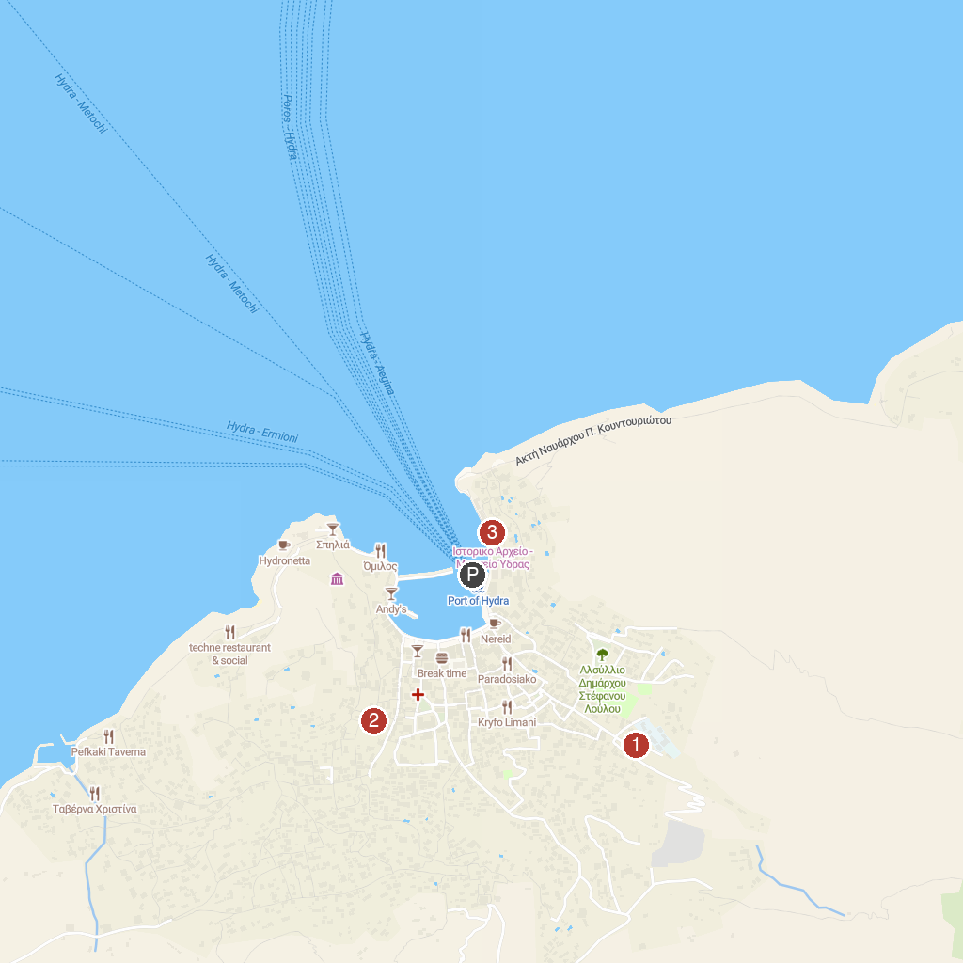
MAP KEY
1. Harriets Hydra Horses | 3. Historical Archive - Museum of Hydra
2. Mansion of Lazaros Kountouriotis | 4. Λεμονοδάσος
P. Cruise port / terminal
Map © MapTiler © OpenStreetMap contributors · cruiseports.org

