Hyannis, Cape Cod, Massachusetts, USA
Cape Cod's bustling hub where Kennedy family history, fresh lobster rolls, and classic New England shingle architecture greet you steps from the dock. Day-trippers can ferry out to Nantucket or just stroll the harbor walkway — both are equally rewarding.
⚓ Docked (small ships) / Tender (large vessels) · 🕒 Typical call: 6-8 hrs · 💵 USD · 🗣️ English · 🦞 New England seafood scene
✍️ MY DAY IN PORT (FILL IN)
Ship / Date
In port | arrive ______ · all aboard ______
Booked excursion
Notes / meeting point
GETTING ASHORE
- Docking: Small ships (American Cruise Lines) dock at Hyannis Harbor; larger vessels tender
- Walk to center: ~5 min to Main Street from Ocean Street Dock
- Best For: Cape Cod charm, JFK history, Nantucket day-trip by ferry
- Don't Miss: Kennedy Hyannis Museum and a harbor cruise past the Kennedy Compound
GETTING AROUND
- 🚕 Taxi: $10–$20 — Taxis available at the ferry/cruise terminal on Ocean Street. Short rides to Main Street or other downtown spots are qui
- 📱 Rideshare: ✅ Uber, Lyft
- 🚌 Hop-on hop-off: ✅
TOP THINGS TO DO
- JFK Hyannis Museum — The John F.
- Nantucket Ferry Day Trip — Hy-Line Cruises runs a fast ferry (1 hr) from Hyannis Harbor to Nantucket.
- Kennedy Compound Harbor Cruise — The Kennedy Compound in Hyannis Port is not accessible by land, but local harbor cruises pass by water offering views of the…
- Kalmus Beach — A broad sandy beach on Nantucket Sound, a short ride from the harbor.
- Main Street Stroll & Shopping — Hyannis's Main Street runs parallel to the harbor and is lined with Cape Cod-style boutiques, art galleries, fudge shops, taffy…
BEST WALKS
- Harbor to Main Street Loop: 1.5 miles • Easy • 30-45 min — From the Ocean Street Dock, walk up Ocean Street past the Artist Shanties at Bismore Park, continue…
- Waterfront & Veterans Memorial Park: 0.5 miles • Easy • 20 min — A short, pleasant walk from the dock along the harbor waterfront to Veterans Memorial Park, which…
WEATHER · DAYLIGHT · MONEY
Month | High °F | Low °F | Rainy days
May | 66 | 45 | 14
Jul | 85 | 63 | 9
Sep | 76 | 54 | 6
Daylight: May 5:00AM–7:02PM · Jul 5:05AM–7:15PM · Sep 6:10AM–6:00PM
cruiseports.org/hyannis-barnstable-ma · Confirm terminal & all-aboard time with your ship

Hyannis, Cape Cod, Massachusetts, USA — Port Map
Red = walkable sights · Amber = excursions farther out · P = cruise terminal
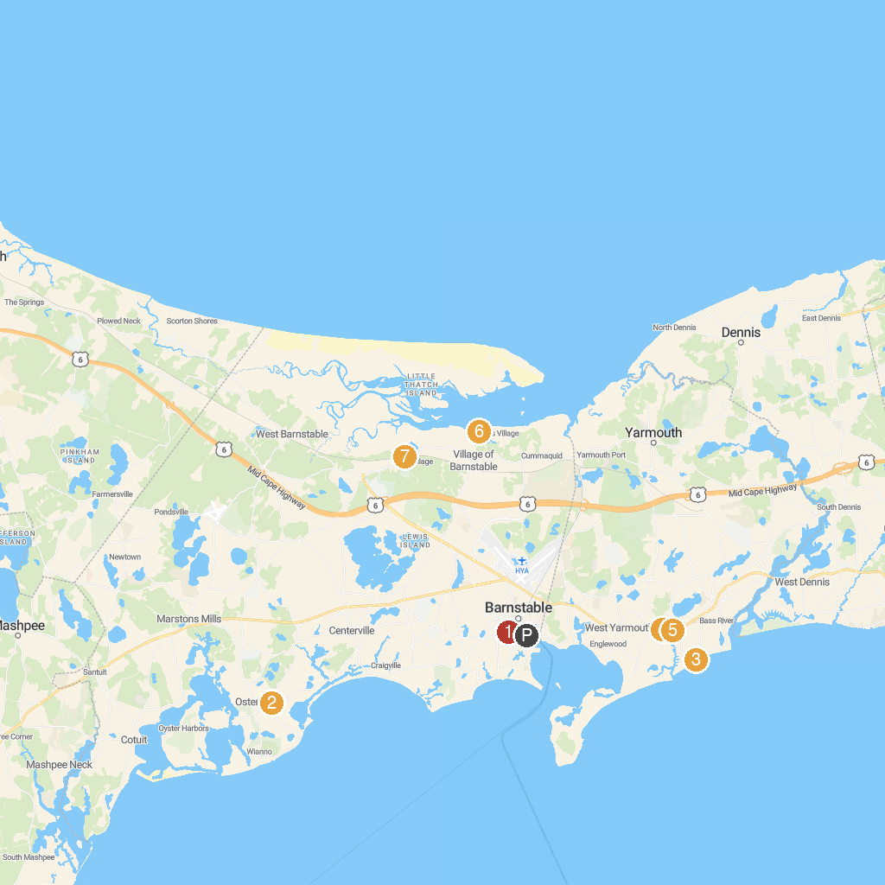
MAP KEY
1. St. Francis Xavier Parish | 5. Whydah Pirate Museum
2. Armstrong-Kelley Park | 6. Pirate's Cove Adventure Golf
3. Cotuit Center for the Arts | 7. Millway Beach
4. Parker River Beach | 8. Mass Audubon's Barnstable Great Marsh Wildlife Sanctuary
P. Cruise port / terminal
Map © MapTiler © OpenStreetMap contributors · cruiseports.org

