Hvar, Dalmatia, Croatia
Shimmering Venetian stones, a fortress overlooking the Adriatic, and Croatia's sunniest island waiting just beyond the tender dock — Hvar punches well above its size.
⚓ Tender port (large ships) · 🕒 Typical call: 6–8 hrs · 💶 Currency: Euro (€) · 🗣️ Language: Croatian · ☀️ Sunniest island in Croatia
✍️ MY DAY IN PORT (FILL IN)
Ship / Date
In port | arrive ______ · all aboard ______
Booked excursion
Notes / meeting point
GETTING ASHORE
- Docking: Tender — large ships anchor in the bay; tender drops you on the Riva waterfront
- Walk to center: 0 min — tender dock lands directly on St. Stephen's Square
- Best For: History, Adriatic beaches, Dalmatian food & wine, island atmosphere
- Don't Miss: Hike the Spanish Fortress (Fortica) for panoramic harbor views
GETTING AROUND
- 🚕 Taxi: €40–45 (Stari Grad to Hvar Town) — Taxis available at Stari Grad port for the 20km ride to Hvar Town. If tendering to Hvar Town itself, taxis are useful fo
- 📱 Rideshare: ✅ Uber, PickApp
TOP THINGS TO DO
- Spanish Fortress (Fortica) — A 16th-century hilltop fortress offering the island's best panoramic views — harbor, old town, and the Pakleni Islands laid out…
- Pakleni Islands Beach Day — Taxi boats from the Riva whisk you to the Pakleni Islands in 10–15 minutes.
- Franciscan Monastery & Last Supper — A 15th-century monastery with a serene cloister garden and a museum housing a 2-by-8-meter painting of The Last Supper, variously…
- Hvar Arsenal & Historic Theatre — Europe's oldest public community theater (1612) occupies the upper floor of the massive Arsenal building on St.
- Dalmatian Food & Wine Tasting — Sample Hvar's 2,400-year-old wine tradition — Plavac Mali red and Bogdanuša white — alongside Hvarska Gregada fish stew and…
BEST WALKS
- Old Town Circuit: 45–60 min | Easy | Flat stones — From the tender dock on the Riva, loop through St.
- Fortress Climb: 1–1.5 hrs | Moderate | Uphill — From St.
- Bonj Beach Walk: 30 min each way | Easy | Coastal path — Head north from the Riva along the coastal promenade to Bonj Beach — a pebble-and-clear-water…
cruiseports.org/hvar-island-croatia · Confirm terminal & all-aboard time with your ship

Hvar, Dalmatia, Croatia — Port Map
Red = walkable sights · Amber = excursions farther out · P = cruise terminal
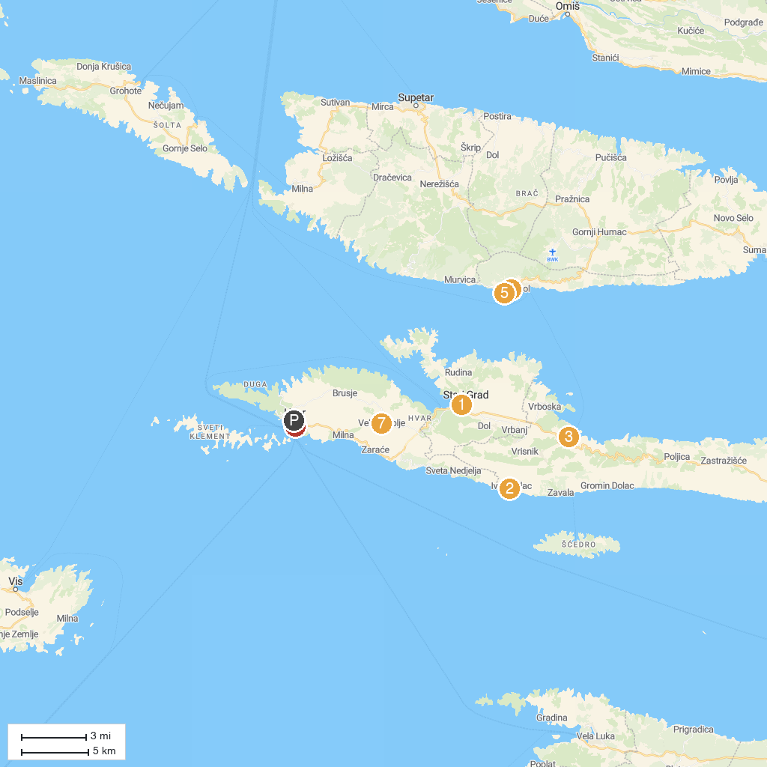
MAP KEY
1. Muzej Staroga Grada | 5. Golden Horn Beach
2. Plaža Ivan Dolac | 6. Franciscan Monastery
3. Jelsa Municipal Museum | 7. Velo Grablje
4. Nautic center Bol
P. Cruise port / terminal
Map © MapTiler © OpenStreetMap contributors · cruiseports.org

