Húsavík, Northeast Iceland, Iceland
The whale watching capital of Europe sits on a bay so rich in marine life that humpbacks surface within minutes of leaving the harbor. Add geothermal sea baths with Arctic mountain views and you have one of Iceland's most rewarding cruise calls.
⚓ Pier (small ships) / Tender (large ships) · 🕒 Typical call: 6–8 hrs · 💵 Icelandic Króna (ISK) — cards universally accepted · 🗣️ Icelandic / English widely spoken · 🐋 Whale watching capital of Europe
✍️ MY DAY IN PORT (FILL IN)
Ship / Date
In port | arrive ______ · all aboard ______
Booked excursion
Notes / meeting point
GETTING ASHORE
- Docking: Direct pier for ships up to 220 m; tender for larger vessels anchoring in Skjálfandi Bay
- Walk to Center: 1–3 min from pier or tender dock; GeoSea Baths 20–25 min on foot
- Best For: Whale watching, geothermal baths, Icelandic seafood, scenic Arctic landscapes
- Don't Miss: A whale watching boat from North Sailing or Gentle Giants — success rates exceed 95%
GETTING AROUND
- 🚕 Taxi: ~4,000–6,000 ISK (~$28–$42 USD) for short trips — Taxis serve Húsavík but are limited and must be pre-booked. Iceland taxi fares are high: base ~730–880 ISK plus ~350–480
- 📱 Rideshare: ❌ not available
TOP THINGS TO DO
- Classic Whale Watching — Oak Boat or RIB — Skjálfandi Bay has some of the highest whale encounter rates in the North Atlantic.
- GeoSea Geothermal Sea Baths — Infinity-edge pools filled with warm (38–40°C) mineral-rich seawater perched on the cliffs of Húsavíkurhöfði.
- Húsavík Whale Museum — One of the world's premier whale museums, with 11 complete skeletons including a 25-meter blue whale.
- Exploration Museum — NASA's Iceland Connection — Apollo astronauts including Neil Armstrong trained in the lunar-like volcanic landscapes near Húsavík in 1965 and 1967.
- Lake Botnsvatn Walk & Lupine Fields — A 3 km walk inland from town leads to a peaceful lake ringed by lupine-covered hills in summer.
BEST WALKS
- Harbor to GeoSea & Lighthouse Loop: 4 km round trip | 1–1.5 hrs | Moderate (uphill stretch) — From the harbor walk north along the waterfront, past the colorful wooden buildings, up to the…
- Town Center Stroll — Church, Museum & Eurovision Spots: 1.5 km loop | 30–45 min | Easy — Compact loop from the harbor taking in Húsavíkurkirkja (Iceland's most beautiful wooden church)…
WEATHER · DAYLIGHT · MONEY
Month | High °F | Low °F | Rainy days
May | 45 | 36 | 14
Jul | 54 | 46 | 16
Sep | 51 | 42 | 17
Daylight: Sep 6:30AM–7:36PM
cruiseports.org/husavik · Confirm terminal & all-aboard time with your ship

Húsavík, Northeast Iceland, Iceland — Port Map
Red = walkable sights · Amber = excursions farther out · P = cruise terminal
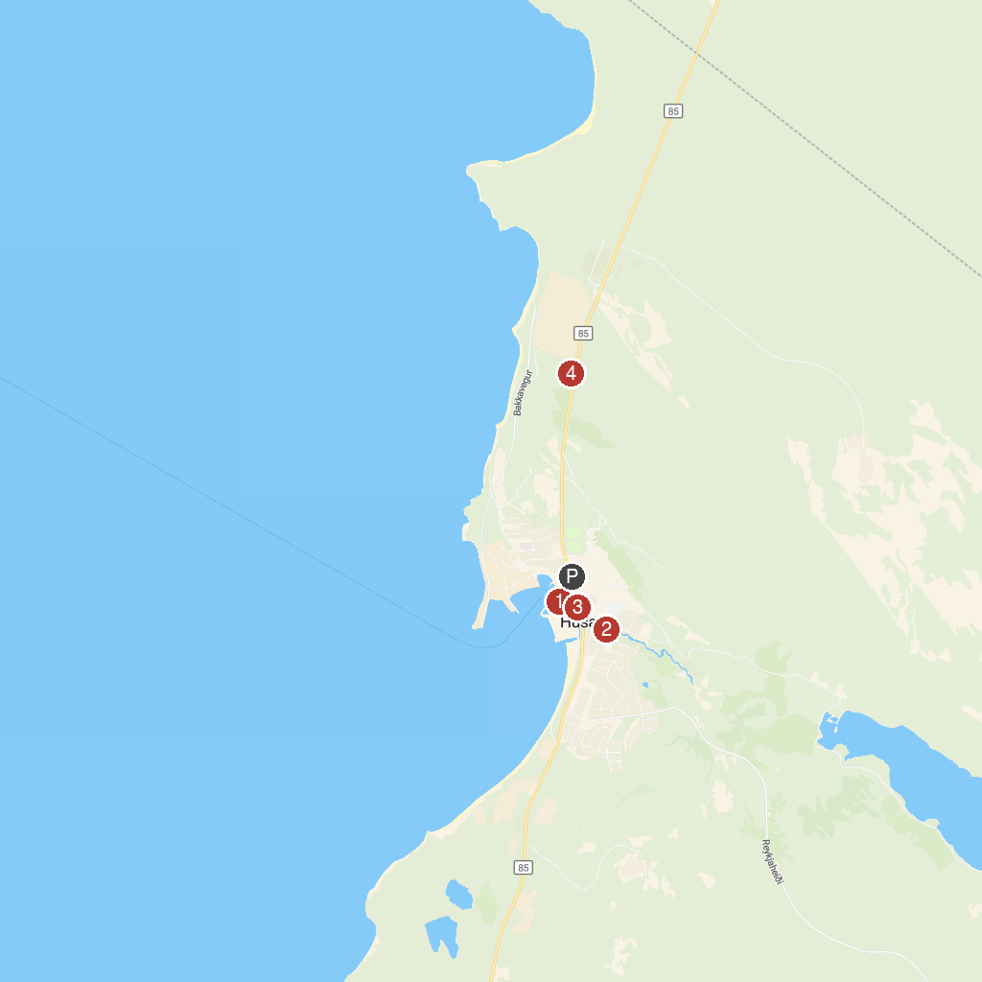
MAP KEY
1. Húsavík Harbor | 3. Friends of Moby Dick - Whale Watching
2. Husavik Park | 4. Husavik Viewpoint Parking
P. Cruise port / terminal
Map © MapTiler © OpenStreetMap contributors · cruiseports.org

