Hurghada, Red Sea, Egypt
Crystal-clear Red Sea waters meet the Sahara Desert at Hurghada — Egypt's premier resort coast and the closest cruise port to the ancient wonders of Luxor.
⚓ Pier (direct docking) · 🕒 Typical call: 8-12 hrs · 💵 Egyptian Pound (EGP); USD/€ accepted · 🗣️ Arabic; English & German widely spoken
✍️ MY DAY IN PORT (FILL IN)
Ship / Date
In port | arrive ______ · all aboard ______
Booked excursion
Notes / meeting point
GETTING ASHORE
- Docking: Pier — ships dock alongside the quay; tendering is rare
- Walk to center: Marina is in the same Sekala district; short walk/taxi. El Dahar old town ~7 km
- Best For: Snorkeling, reef diving, desert safaris, Luxor day trips
- Don't Miss: Giftun Island snorkeling or a glass-bottom boat over the coral reef
GETTING AROUND
- 🚕 Taxi: 100–250 EGP (~$3–8) — Taxis are plentiful at the port but meters are rarely used for tourists. Agree on the fare before you get in and pay in
- 📱 Rideshare: ✅ Uber, Careem, inDrive
TOP THINGS TO DO
- Giftun Island & Orange Bay Snorkeling — Boat trip to the protected Giftun Islands National Park — shallow coral gardens, brilliant reef fish, and powdery white sand in…
- Luxor & Valley of the Kings Day Trip — A 3.5–4 hr desert drive brings you to Karnak Temple, Luxor Temple, and the Valley of the Kings — the greatest open-air museum on…
- Desert Quad Biking & Bedouin Safari — ATV or 4x4 jeep into the Eastern Desert, followed by a camel ride, Bedouin village visit, mint tea, and a traditional dinner show…
- Resort Beach Day Pass — Buy a day pass at a Red Sea resort (Steigenberger Al Dau, Marriott Red Sea, or similar) for private beach access, sunbeds, and…
- Sindbad Submarine Reef Tour — A real submarine descends about 22 metres into the Red Sea so non-swimmers and families can witness the coral reef and its…
BEST WALKS
- Hurghada Marina Boulevard Stroll: Easy · ~1.5 km · Flat — A pedestrian-only promenade lined with yachts, cafes, and souvenir shops.
- El Dahar Old Town & Souq: Easy · ~1 km loop · Flat · ~7 km / short taxi from port — The authentic, lived-in heart of Hurghada, about 7 km north of the port in the old town.
WEATHER · DAYLIGHT · MONEY
Month | High °F | Low °F | Rainy days
May | 88 | 74 | 0
Jul | 94 | 83 | 0
Sep | 92 | 80 | 0
Daylight: May 5:56AM–7:25PM · Jul 6:00AM–7:41PM · Sep 6:30AM–6:49PM
cruiseports.org/hurghada · Confirm terminal & all-aboard time with your ship

Hurghada, Red Sea, Egypt — Port Map
Red = walkable sights · Amber = excursions farther out · P = cruise terminal
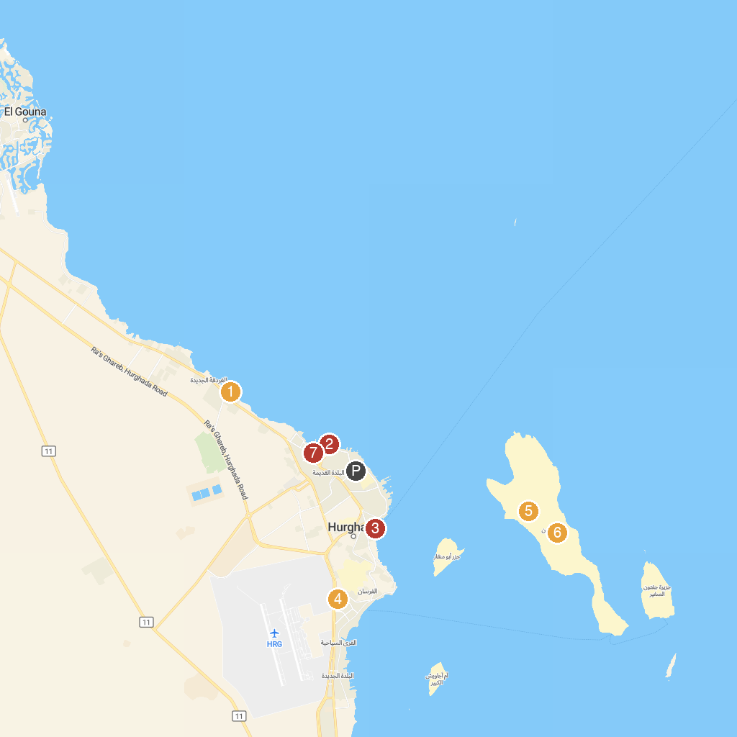
MAP KEY
1. Hurghada Marine Museum & Aquarium | 5. Giftun Islands
2. Red Sea Aquarium | 6. جزيرة الجفتون
3. Hurghada Marina | 7. Hurghada Grand Aquarium
4. Selkhet Papyrus | 8. hurghada.primatrips
P. Cruise port / terminal
Map © MapTiler © OpenStreetMap contributors · cruiseports.org

