Huntington, West Virginia, USA
A proud Ohio River city shaped by Appalachian spirit, Marshall University's green-and-white legacy, and a surprising depth of art and culture — all a short walk from the riverfront dock.
⚓ Docked (Harris Riverfront Park) · 🕒 Typical call: 6-8 hrs · 💵 US Dollar · 🗣️ English · 🌿 Appalachian culture
✍️ MY DAY IN PORT (FILL IN)
Ship / Date
In port | arrive ______ · all aboard ______
Booked excursion
Notes / meeting point
GETTING ASHORE
- Docking: Docked at Harris Riverfront Park on the Ohio River
- Walk to downtown: 5–10 min through the floodwall gate
- Best For: Appalachian history, art glass, local food & Marshall University culture
- Don't Miss: Huntington Museum of Art and a Huntington-style hot dog
GETTING AROUND
- 🚕 Taxi: $9–$15 — Local taxis serve the port area. Yellow Cab (304-529-7131) and Express Cab (304-736-0717) are established operators. Bas
- 📱 Rideshare: ✅ Uber, Lyft
TOP THINGS TO DO
- Huntington Museum of Art — West Virginia's largest art museum holds American and European paintings, stunning art glass collections (Blenko and others), an…
- Heritage Farm Museum & Village — A Smithsonian-affiliate outdoor museum with seven galleries on pioneer and Appalachian life, a petting zoo, wagon rides…
- Huntington Hot Dog Tour — Huntington is famous for its distinct style of hot dog — a steamed bun topped with chili, coleslaw, and mustard.
- We Are Marshall Heritage Walk — The 1970 plane crash that killed nearly the entire Marshall University football team profoundly shaped Huntington.
- Camden Park Amusement Park — One of America's oldest continuously operating amusement parks, with classic rides, water slides, mini-golf, and paddle boats on…
BEST WALKS
- Riverfront to Downtown Heritage Walk: 1.5 miles · Easy · 30-45 min — Walk from the park through the floodwall, up to Heritage Station, through the 4th Avenue corridor…
- Ritter Park Stroll: 2 miles round-trip in park · Easy · 45 min — A short Uber ride gets you to Huntington's crown-jewel park — a 67-acre green space with a famous…
WEATHER · DAYLIGHT · MONEY
Month | High °F | Low °F | Rainy days
May | 75 | 56 | 13
Jul | 86 | 69 | 14
Sep | 80 | 62 | 8
Daylight: May 6:18AM–8:34PM · Jul 6:18AM–8:52PM · Sep 7:11AM–7:37PM
cruiseports.org/huntington-wv · Confirm terminal & all-aboard time with your ship

Huntington, West Virginia, USA — Port Map
Red = walkable sights · Amber = excursions farther out · P = cruise terminal
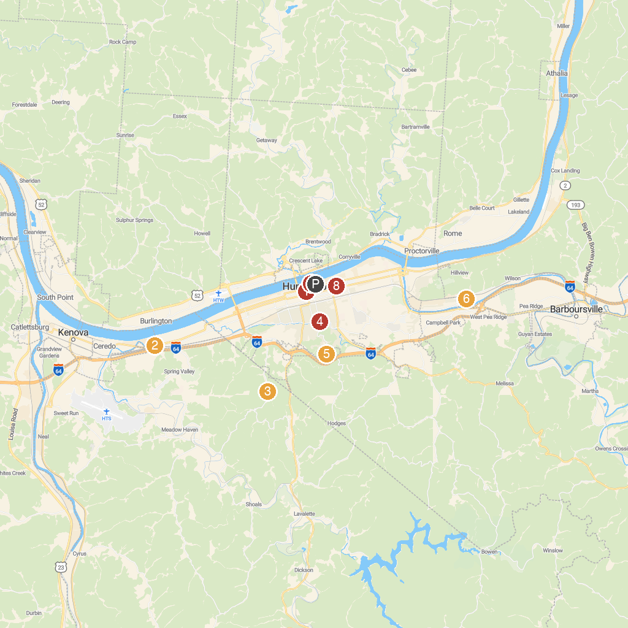
MAP KEY
1. Huntington Downtown Historic District | 5. Huntington Museum of Art
2. Camden Park | 6. Altizer Park
3. Heritage Farm Museum & Village | 7. Harris Riverfront Park
4. Ritter Park | 8. Memorial Fountain
P. Cruise port / terminal
Map © MapTiler © OpenStreetMap contributors · cruiseports.org

