Hundested, North Zealand, Denmark
A former fishing village reinvented as a creative harbor — glassblowers, smokehouse seafood, and the home of Denmark's greatest polar explorer, all within easy walking distance of the pier.
⚓ Pier (docked) · 🕒 Typical call: 6-8 hrs · 💵 Danish Krone (DKK) — but cards accepted everywhere · 🗣️ Danish / English widely spoken
✍️ MY DAY IN PORT (FILL IN)
Ship / Date
In port | arrive ______ · all aboard ______
Booked excursion
Notes / meeting point
GETTING ASHORE
- Docking: Direct pier at Hundested Havn — two cruise quays up to 350 m
- Walk to centre: ~5 min (300–400 m) to harbor shops and restaurants
- Best For: Artisan culture, seafood, polar history, easy day trips
- Don't Miss: Knud Rasmussen's House and the glassblowing studios on the quay
GETTING AROUND
- 🚕 Taxi: 80–150 DKK (~$12–23 USD) for short local trips — Local taxis serve Hundested. Base fare is approximately 45 DKK plus ~14 DKK/km. Companies such as Taxa 4x35 and Dantaxi
TOP THINGS TO DO
- Knud Rasmussen's House — The preserved cottage of Denmark's greatest polar explorer sits on the cliffs above the lighthouse, filled with Arctic artifacts…
- Artisan Harbor Walkabout — Wander the Kulturhavn and duck into open glassblowing studios, ceramic workshops, and galleries.
- Spodsbjerg Lighthouse & Coastal Path — Follow the Fyrstien coastal path from the harbor up 30-metre moraine cliffs to the lighthouse (current tower built 1907, a light…
- Day Trip: Frederiksborg Castle — Hop the local train to Hillerød for Denmark's finest Renaissance castle — the 'Danish Versailles' set on a lake, now home to the…
- Trekanten Beach — A Blue Flag sandy beach protected by breakwaters, just 3 minutes' walk from the ship.
BEST WALKS
- Harbor & Artisan Quarter Loop: 1.5 km · 25 min · flat — From the cruise quay, stroll the length of Kulturhavn past workshops and galleries, swing through…
- Fyrstien — Lighthouse Cliff Walk: 3.5 km one-way · ~50 min · moderate — Head north from the harbor along the coastal path past Trekanten Beach, up the heathland cliffs to…
WEATHER · DAYLIGHT · MONEY
Month | High °F | Low °F | Rainy days
May | 59 | 49 | 12
Jul | 69 | 60 | 15
Sep | 63 | 56 | 12
Daylight: May 5:00AM–9:19PM · Jul 4:48AM–9:47PM · Sep 6:44AM–7:29PM
cruiseports.org/hundested · Confirm terminal & all-aboard time with your ship

Hundested, North Zealand, Denmark — Port Map
Red = walkable sights · Amber = excursions farther out · P = cruise terminal
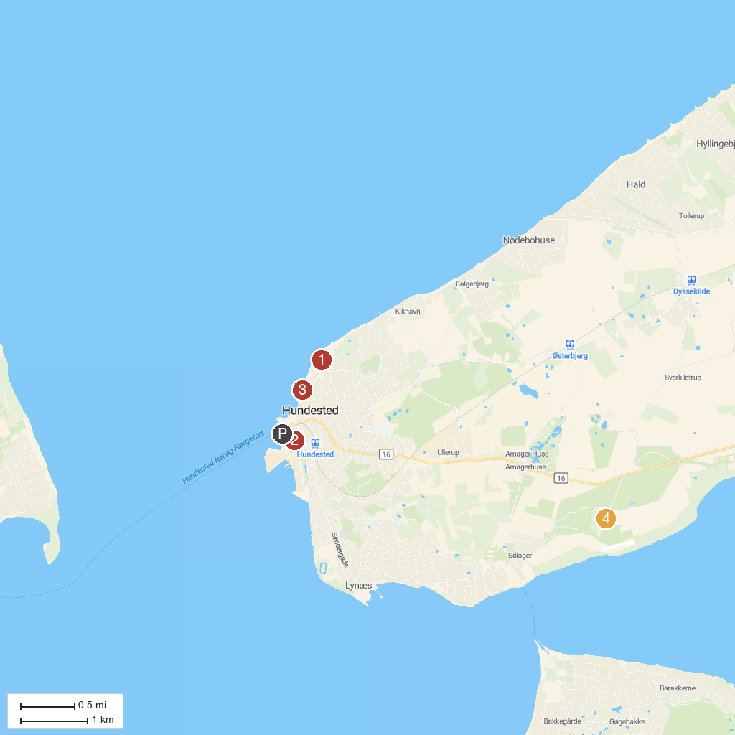
MAP KEY
1. Jægerspris Castle | 5. TimeWinder Nostalgia Festival
2. Knud Rasmussens House | 6. Stængehus Beach
3. Hundested Sand Sculpture Festival | 7. Ølsted grusgrav
4. Skansen i Hundested | 8. Auderød Havn
P. Cruise port / terminal
Map © MapTiler © OpenStreetMap contributors · cruiseports.org

