Hull, East Yorkshire, England
Once a great whaling and trading port, Hull has reinvented itself as a cultural heavyweight — all those free world-class museums are waiting, and the Hull Patty from a chippy is non-negotiable.
⚓ Docked at King George Dock · 🕒 Typical call: 8–10 hrs · 💷 British Pound Sterling (GBP) · 🗣️ English · 🚌 Shuttle required (dock to city)
✍️ MY DAY IN PORT (FILL IN)
Ship / Date
In port | arrive ______ · all aboard ______
Booked excursion
Notes / meeting point
GETTING ASHORE
- Docking: Pier (King George Dock) — ships lock into enclosed wet dock; no tendering
- Walk to centre: Not walkable — dock is industrial; shuttle or taxi ~10–15 min to city
- Best For: History buffs, free museums, maritime heritage, quirky local culture
- Don't Miss: Wilberforce House, The Deep aquarium, a Hull Patty with chip spice
GETTING AROUND
- 🚕 Taxi: £10–£15 — Taxis are available at King George Dock terminal. The city centre is about 10 minutes away; easiest option with luggage.
- 📱 Rideshare: ✅ Uber
TOP THINGS TO DO
- Old Town & Museums Quarter Walk — Hull's High Street Museums Quarter clusters three free world-class museums: Wilberforce House (birthplace of the abolitionist)…
- The Deep Aquarium — One of the UK's most spectacular aquariums, housed in a ship-prow-shaped building at the confluence of the Hull and Humber rivers.
- Ferens Art Gallery & Queen Victoria Square — An award-winning civic gallery with a stellar permanent collection including works by Lorenzetti, Frans Hals, Canaletto, and…
- Humber Bridge Walk — Formerly the world's longest single-span suspension bridge, the Humber Bridge offers dramatic views across the estuary.
- Spurn Point Nature Reserve — A narrow, constantly shifting sand-and-shingle peninsula at the mouth of the Humber — one of England's most dramatic coastal…
BEST WALKS
- The Fish Trail: Hull Old Town Loop: 1.5 miles · 45–60 min · Easy, flat — 41 life-size fish carved into the pavements thread through Hull's Old Town, connecting the key…
- Humber Waterfront to The Deep: 0.8 miles · 20 min · Easy — From the Ferens gallery, walk east along the Humber waterfront past the striking Scale Lane Bridge…
WEATHER · DAYLIGHT · MONEY
Month | High °F | Low °F | Rainy days
May | 59 | 46 | 12
Jul | 69 | 56 | 14
Sep | 64 | 52 | 12
Daylight: May 4:59AM–8:56PM · Jul 4:50AM–9:23PM · Sep 6:35AM–7:16PM
cruiseports.org/hull · Confirm terminal & all-aboard time with your ship

Hull, East Yorkshire, England — Port Map
Red = walkable sights · Amber = excursions farther out · P = cruise terminal
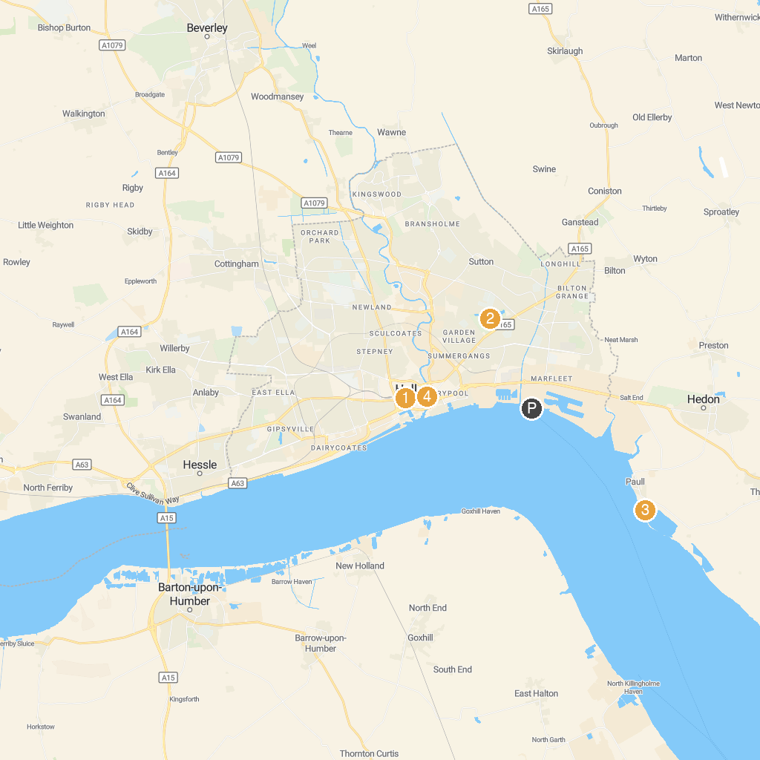
MAP KEY
1. Hull City Hall | 4. Streetlife Museum
2. East Park | 5. Beverley Minster
3. Fort Paull
P. Cruise port / terminal
Map © MapTiler © OpenStreetMap contributors · cruiseports.org

