Huelva, Andalusia, Spain
Columbus sailed from here in 1492 — today Huelva rewards curious cruisers with white prawns, Victorian English streets in the heart of Andalusia, and replica caravels you can actually board.
⚓ Pier (Muelle Sur, outer port) · 🚌 Shuttle to city center · 🕒 Typical call: 8-10 hrs · 💶 Currency: Euro (€) · 🗣️ Language: Spanish
✍️ MY DAY IN PORT (FILL IN)
Ship / Date
In port | arrive ______ · all aboard ______
Booked excursion
Notes / meeting point
GETTING ASHORE
- Docking: Pier at Muelle Sur outer port (~15 km from city center); shuttle provided. Luxury/small ships may use inner Muelle de Levante.
- Walk to center: Not walkable from Muelle Sur — take cruise shuttle or taxi (20 min). Inner port: 15-20 min walk.
- Best For: Columbus history, Ibérico ham & white prawns, Doñana Nature Reserve, off-the-beaten-track Andalusia
- Don't Miss: Boarding the replica Columbus caravels at Palos de la Frontera (€3.60)
GETTING AROUND
- 🚕 Taxi: €25–€28 — Official taxis meet ships at Muelle Sur port (approx. 17 km from city center). Fixed-rate private transfers are also boo
- 📱 Rideshare: ✅ Uber
TOP THINGS TO DO
- Columbus Caravels & La Rábida Monastery — Board full-scale replicas of the Niña, Pinta, and Santa María at Palos de la Frontera, then walk to the 15th-century monastery…
- Doñana National Park 4×4 Safari — One of Europe's most important wetlands — flamingos, Iberian lynx, and wild horses.
- Barrio Reina Victoria (British Mining Quarter) — Walk through a surreal neighborhood of Victorian English cottages built for Rio Tinto Company workers from 1916 through the 1920s…
- Huelva Gastronomy Tour — Huelva was Spain's Capital of Gastronomy 2017.
- Day Trip to Seville — Seville's Alcázar palace, Cathedral, and Giralda tower are 75 minutes away.
BEST WALKS
- City Center Highlights Walk: 2.5 km · 45–60 min · Easy · Free — From the shuttle drop near Casa Colón, walk to Plaza de las Monjas and the Columbus statue, then…
- Columbus Monument & Cinta Hermitage: 4 km · 75 min · Easy · Free — Walk or take a short taxi to the giant Columbus monument at Punta del Sebo, then continue uphill to…
WEATHER · DAYLIGHT · MONEY
Month | High °F | Low °F | Rainy days
May | 80 | 59 | 4
Jul | 92 | 69 | 0
Sep | 85 | 65 | 4
Daylight: May 7:19AM–9:29PM · Jul 7:19AM–9:47PM · Sep 8:10AM–8:35PM
cruiseports.org/huelva · Confirm terminal & all-aboard time with your ship

Huelva, Andalusia, Spain — Port Map
Red = walkable sights · Amber = excursions farther out · P = cruise terminal
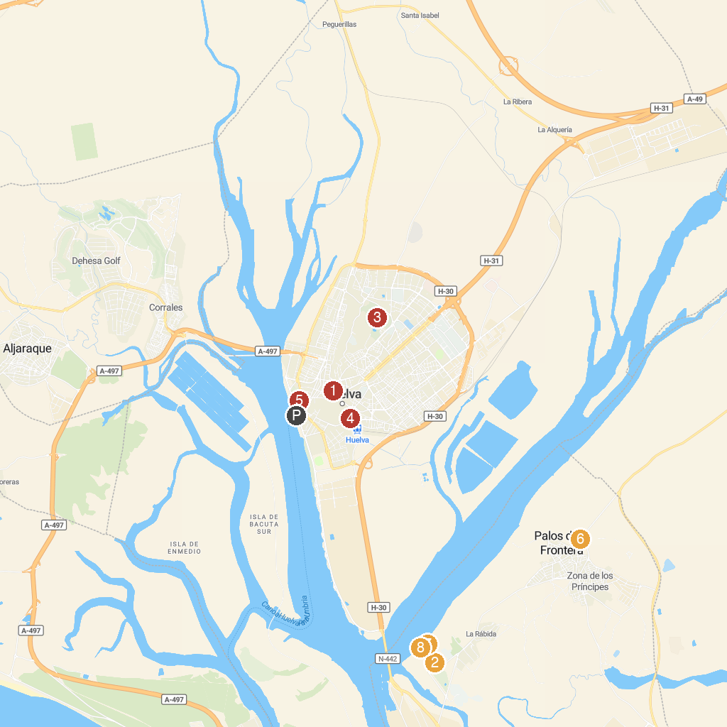
MAP KEY
1. Parroquia Mayor de San Pedro de Huelva | 5. Zafra Park
2. La Rabida Monastery | 6. La Fontanilla
3. Parque Moret | 7. Muelle de las Carabelas
4. Monumento a la Virgen del Rocío | 8. Plus Ultra monument
P. Cruise port / terminal
Map © MapTiler © OpenStreetMap contributors · cruiseports.org

