Hualien, Taiwan
Taiwan's wild east coast delivers jaw-dropping gorge scenery, marble-paved streets, and a deep indigenous culture that big-city ports can't match. Taroko is the draw — but even without it, Hualien earns its place on any Asia itinerary.
⚓ Pier (Wharf 23) · 🕒 Typical call: 8-10 hrs · 💵 New Taiwan Dollar (NT$) · 🗣️ Mandarin Chinese · 🏔️ Taroko Gorge nearby
✍️ MY DAY IN PORT (FILL IN)
Ship / Date
In port | arrive ______ · all aboard ______
Booked excursion
Notes / meeting point
GETTING ASHORE
- Docking: Pier — Wharf 23 (industrial port, ~5.5 km from city center)
- Walk to Center: Not walkable — shuttle bus or taxi required (20 min)
- Best For: Taroko Gorge, marble scenery, indigenous food culture
- Don't Miss: Bomber scallion pancake on Fuxing Street; Tzen's mochi
GETTING AROUND
- 🚕 Taxi: NT$150–250 (~US$5–8) — Metered taxis wait at the cruise pier. The port is about 5–6 km from the city center; expect NT$150–250 for the short ri
- 📱 Rideshare: ❌ not available
- 🚌 Hop-on hop-off: ✅
TOP THINGS TO DO
- Taroko Gorge — Marble canyon carved by the Liwu River — one of Asia's great natural wonders.
- Whale & Dolphin Watching — Hualien's Pacific waters host spinner and bottlenose dolphins plus migrating whales.
- Indigenous Village & Amis Culture — Hualien has Taiwan's largest indigenous population — Amis, Atayal, and Truku peoples.
- East Coast Scenic Area & Qixingtan Beach — A crescent of polished marble and black pebbles backed by green mountains.
- Pine Garden (Songyuan Bieguan, 松園別館) — A quiet hilltop Japanese colonial villa once used as a recreation center for WWII pilots.
BEST WALKS
- Downtown Hualien City Loop: 2-3 km · Flat · 45-60 min — Walk from the shuttle drop-off near Hualien Railway Station through the Cultural and Creative…
- Qixingtan Coastal Path: 2 km · Flat · 30-40 min — Follow the paved coastal path along Qixingtan (Chihsingtan) beach's marble pebble shoreline with…
WEATHER · DAYLIGHT · MONEY
Month | High °F | Low °F | Rainy days
May | 81 | 72 | 25
Jul | 87 | 77 | 21
Sep | 84 | 75 | 23
Daylight: May 5:11AM–6:28PM · Jul 5:15AM–6:43PM · Sep 5:40AM–5:57PM
cruiseports.org/hualien · Confirm terminal & all-aboard time with your ship

Hualien, Taiwan — Port Map
Red = walkable sights · Amber = excursions farther out · P = cruise terminal
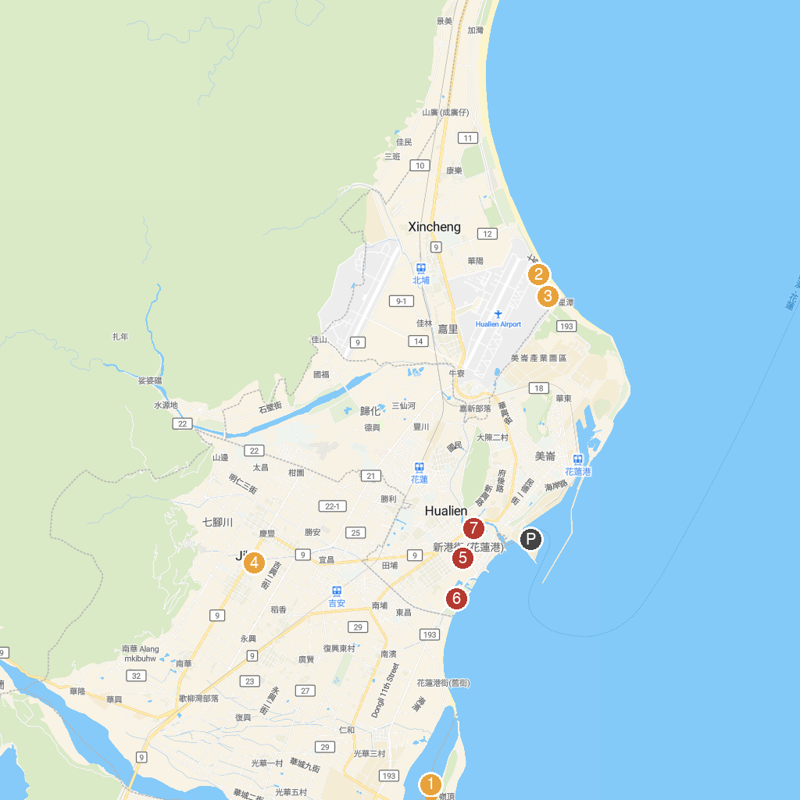
MAP KEY
1. Farglory Ocean Park | 5. Hualien Railway Culture Park
2. Qixingtan Scenic Area | 6. Taipingyang Park
3. Chisingtan Katsuo Museum | 7. Jiang Jun Fu 1936
4. Ji'an Qingxiu Temple
P. Cruise port / terminal
Map © MapTiler © OpenStreetMap contributors · cruiseports.org

