Huahine Island, Society Islands, French Polynesia
The garden island of the Society Islands, Huahine rewards curious cruisers with the largest concentration of ancient Polynesian marae in French Polynesia, sacred freshwater eels, and a laid-back lagoon that Bora Bora used to be.
⚓ Tender port · 🕒 Typical call: 7-9 hrs · 💵 XPF / Credit cards in Fare · 🗣️ French & Tahitian · 🌿 Nature & history focus
✍️ MY DAY IN PORT (FILL IN)
Ship / Date
In port | arrive ______ · all aboard ______
Booked excursion
Notes / meeting point
GETTING ASHORE
- Docking: Tender only — ships anchor off Fare, ~10 min boat ride
- Walk to center: 0 min — tender drops at Fare village waterfront
- Best For: Ancient marae, sacred eels, lagoon tours, snorkeling, Avea Beach
- Don't Miss: Blue-eyed eels at Faie stream & Maeva archaeological site
GETTING AROUND
- 🚕 Taxi: ~600–1,000 XPF (~–13 USD) short trip; 2,500+ XPF for longer rides — Taxis are available but scarce — pre-book through your cruise line or arrange at the pier. A short ride from the tender
- 📱 Rideshare: ❌ not available
TOP THINGS TO DO
- Maeva Archaeological Site & Marae — Wander the largest concentration of ancient Polynesian stone temples in French Polynesia.
- Sacred Blue-Eyed Eels of Faie — In the stream running through Faie village live enormous freshwater eels with striking icy-blue eyes, considered sacred by locals.
- Lagoon Outrigger & Motu Picnic — Spend the day on a motorized outrigger canoe snorkeling crystal-clear coral gardens, feeding stingrays, and eating a traditional…
- Scooter or 4WD Island Circuit — Rent a scooter or small car and circuit the island independently — Maeva marae, Faie eels, the Belvedere lookout over Maroe Bay…
- Avea Beach, Huahine Iti — The postcard-perfect beach of Huahine — miles of powdery white sand, shallow turquoise water, and coconut palms on the southern…
BEST WALKS
- Fare Village & Beach Stroll: 1 km · flat · 20-30 min — From the tender pier, walk the main street past local shops, the Super U supermarket, and the…
- Fare to Huahine Distillery: 0.5 km · flat · 10 min — Walk from the tender pier to Distillerie Huahine Passion near the village centre for free tastings…
WEATHER · DAYLIGHT · MONEY
Month | High °F | Low °F | Rainy days
May | 81 | 78 | 21
Jul | 79 | 77 | 17
Sep | 78 | 76 | 17
Daylight: May 6:20AM–5:40PM · Jul 6:33AM–5:46PM · Sep 5:59AM–5:59PM
cruiseports.org/huahine-island · Confirm terminal & all-aboard time with your ship

Huahine Island, Society Islands, French Polynesia — Port Map
Red = walkable sights · Amber = excursions farther out · P = cruise terminal
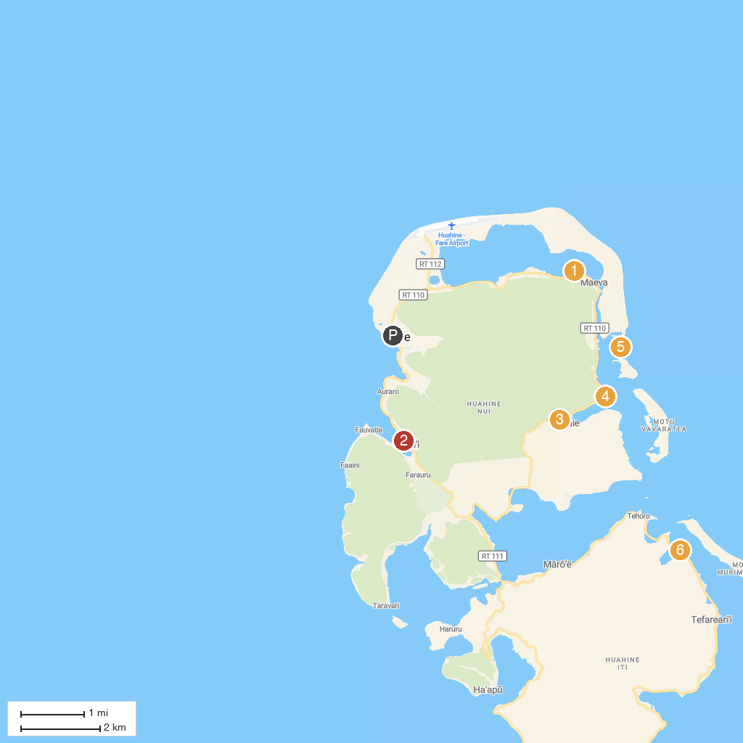
MAP KEY
1. Fare pote'e maeva huahine | 4. Huahine Pearl Farm
2. HineOraVai Island Tour | 5. Plage de l'ancien Sofitel
3. Anguilles sacrées | 6. Huahine Dream Tours
P. Cruise port / terminal
Map © MapTiler © OpenStreetMap contributors · cruiseports.org

