Galveston, Texas, USA
Galveston punches above its weight: Victorian ironwork buildings, a legendary Seawall, fresh Gulf seafood, and warm barrier-island beaches — all within minutes of the pier.
⚓ Pier (all terminals) · 🕒 Typical call: homeport / turnaround · 💵 USD · 🗣️ English · 🌊 Gulf Coast beach town
✍️ MY DAY IN PORT (FILL IN)
Ship / Date
In port | arrive ______ · all aboard ______
Booked excursion
Notes / meeting point
GETTING ASHORE
- Docking: All ships pier-side — no tendering
- Walk to center: Terminals 25/28: 5-10 min to The Strand; Terminal 10: ~10-15 min walk (0.5 mi)
- Best For: Historic downtown, Gulf beaches, seafood, families
- Don't Miss: The Strand National Historic Landmark District and La King's Confectionery
GETTING AROUND
- 🚕 Taxi: $7–$10 — Short ride from the cruise terminal to downtown Galveston or The Strand. Fares are low due to the compact island layout.
- 📱 Rideshare: ✅ Uber, Lyft
TOP THINGS TO DO
- The Strand Historic District Walk — Stroll the National Historic Landmark district lined with ornate cast-iron Victorian buildings.
- Gulf Coast Beach Day — Stewart Beach has lifeguards, chair rentals, and restrooms — perfect for families.
- Moody Gardens Aquarium & Rainforest — Three glass pyramids house a world-class aquarium, lush rainforest with exotic animals, and a discovery science exhibit.
- Gulf Fishing Charter — Head offshore from Pier 19 on a half-day or full-day fishing charter targeting red snapper, grouper, and kingfish.
- Ocean Star Offshore Drilling Museum — A retired jack-up drilling rig moored right next to Terminal 25.
BEST WALKS
- The Strand to the Seawall: 1.5 miles | Easy | ~30 min one way — Walk south from the cruise terminals along 25th Street through The Strand historic district, past…
- Seawall Promenade: Up to 10 miles | Easy | Go as far as you like — The world's longest continuous sidewalk runs 10.3 miles along the Seawall.
WEATHER · DAYLIGHT · MONEY
Month | High °F | Low °F | Rainy days
May | 80 | 73 | 15
Jul | 87 | 81 | 14
Sep | 84 | 78 | 16
Daylight: May 6:27AM–8:04PM · Jul 6:30AM–8:19PM · Sep 7:04AM–7:23PM
cruiseports.org/houston · Confirm terminal & all-aboard time with your ship

Galveston, Texas, USA — Port Map
Red = walkable sights · Amber = excursions farther out · P = cruise terminal
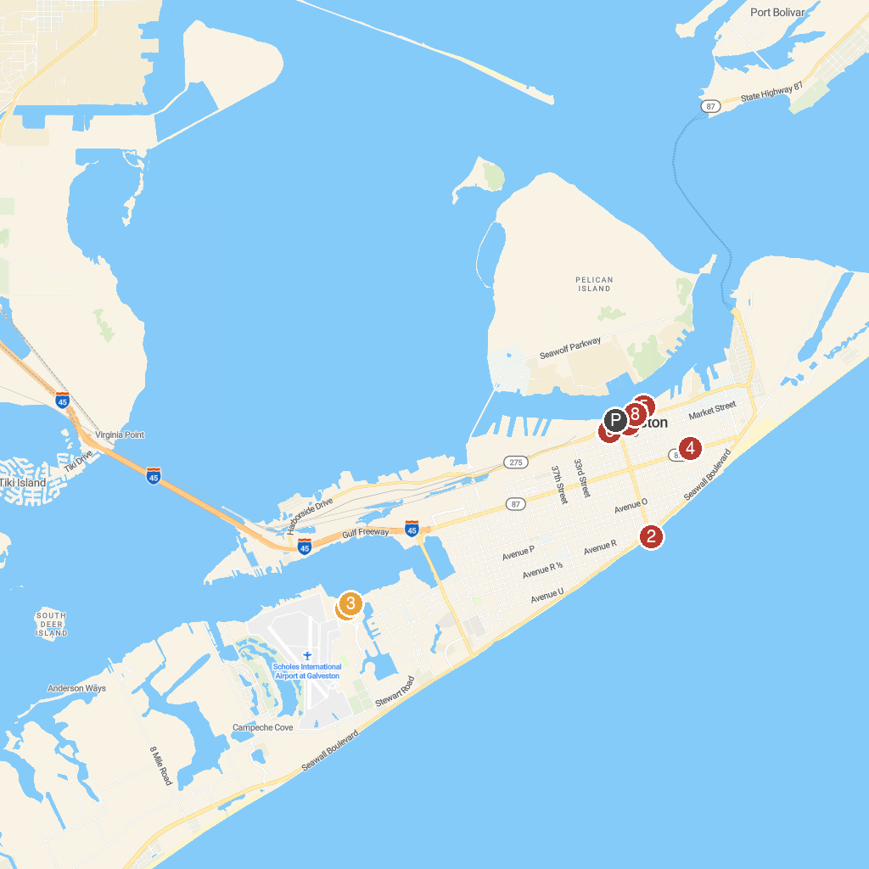
MAP KEY
1. Moody Gardens Attractions Theme Park | 5. Ocean Star Offshore Drilling Rig and Museum
2. Galveston Island Historic Pleasure Pier | 6. Galveston Railroad Museum
3. Palm Beach At Moody Gardens Water Park | 7. Saengerfest Park
4. Bishop’s Palace | 8. Galveston Historic Seaport - Home of the 1877 Tall Ship ELISSA
P. Cruise port / terminal
Map © MapTiler © OpenStreetMap contributors · cruiseports.org

