Horta, Faial Island, Azores, Portugal
Where sailors have stopped for centuries on Atlantic crossings, Horta greets you with the world's most colourful harbour walls, a view of Portugal's highest peak across the water, and some of the best whale watching on Earth.
⚓ Pier (Cais de Santa Cruz) · 🕒 Typical call: 6–8 hrs · 💶 Euro (€) · 🗣️ Portuguese (English widely spoken)
✍️ MY DAY IN PORT (FILL IN)
Ship / Date
In port | arrive ______ · all aboard ______
Booked excursion
Notes / meeting point
GETTING ASHORE
- Docking: Pier — Cais de Santa Cruz, 500 m from town
- Walk to center: 10–15 min flat waterfront walk
- Best For: Marina art, volcanic hikes, whale watching
- Don't Miss: Capelinhos Volcano & grilled limpets at Peter Cafe Sport
GETTING AROUND
- 🚕 Taxi: €5–€8 — Taxis are available at the port and regulated by the municipality. The short ride to city center takes 3–5 minutes; agre
- 📱 Rideshare: ❌ not available
TOP THINGS TO DO
- Capelinhos Volcano — Walk across black ash fields from the 1957–58 eruption that added new land to Faial, then descend into the award-winning…
- Whale & Dolphin Watching — The Azores is one of the world's premier whale-watching destinations.
- Caldeira do Faial Crater Hike — Drive to the island's volcanic core and walk the rim of a 2 km-wide lush green caldeira, 400 m deep.
- Horta Marina Wall Art — Sailor superstition demands every yacht crew leave a painted mural on the marina walls or risk bad luck at sea.
- Peter Cafe Sport & Scrimshaw Museum — The world's most famous sailor's bar has been serving Atlantic crossers since 1918.
BEST WALKS
- Harbourfront to Marina & Porto Pim: 2.5 km · 40 min · Flat — Walk west from the pier along the Avenida Marginal to the marina to see the famous sailor murals…
- Town Centre Stroll: 1.5 km · 30 min · Flat — Head into Horta's centre, stopping at the Igreja Matriz de São Salvador for its ornate azulejo…
WEATHER · DAYLIGHT · MONEY
Month | High °F | Low °F | Rainy days
May | 73 | 53 | 7
Jul | 88 | 66 | 3
Sep | 78 | 60 | 6
Daylight: May 6:41AM–9:09PM · Jul 6:40AM–9:29PM · Sep 7:39AM–8:07PM
cruiseports.org/horta · Confirm terminal & all-aboard time with your ship

Horta, Faial Island, Azores, Portugal — Port Map
Red = walkable sights · Amber = excursions farther out · P = cruise terminal
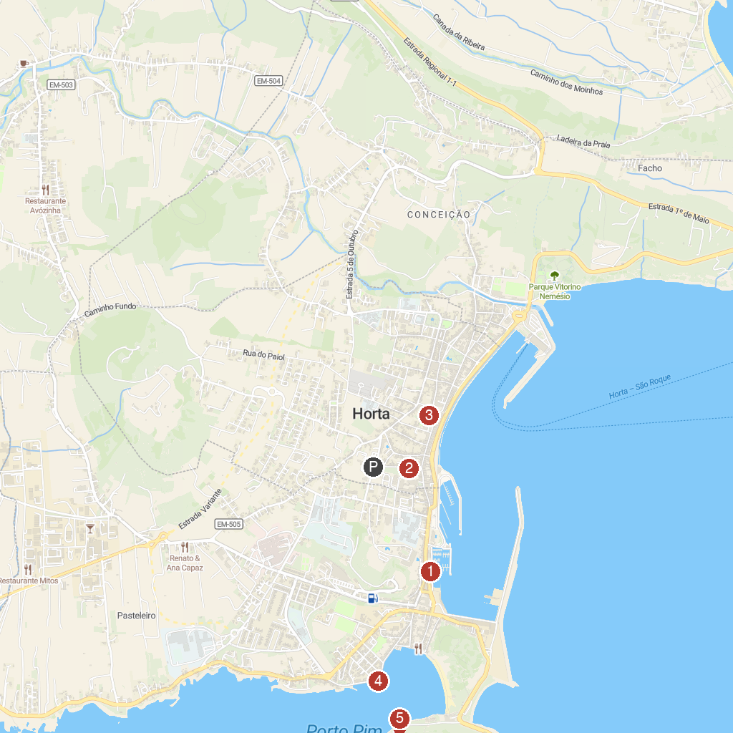
MAP KEY
1. Naturalist - Science & Tourism | Whale Watching | 4. Forte de São Sebastião
2. Casa Manuel de Arriaga | 5. Estação de Peixes Vivos // Aquário do Porto Pim
3. Church of the Holy Savior
P. Cruise port / terminal
Map © MapTiler © OpenStreetMap contributors · cruiseports.org

