Hoorn, North Holland, Netherlands
Cape Horn was named after this town — and one afternoon here explains why Hoorn's merchant sailors were the boldest in the world. Golden-age gables, a working harbour, and kibbeling at the quayside.
⚓ Pier (docked at historic quays) · 🕒 Typical call: 6–8 hrs · 💶 Euro (€) · 🗣️ Dutch (English widely spoken) · 🚶 Compact, fully walkable centre
✍️ MY DAY IN PORT (FILL IN)
Ship / Date
In port | arrive ______ · all aboard ______
Booked excursion
Notes / meeting point
GETTING ASHORE
- Docking: Pier — ships berth directly at the historic harbour quays; no tender
- Walk to centre: 5–10 min from quays to Roode Steen square (~500 m, flat)
- Best For: Dutch Golden Age history, VOC heritage, charming cobblestone streets
- Don't Miss: Hoofdtoren (1532 harbour tower), Bossuhuizen frieze, steam train to Medemblik
GETTING AROUND
- 🚕 Taxi: €8–€15 — Local taxis (Staxi, ClubTaxi) serve Hoorn with fixed-fare pricing. Pre-booking is recommended as street-hail availabilit
- 📱 Rideshare: ✅ Uber
TOP THINGS TO DO
- Roode Steen & the Golden Age Quarter — Wander the central square anchored by the ornate 1609 Waag (weigh house) and the statue of controversial VOC governor Jan…
- Hoofdtoren Harbour Walk — The 1532 Hoofdtoren defensive tower guards the harbour entrance and is Hoorn's most photographed landmark.
- Museum of the 20th Century (Oostereiland) — Right next to the cruise quay on Oostereiland, this nostalgic museum recreates how Dutch everyday life changed across the 1900s…
- Steam Train to Medemblik — Board the Museumstoomtram Hoorn–Medemblik, a fully operational historic steam train running through the West Frisian countryside…
- Cape Horn Connection: VOC Heritage Walk — Hoorn's biggest claim to fame: navigator Willem Schouten sailed from here in 1616 and named Cape Horn after his home city.
BEST WALKS
- Harbour & Golden Age Loop: 2 km · 30–45 min · Easy · Flat cobblestones — From the quay, walk to the Hoofdtoren, continue along Veermanskade past the historic ships to the…
- Oostereiland to Old Town: 1.5 km · 20–30 min · Easy — Start at Oostereiland (Museum of the 20th Century), cross to the inner harbour, walk the…
WEATHER · DAYLIGHT · MONEY
Month | High °F | Low °F | Rainy days
May | 61 | 49 | 12
Jul | 70 | 59 | 12
Sep | 66 | 55 | 11
Daylight: May 5:43AM–9:30PM · Jul 5:34AM–9:55PM · Sep 7:14AM–7:54PM
cruiseports.org/hoorn · Confirm terminal & all-aboard time with your ship

Hoorn, North Holland, Netherlands — Port Map
Red = walkable sights · Amber = excursions farther out · P = cruise terminal
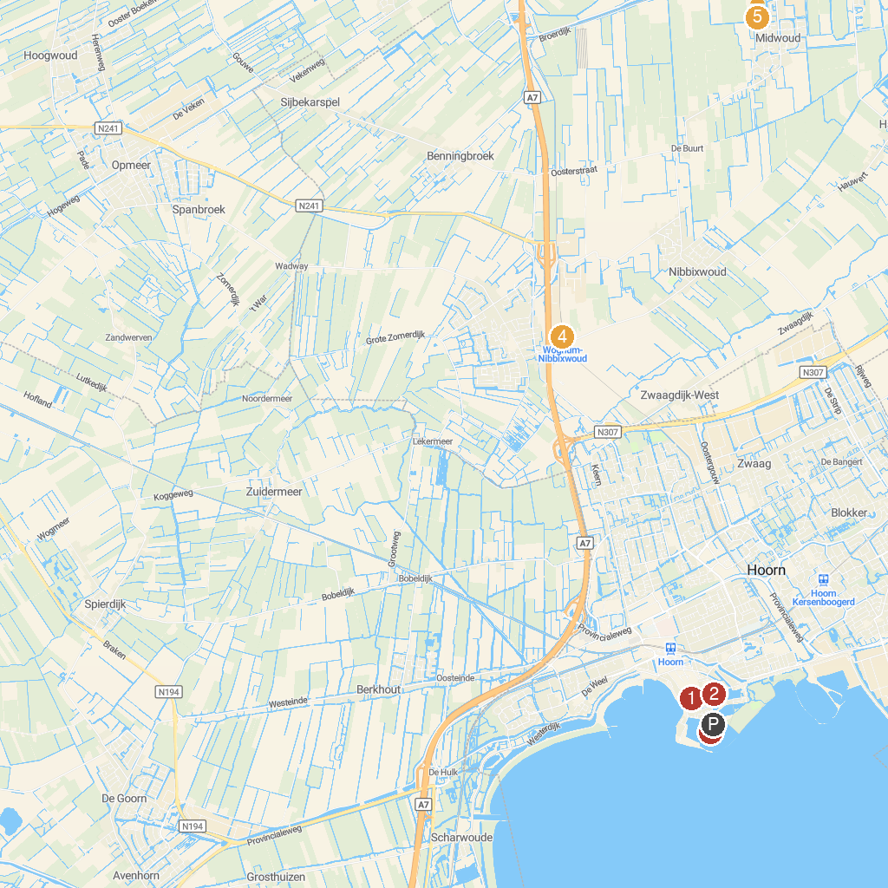
MAP KEY
1. Westfriesmuseum | 4. Stoomtramstation Wognum-Nibbixwoud
2. Oosterkerk | 5. Stoomtramstation Twisk
3. Museum of the 20th Century | 6. Museumboerderij West-Frisia
P. Cruise port / terminal
Map © MapTiler © OpenStreetMap contributors · cruiseports.org

