Honolulu, Oahu, Hawaii, USA
Hawaii's capital delivers in one day: history at Pearl Harbor, iconic views from Diamond Head, legendary surf and sand at Waikiki — all from a deep-water pier steps from the Aloha Tower.
⚓ Docked (Pier 2 or Pier 11) · 🕒 Typical call: 8–12 hrs · 💵 US Dollar (USD) · 🗣️ English / Hawaiian
✍️ MY DAY IN PORT (FILL IN)
Ship / Date
In port | arrive ______ · all aboard ______
Booked excursion
Notes / meeting point
GETTING ASHORE
- Docking: Pier 2 (most lines) or Pier 11 near Aloha Tower Marketplace; all ships dock — no tendering
- Walk to center: 5 min to downtown Honolulu; Waikiki is ~4 miles (taxi/trolley recommended)
- Best For: Pearl Harbor history, Diamond Head hike, Waikiki beach day, island circle tours
- Don't Miss: USS Arizona Memorial — book timed tickets online well before your cruise
GETTING AROUND
- 🚕 Taxi: $20–$40 — Taxis are readily available at the cruise terminal. Flat rate to Waikiki is approximately $26 from Pier 2; metered fares
- 📱 Rideshare: ✅ Uber, Lyft, Holoholo
- 🚌 Hop-on hop-off: ✅ Waikiki Trolley · from 20
TOP THINGS TO DO
- Pearl Harbor & USS Arizona Memorial — The most-visited site in Hawaii.
- Diamond Head Crater Hike — Climb inside the rim of this ancient volcanic tuff cone for panoramic views over Waikiki and the Pacific.
- Waikiki Beach & Surfing Lesson — The world's most famous beach sits 4 miles from the pier.
- Iolani Palace & Downtown Historic Walk — Tour Iolani Palace — the only royal palace on US soil — then walk to the King Kamehameha statue, Hawaii State Capitol, and…
- Oahu Circle Island Tour — See the whole island in a day: the lush Windward Coast, Nuuanu Pali Lookout, the North Shore surfing mecca (Waimea Bay, Sunset…
BEST WALKS
- Aloha Tower to Iolani Palace Walk: 1.5 miles • 30–40 min • Easy flat — Stroll from the pier past the 1926 Aloha Tower landmark, through the edge of Chinatown, up to the…
- Waikiki Beachfront Promenade: 1.5 miles • 30 min • Easy flat — Walk the full length of Waikiki Beach from Kapiolani Park and the Waikiki Aquarium end down to the…
WEATHER · DAYLIGHT · MONEY
Month | High °F | Low °F | Rainy days
May | 80 | 72 | 9
Jul | 83 | 75 | 7
Sep | 84 | 75 | 8
Daylight: May 5:53AM–7:02PM · Jul 5:58AM–7:16PM · Sep 6:18AM–6:33PM
cruiseports.org/honolulu · Confirm terminal & all-aboard time with your ship

Honolulu, Oahu, Hawaii, USA — Port Map
Red = walkable sights · Amber = excursions farther out · P = cruise terminal
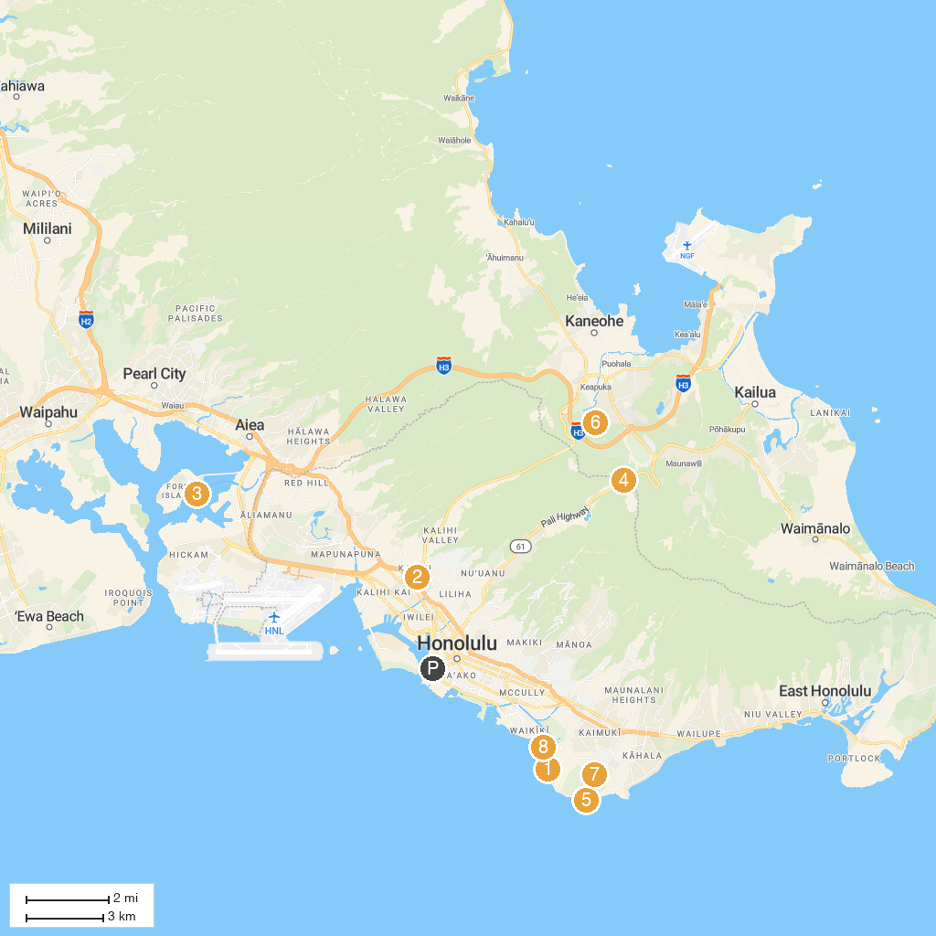
MAP KEY
1. Waikiki Aquarium | 5. Diamond Head Beach Park
2. Bishop Museum | 6. Hoʻomaluhia Botanical Garden
3. USS Missouri (BB-63) - Battleship Museum | 7. Diamond Head State Monument
4. Nuʻuanu Pali State Wayside | 8. St. Augustine by the Sea
P. Cruise port / terminal
Map © MapTiler © OpenStreetMap contributors · cruiseports.org

