Honningsvåg, Finnmark, Norway
The northernmost city in Norway sits at 71°N, where cruise ships dock steps from the harbor and the iconic North Cape cliff looms just 34 km away above the Arctic Ocean.
⚓ Pier (occasional tender for large ships) · 🕒 Typical call: 6–8 hrs · 💳 NOK — Norway is virtually cashless · 🗣️ Norwegian (English widely spoken) · 🌅 Midnight Sun: mid-May to late July
✍️ MY DAY IN PORT (FILL IN)
Ship / Date
In port | arrive ______ · all aboard ______
Booked excursion
Notes / meeting point
GETTING ASHORE
- Docking: Pier at Honningsvåg Havn (Storkaia), central location; rare tender for oversized calls
- Walk to center: 2–5 min from gangway to Storgata shops and restaurants
- Best For: North Cape (Nordkapp), king crab feasts, WWII history, Arctic birdwatching
- Don't Miss: The globe monument at Nordkapp and fresh king crab pulled from the Barents Sea
GETTING AROUND
- 🚕 Taxi: 150–300 NOK within town; ~1,600 NOK round-trip to North Cape (up to 4 people) — Local taxis are available near the port. For the 34 km trip to North Cape, sharing a taxi is a flexible and popular opti
TOP THINGS TO DO
- North Cape (Nordkapp) — Stand at the sheer 307-metre cliff at the top of Europe and pose with the globe monument.
- King Crab Safari — Head out by boat to haul up traps packed with giant Red King Crabs from the cold Barents Sea, then sit down to a feast of fresh…
- Bird Safari — Gjesværstappan — Boat tour from the fishing village of Gjesvær to one of Norway's largest seabird colonies: puffins, razorbills, guillemots, and…
- Nordkappmuseet (North Cape Museum) — Right on the harbor, this museum covers Magerøya's history, the rise of Arctic tourism, and the devastating German scorched-earth…
- Storefjell Hike — A moderately steep trail starting near the church climbs to panoramic views over Honningsvåg harbor, your ship, and the…
BEST WALKS
- Harbor Town Stroll: 30–45 min · Flat · Free — Walk Storgata from the pier to Honningsvåg Church (1885, one of the only buildings to survive…
- Storefjell Summit Hike: 1.5–2 hrs · Moderate ascent · Free — Follow the trail behind Honningsvåg Church up Storefjell for sweeping Arctic views of the harbor…
WEATHER · DAYLIGHT · MONEY
Month | High °F | Low °F | Rainy days
May | 42 | 35 | 16
Jul | 55 | 48 | 12
Sep | 49 | 43 | 15
Daylight: Sep 5:27AM–6:52PM
cruiseports.org/honningsvag · Confirm terminal & all-aboard time with your ship

Honningsvåg, Finnmark, Norway — Port Map
Red = walkable sights · Amber = excursions farther out · P = cruise terminal
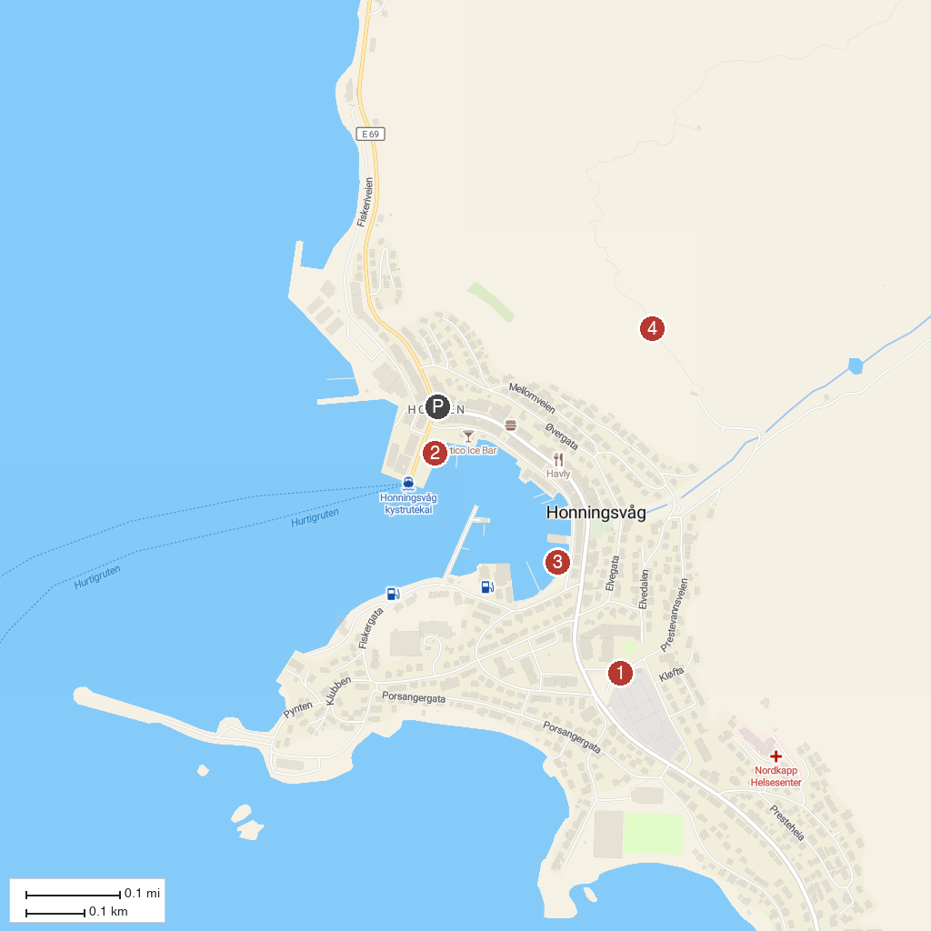
MAP KEY
1. Honningsvåg Church | 3. North Cape Experience
2. Nordkappmuseet | 4. Nordkapin portaat
P. Cruise port / terminal
Map © MapTiler © OpenStreetMap contributors · cruiseports.org

