Holyhead, Anglesey, Wales
Holy Island's working port punches well above its size — ancient Roman forts, puffin-lined sea cliffs, and three UNESCO castles are all within reach on a single shore day.
⚓ Usually Pier (Orthios Berth) · 🕒 Typical call: 8-10 hrs · 💷 British Pound (GBP) · 🗣️ English & Welsh
✍️ MY DAY IN PORT (FILL IN)
Ship / Date
In port | arrive ______ · all aboard ______
Booked excursion
Notes / meeting point
GETTING ASHORE
- Docking: Orthios Deepwater Berth (most ships); shuttle bus to town (1.5 mi)
- Walk to centre: Shuttle to Celtic Gateway Bridge, then 5 min walk
- Best For: Medieval castles, coastal walks, Snowdonia scenery
- Don't Miss: South Stack Lighthouse cliffs or Caernarfon Castle
GETTING AROUND
- 🚕 Taxi: £5–£10 est. — Taxis are scarce in Holyhead; pre-booking is essential. Local firms include Holyhead Taxi (07759 433 633) and GH Private
TOP THINGS TO DO
- Caernarfon Castle & Town — Edward I's 13th-century masterpiece — polygonal towers modelled on Constantinople, towering above a charming walled medieval town.
- South Stack Cliffs & Lighthouse — Three miles from town, dramatic sea cliffs host thousands of nesting puffins, guillemots, and razorbills (spring–midsummer).
- Beaumaris Castle & Anglesey — Europe's finest example of concentric castle design, surrounded by a water-filled moat.
- Snowdonia / Eryri National Park — Head into Wales' highest mountain range for scenic drives through Llanberis Pass, views of Yr Wyddfa (Snowdon), and photo stops…
- St. Cybi's Church & Roman Fort — In Holyhead town centre, a 13th-century church built inside the walls of a 4th-century Roman fort (Caer Gybi) — one of the few…
BEST WALKS
- Town Centre & Roman Fort Walk: 1.5 km · Flat · 30-45 min — From the Celtic Gateway Bridge stroll through Holyhead town to St.
- Holyhead Mountain & Clifftop Loop: 4 km · Moderate · 1.5-2 hrs — A short taxi ride gets you to the RSPB South Stack car park.
WEATHER · DAYLIGHT · MONEY
Month | High °F | Low °F | Rainy days
May | 58 | 48 | 13
Jul | 65 | 56 | 14
Sep | 62 | 54 | 14
Daylight: May 5:19AM–9:11PM · Jul 5:10AM–9:38PM · Sep 6:52AM–7:33PM
cruiseports.org/holyhead · Confirm terminal & all-aboard time with your ship

Holyhead, Anglesey, Wales — Port Map
Red = walkable sights · Amber = excursions farther out · P = cruise terminal
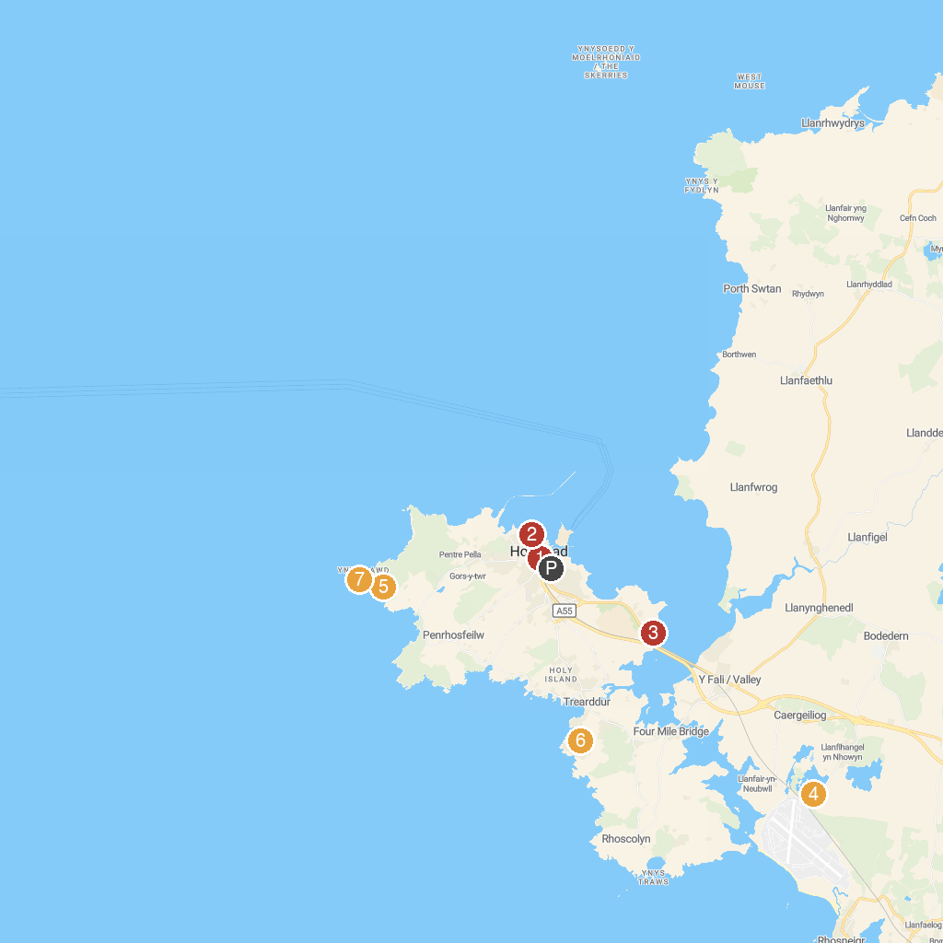
MAP KEY
1. St Cybi’s Church | 5. RSPB South Stack
2. Holyhead Maritime Museum | 6. Porth Diana North Wales Wildlife Trust Nature Reserve
3. Parc Arfordirol Penrhos Coastal Park | 7. South Stack Lighthouse
4. RSPB Valley Wetlands | 8. Barclodiad y Gawres
P. Cruise port / terminal
Map © MapTiler © OpenStreetMap contributors · cruiseports.org

