Holland, Michigan, USA
One of America's most Dutch cities sits where Lake Macatawa meets Lake Michigan — small ships glide in past the Big Red lighthouse to a port full of windmills, white-sand beaches, and craft beer.
⚓ Pier (ships dock on Lake Macatawa) · 🕒 Typical call: 7–9 hrs · 💵 USD · 🗣️ English · 🌷 Best May–September
✍️ MY DAY IN PORT (FILL IN)
Ship / Date
In port | arrive ______ · all aboard ______
Booked excursion
Notes / meeting point
GETTING ASHORE
- Docking: Ships dock on Lake Macatawa (not Lake Michigan); pier berthing, no tendering
- Walk to center: Shuttle required — dock is ~1.5–2.5 mi from 8th Street downtown
- Best For: Dutch heritage, fresh-water beaches, craft breweries, quiet Midwest charm
- Don't Miss: De Zwaan windmill at Windmill Island — the oldest authentic working Dutch windmill in the US
GETTING AROUND
- 🚕 Taxi: $20–$30 — Uber and Lyft are available in Holland. Estimated fare from the dock area (Holland State Park / Yacht Basin Marina) to d
- 📱 Rideshare: ✅ Uber, Lyft
TOP THINGS TO DO
- Windmill Island Gardens & De Zwaan — The undisputed highlight of Holland.
- Holland State Park & Big Red Lighthouse — Holland's most photographed spot — the square, bright-red 'Big Red' lighthouse sits at the mouth of the Lake Macatawa channel.
- Mt. Pisgah Dune Climb & Lake Michigan Views — Climb 239 steps up a boardwalk staircase to 157 feet above sea level for panoramic views of Lake Michigan, Lake Macatawa, and the…
- Nelis' Dutch Village — A nostalgic family-friendly park styled after a 19th-century Dutch village.
- Downtown Craft Beer & Dutch Pastry Walk — New Holland Brewing (home of the famous Dragon's Milk bourbon-barrel stout) anchors 8th Street's craft scene.
BEST WALKS
- 8th Street Downtown Stroll: 1.2 mi loop • Easy • 30–45 min — Walk 8th Street from River Ave to College Ave and back — 100+ locally owned shops, deBoer Bakkerij…
- Kollen Park Waterfront Walk: 0.8 mi • Easy • 20–30 min — Stroll Kollen Park on the south shore of Lake Macatawa — boardwalk, manicured gardens, and a…
WEATHER · DAYLIGHT · MONEY
Month | High °F | Low °F | Rainy days
May | 64 | 48 | 13
Jul | 72 | 58 | 14
Sep | 67 | 53 | 11
Daylight: May 6:22AM–9:00PM · Jul 6:19AM–9:21PM · Sep 7:24AM–7:55PM
cruiseports.org/holland-mi · Confirm terminal & all-aboard time with your ship

Holland, Michigan, USA — Port Map
Red = walkable sights · Amber = excursions farther out · P = cruise terminal
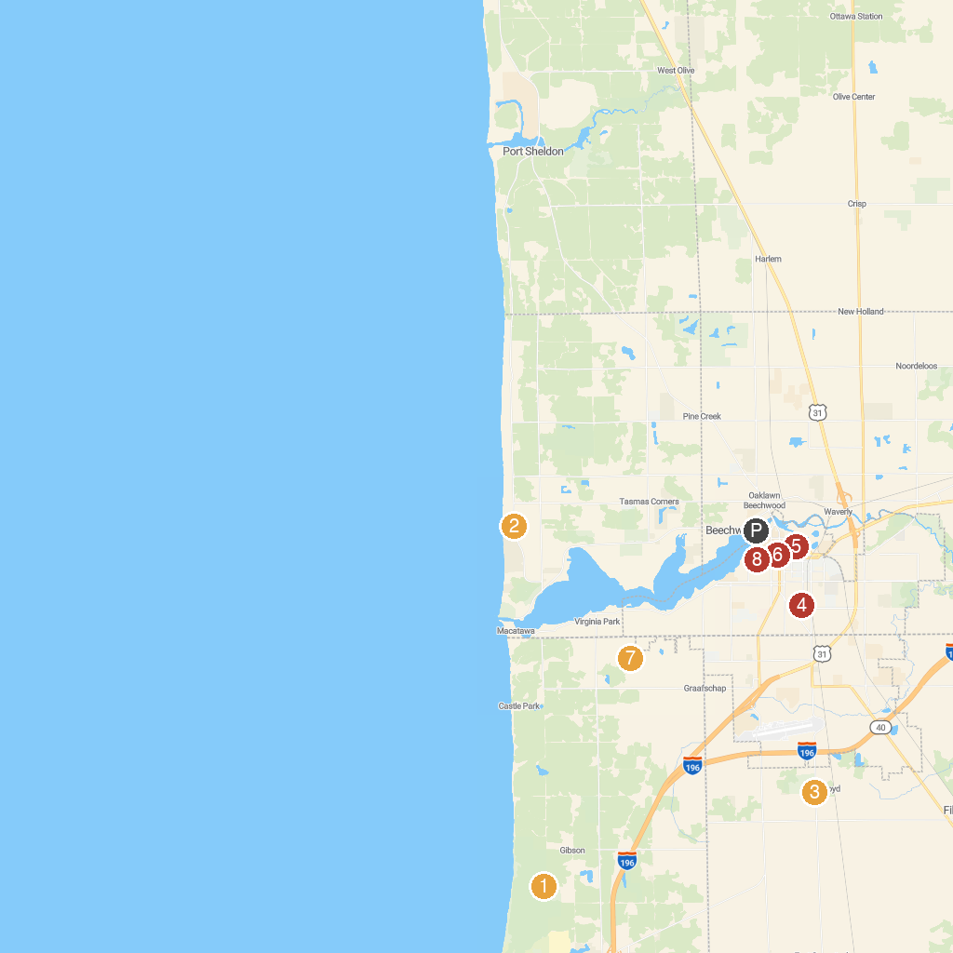
MAP KEY
1. Saugatuck Dunes State Park | 5. Window on the Waterfront
2. Tunnel Park | 6. Tulip Time Festival Office
3. Outdoor Discovery Center | 7. Wolters Woods Park
4. Prospect Park | 8. The Cappon House
P. Cruise port / terminal
Map © MapTiler © OpenStreetMap contributors · cruiseports.org

