Hobart, Tasmania, Australia
Tasmania's capital punches well above its size — a walkable waterfront with Georgian sandstone warehouses, the provocative MONA gallery, and a wild mountain looming right behind town.
⚓ Pier (Macquarie Wharf) · 🕒 Typical call: 8-10 hrs · 💵 Australian Dollar (AUD) · 🗣️ English · 🌿 Tasmanian wildlife & wilderness
✍️ MY DAY IN PORT (FILL IN)
Ship / Date
In port | arrive ______ · all aboard ______
Booked excursion
Notes / meeting point
GETTING ASHORE
- Docking: All ships dock at Macquarie Wharf No. 2 — no tender required
- Walk to centre: ~800 m flat walk to Salamanca Place and the CBD
- Best For: Art lovers, history buffs, wildlife, and great food & whisky
- Don't Miss: MONA (Museum of Old and New Art) — take the ferry upstream
GETTING AROUND
- 🚕 Taxi: AUD $23–$27 — Metered taxis available at the terminal. Approximately 7 km to the city center; night/weekend rates are slightly higher.
- 📱 Rideshare: ✅ Uber
- 🚌 Hop-on hop-off: ✅ Red Decker
TOP THINGS TO DO
- MONA — Museum of Old and New Art — Australia's most talked-about gallery is a 25-minute ferry ride up the Derwent River.
- kunanyi / Mount Wellington Summit — The 1,271 m peak towers over the city and offers panoramic views to the Derwent Valley and Southern Ocean.
- Port Arthur Historic Site — A UNESCO World Heritage–listed convict settlement on the Tasman Peninsula, about 90 minutes by road.
- Bonorong Wildlife Sanctuary — Hand-feed kangaroos and get close to Tasmanian devils at this conservation sanctuary 25 minutes north of Hobart.
- Richmond Village & Oldest Bridge — A well-preserved Georgian village 25 km from Hobart, home to the oldest bridge in Australia (1823) and the oldest…
BEST WALKS
- Waterfront to Salamanca Loop: 1.5 km | Easy | 30-45 min — Walk from Macquarie Wharf along the waterfront past Constitution Dock and Fishing boat harbour to…
- Battery Point Heritage Walk: 2 km | Easy | 45-60 min — From Salamanca Place, climb the short rise into Battery Point — Hobart's oldest residential suburb…
WEATHER · DAYLIGHT · MONEY
Month | High °F | Low °F | Rainy days
May | 58 | 44 | 9
Jul | 53 | 40 | 10
Sep | 59 | 43 | 10
Daylight: May 7:16AM–4:57PM · Jul 7:37AM–4:55PM · Sep 6:13AM–5:59PM
cruiseports.org/hobart · Confirm terminal & all-aboard time with your ship

Hobart, Tasmania, Australia — Port Map
Red = walkable sights · Amber = excursions farther out · P = cruise terminal
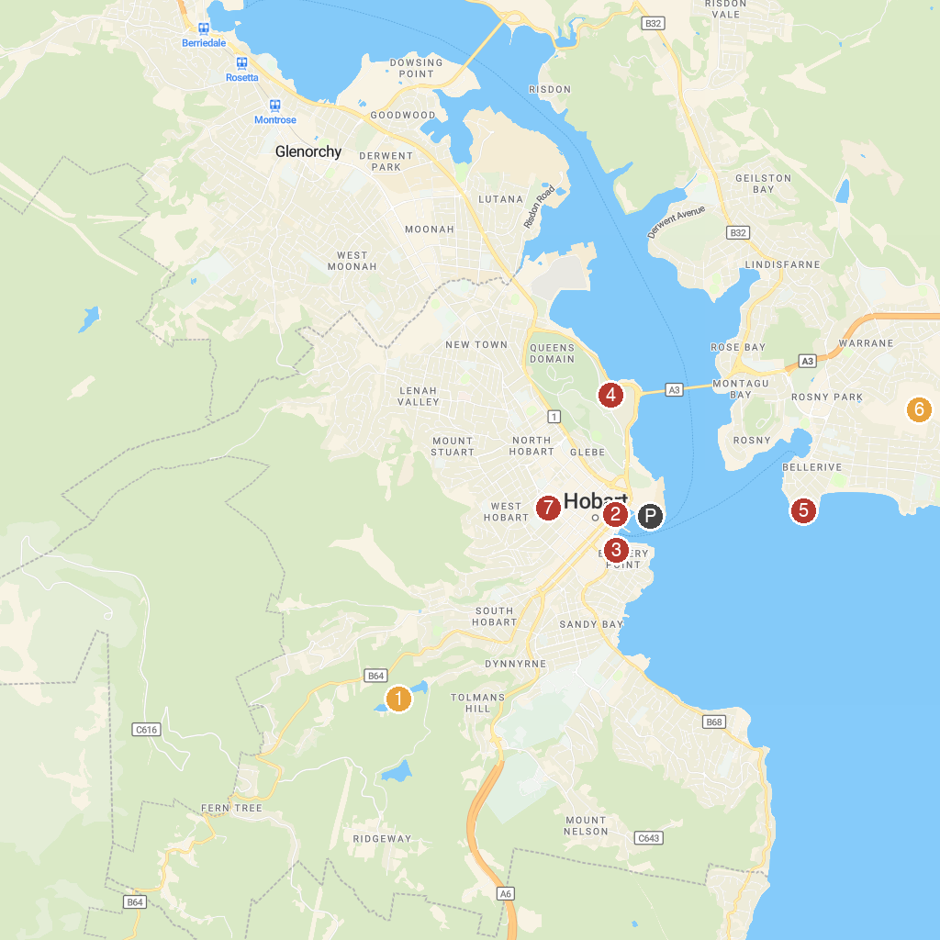
MAP KEY
1. Waterworks Reserve | 5. Par Avion
2. Tasmanian Museum and Art Gallery | 6. Kangaroo Bluff Historic Site
3. Salamanca Market | 7. Waverley Flora Park
4. Royal Tasmanian Botanical Gardens | 8. St Mary's Cathedral
P. Cruise port / terminal
Map © MapTiler © OpenStreetMap contributors · cruiseports.org

