Hiroshima City, Hiroshima Prefecture, Japan
The City of Peace carries its history gently — solemn memorials give way to lively arcades, soul-warming okonomiyaki, and the sacred island of Miyajima floating just 30 minutes offshore.
⚓ Docked (pier — no tender) · 🕒 Typical call: 8–10 hrs · 💴 Currency: Japanese Yen (JPY) · 🗣️ Language: Japanese
✍️ MY DAY IN PORT (FILL IN)
Ship / Date
In port | arrive ______ · all aboard ______
Booked excursion
Notes / meeting point
GETTING ASHORE
- Docking: Pier — Ujina Wharf (smaller ships) or Itsukaichi Wharf (large ships)
- Walk to center: Not walkable — 6 km from Ujina; shuttle or tram required
- Best For: History, culture, Miyajima Island day trip, Japanese food
- Don't Miss: Peace Memorial Museum + Miyajima floating Torii gate
GETTING AROUND
- 🚕 Taxi: ¥2,200–¥3,000 — From Ujina Wharf (Hiroshima Port) to Peace Memorial Park or Hiroshima Station — roughly 5–6 km. Itsukaichi Wharf taxis r
- 📱 Rideshare: ✅ Uber
- 🚌 Hop-on hop-off: ✅
TOP THINGS TO DO
- Peace Memorial Park & Museum — The emotional heart of Hiroshima.
- Miyajima Island & Itsukushima Shrine — The sacred island famous for its vermilion Torii gate that appears to float at high tide.
- Hiroshima Okonomiyaki Village — Hiroshima's signature layered savory pancake — distinct from Osaka's version — is made with cabbage, pork, yakisoba noodles, and…
- Hiroshima Castle — The 'Carp Castle,' a 1590s feudal castle reconstructed after the war.
- Mt. Misen Ropeway, Miyajima — Take the two-stage ropeway up to near the summit of sacred Mt.
BEST WALKS
- Peace Park Loop: 1.5 km · 30–45 min · Flat — From the Peace Memorial Museum, walk to the Cenotaph, Children's Peace Monument, Peace Flame, and…
- Miyajima Waterfront & Shrine: 1.5 km · 30 min · Easy flat stroll — From the Miyajima ferry pier, stroll the waterfront past tame deer to the Itsukushima Shrine…
WEATHER · DAYLIGHT · MONEY
Month | High °F | Low °F | Rainy days
May | 72 | 56 | 9
Jul | 84 | 73 | 15
Sep | 80 | 68 | 13
Daylight: May 5:08AM–7:05PM · Jul 5:09AM–7:22PM · Sep 5:53AM–6:17PM
cruiseports.org/hiroshima-city · Confirm terminal & all-aboard time with your ship

Hiroshima City, Hiroshima Prefecture, Japan — Port Map
Red = walkable sights · Amber = excursions farther out · P = cruise terminal
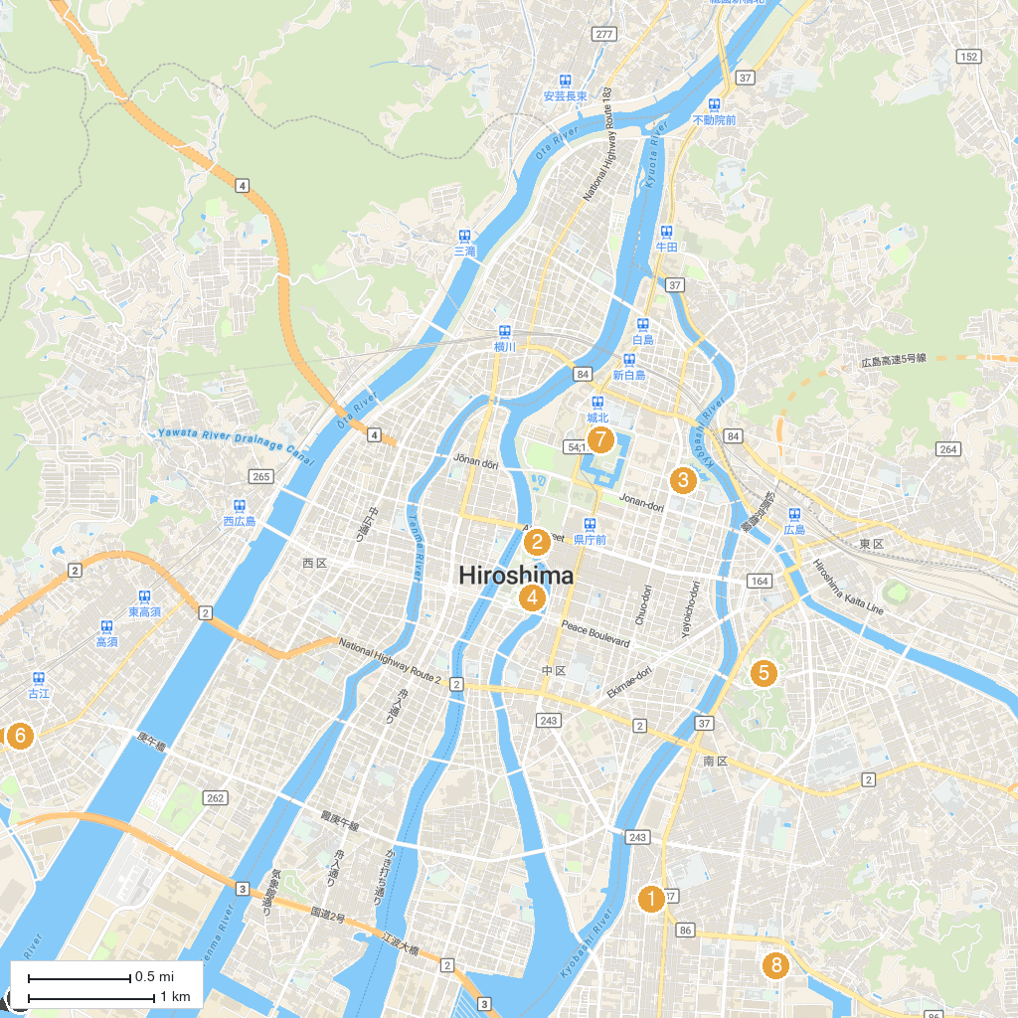
MAP KEY
1. Sendabyo Park | 5. Hiroshima City Museum of Contemporary Art
2. Atomic Bomb Dome | 6. Suzugamine Park
3. Hiroshima Prefectural Art Museum | 7. Hiroshima Castle
4. Hiroshima Peace Memorial Museum | 8. Ujina Natural Hot Spring Honoyu
P. Cruise port / terminal
Map © MapTiler © OpenStreetMap contributors · cruiseports.org

