Himeji, Hyogo Prefecture, Japan
Japan's most spectacular original samurai castle rises above a city that time treated kindly. Himeji Castle is not a reconstruction — it is the real thing, and it is extraordinary.
⚓ Pier (Shikama Wharf) · 🕒 Typical call: 8-10 hrs · 💴 Currency: Japanese Yen (¥) · 🗣️ Language: Japanese · 🏯 UNESCO World Heritage Site
✍️ MY DAY IN PORT (FILL IN)
Ship / Date
In port | arrive ______ · all aboard ______
Booked excursion
Notes / meeting point
GETTING ASHORE
- Docking: Pier at Shikama Wharf, Port of Himeji (~8 km from castle)
- Walk to Castle: Shuttle or taxi required from pier; 15 min walk from Himeji Station
- Best For: History lovers, architecture, Japanese culture, photography
- Don't Miss: Himeji Castle interior climb + Koko-en Garden combined ticket (¥2,600 non-resident)
GETTING AROUND
- 🚕 Taxi: ¥3,600–¥4,500 (~$24-30 USD) — Taxis queue at Shikama Wharf and reach Himeji Castle or Station in 15–20 minutes. Best value for groups of 2 or more; us
- 📱 Rideshare: ✅ Uber
TOP THINGS TO DO
- Himeji Castle — Japan's finest original castle — not a reconstruction.
- Koko-en Garden — Nine walled gardens in Edo-period style sit right beside the castle.
- Mt. Shosha & Engyoji Temple — A 1,000-year-old temple complex clings to forested Mt.
- Himeji City Museum of History — Just a short walk from the castle, this excellent museum traces Himeji's samurai history and the castle's construction.
- Himeji Oden & Local Sake Tasting — Himeji-style oden is drizzled with sweet ginger-soy sauce — nothing like standard oden.
BEST WALKS
- Otemae-dori Castle Walk: 1 km each way · Flat · 15 min · All abilities — From Himeji Station, walk the wide boulevard straight to the castle gates.
- Castle to Koko-en Garden Loop: 0.5 km loop · Easy · 10 min walk · All abilities — After touring the castle, exit through the west gate and cross directly into Koko-en Garden.
WEATHER · DAYLIGHT · MONEY
Month | High °F | Low °F | Rainy days
May | 72 | 56 | 10
Jul | 84 | 73 | 17
Sep | 81 | 68 | 14
Daylight: May 4:58AM–6:57PM · Jul 4:59AM–7:14PM · Sep 5:44AM–6:08PM
cruiseports.org/himeji · Confirm terminal & all-aboard time with your ship

Himeji, Hyogo Prefecture, Japan — Port Map
Red = walkable sights · Amber = excursions farther out · P = cruise terminal
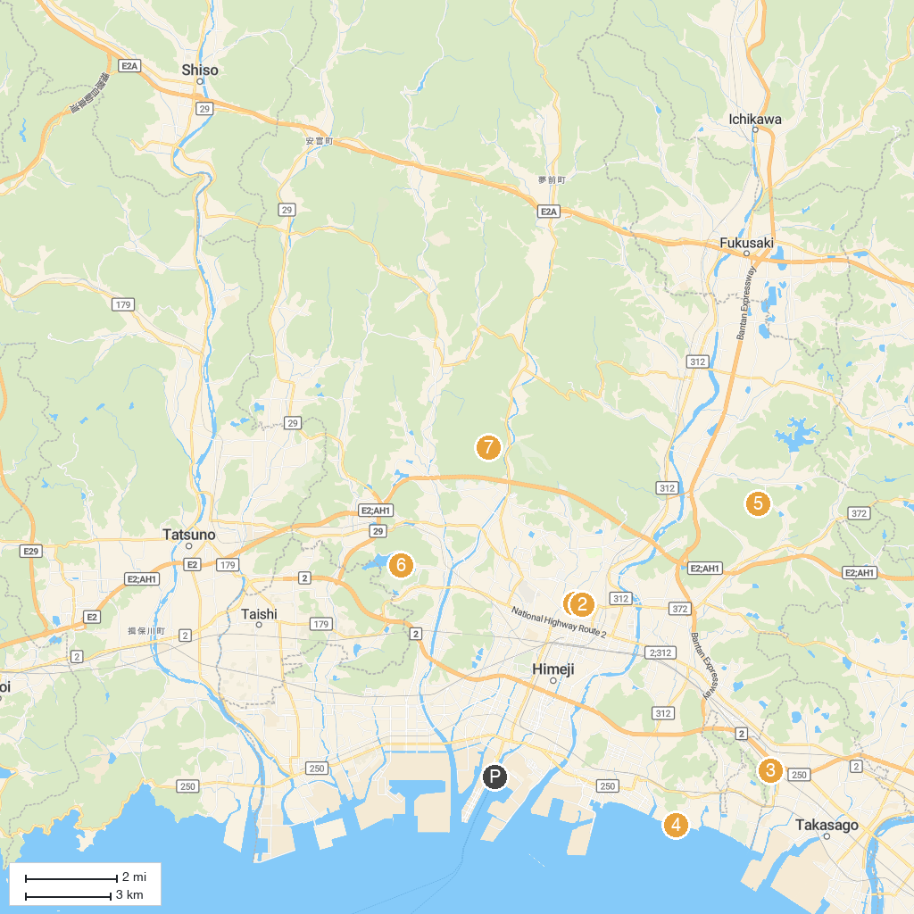
MAP KEY
1. Himeji Castle | 5. Shosekiheki Park
2. Ibo-no-Ito Somen Museum | 6. Himeji Central Park
3. Himeji City Museum of Art | 7. Himeji City Science Museum
4. Tenkawahigashi Park | 8. Engyōji
P. Cruise port / terminal
Map © MapTiler © OpenStreetMap contributors · cruiseports.org

