Hilton Head Island, South Carolina, USA
Twelve miles of Atlantic beach, a candy-striped lighthouse, and Lowcountry marshes teeming with dolphins — Hilton Head is a polished, bikeable island that rewards cruise day-trippers who move fast.
⚓ Tender (no cruise pier) · 🕒 Typical call: 6–8 hrs · 💵 USD · 🗣️ English · 🚲 Bike-friendly island
✍️ MY DAY IN PORT (FILL IN)
Ship / Date
In port | arrive ______ · all aboard ______
Booked excursion
Notes / meeting point
GETTING ASHORE
- Docking: Tender to Harbour Town Marina — no dedicated cruise pier
- Walk to beach: Coligny Beach ~5 mi from Harbour Town; bike or taxi required
- Best For: Beaches, wildlife, cycling, Gullah heritage
- Don't Miss: Harbour Town Lighthouse climb for 360° island views
GETTING AROUND
- 🚕 Taxi: $10–$35 — Local taxis charge $10 for the first mile and $4 per additional mile with a $10 minimum. Short hops across the island ty
- 📱 Rideshare: ✅ Uber, Lyft
TOP THINGS TO DO
- Harbour Town Lighthouse Climb — Climb the 114-step red-and-white lighthouse (90 ft tall) for sweeping views over the Calibogue Sound, marina, and island canopy.
- Coligny Beach Day — Hilton Head's most popular public beach offers 12 miles of Atlantic shoreline, free parking, outdoor showers, a splash fountain…
- Dolphin-Watching Cruise — Atlantic bottlenose dolphins are resident in the Sound year-round.
- Pinckney Island Wildlife Refuge Bike Ride — Just off the island, this 4,000-acre refuge has 14 miles of unpaved trails through maritime forest and salt marsh.
- Gullah Heritage Trail Tour — The Gullah people — descendants of enslaved West Africans — maintained a distinct culture on the Sea Islands.
BEST WALKS
- Harbour Town Marina Loop: 0.5 mi · Easy · 15 min — Circle the marina from the tender dock past boutiques and restaurants to the base of the…
- Coastal Discovery Museum Grounds: 1 mi · Easy · 30–45 min — The museum at Honey Horn Plantation (north end of island) has a self-guided outdoor trail through…
WEATHER · DAYLIGHT · MONEY
Month | High °F | Low °F | Rainy days
May | 80 | 69 | 10
Jul | 87 | 77 | 17
Sep | 83 | 73 | 15
Daylight: May 6:25AM–8:13PM · Jul 6:27AM–8:30PM · Sep 7:07AM–7:28PM
cruiseports.org/hilton-head-island-sc · Confirm terminal & all-aboard time with your ship

Hilton Head Island, South Carolina, USA — Port Map
Red = walkable sights · Amber = excursions farther out · P = cruise terminal
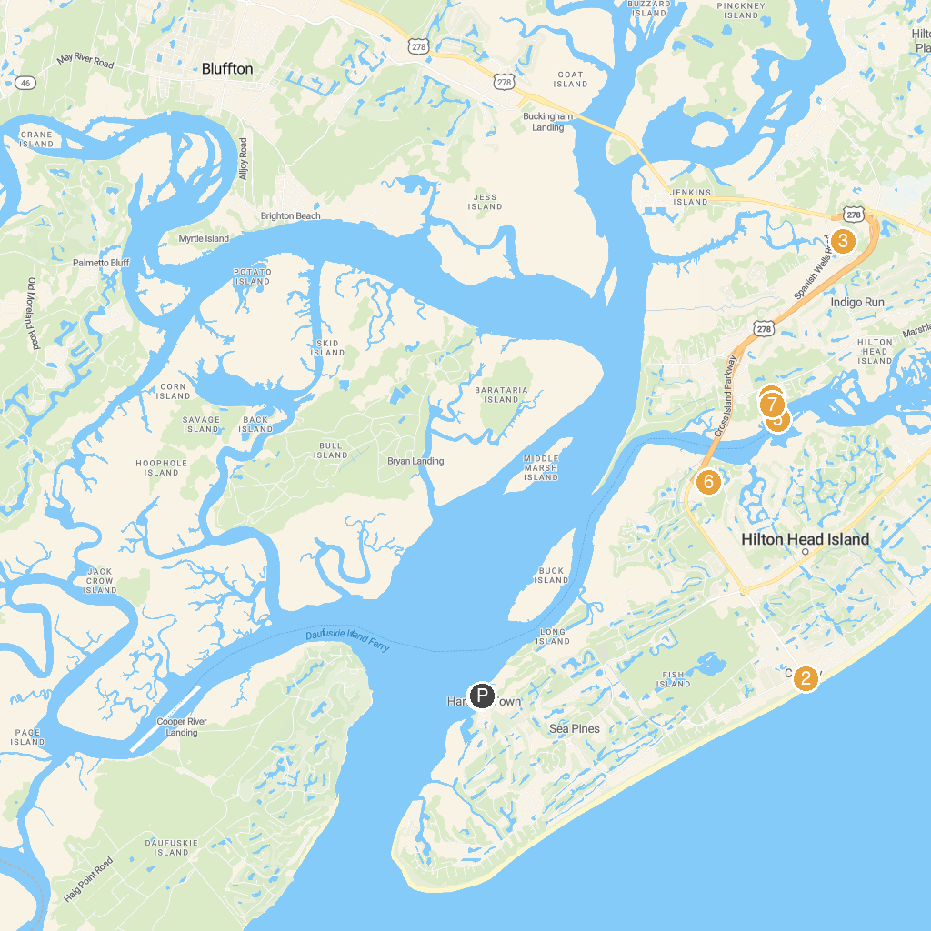
MAP KEY
1. Harbour Town Lighthouse | 5. Kayak Hilton Head
2. Coligny Beach Park | 6. Dolphin & Nature Tour
3. Coastal Discovery Museum | 7. Crossings Park
4. Church of the Cross | 8. Dolphin Discoveries Hilton Head
P. Cruise port / terminal
Map © MapTiler © OpenStreetMap contributors · cruiseports.org

