Hilo, Big Island, Hawaii, USA
The lush, rainy side of the Big Island — where active volcanoes meet towering waterfalls, black-sand beaches, and a relaxed small-town vibe that most Hawaii visitors never see.
⚓ Docked — pier in town · 🕒 Typical call: 8–10 hrs · 💵 US Dollar (USD) · 🗣️ English · Hawaiian
✍️ MY DAY IN PORT (FILL IN)
Ship / Date
In port | arrive ______ · all aboard ______
Booked excursion
Notes / meeting point
GETTING ASHORE
- Docking: Pier 1 / Pier 2, Port of Hilo
- To center: ~2 miles · taxi or walk
- Best For: Volcanoes · Waterfalls · Nature
- Don't Miss: Hawaii Volcanoes National Park
GETTING AROUND
- 🚕 Taxi: $12–16 — Metered taxis from the pier to historic downtown Hilo run about $12–16 (2–3 miles). Readily available on ship-arrival da
- 📱 Rideshare: ✅ Uber, Lyft
- 🚌 Hop-on hop-off: ✅
TOP THINGS TO DO
- Hawaii Volcanoes National Park — The must-do from Hilo.
- Rainbow Falls & Boiling Pots — An 80-foot waterfall plunges into a lava rock pool at Wailuku River State Park — best visited on a sunny morning when rainbows…
- ʻAkaka Falls State Park — Hawaii's most spectacular single-drop waterfall: 442-foot ʻAkaka Falls plunges into a jungle gorge, accessible via an easy…
- Helicopter — Circle of Fire — Soar over active lava fields, the Kilauea summit crater, black-sand coastlines, and the Hilo side's dense rainforest canopy.
- Downtown Hilo & Farmers Market — Hilo's historic downtown has kept its 1940s–50s storefronts intact.
BEST WALKS
- Liliuokalani Gardens & Coconut Island: ~1.5 km loop · 1–1.5 hrs · easy — A 30-acre Japanese-style garden on Hilo Bay, complete with pagodas, fishponds, and stone lanterns.
- Downtown Hilo Historic Walk: ~2 km · 1.5–2 hrs · easy — Start at the Hilo Farmers Market on Mamo Street, then stroll the historic downtown along Kamehameha…
WEATHER · DAYLIGHT · MONEY
Month | High °F | Low °F | Rainy days
May | 77 | 68 | 25
Jul | 79 | 70 | 27
Sep | 80 | 71 | 23
Daylight: May 5:44AM–6:48PM · Jul 5:50AM–7:02PM · Sep 6:08AM–6:22PM
cruiseports.org/hilo · Confirm terminal & all-aboard time with your ship

Hilo, Big Island, Hawaii, USA — Port Map
Red = walkable sights · Amber = excursions farther out · P = cruise terminal
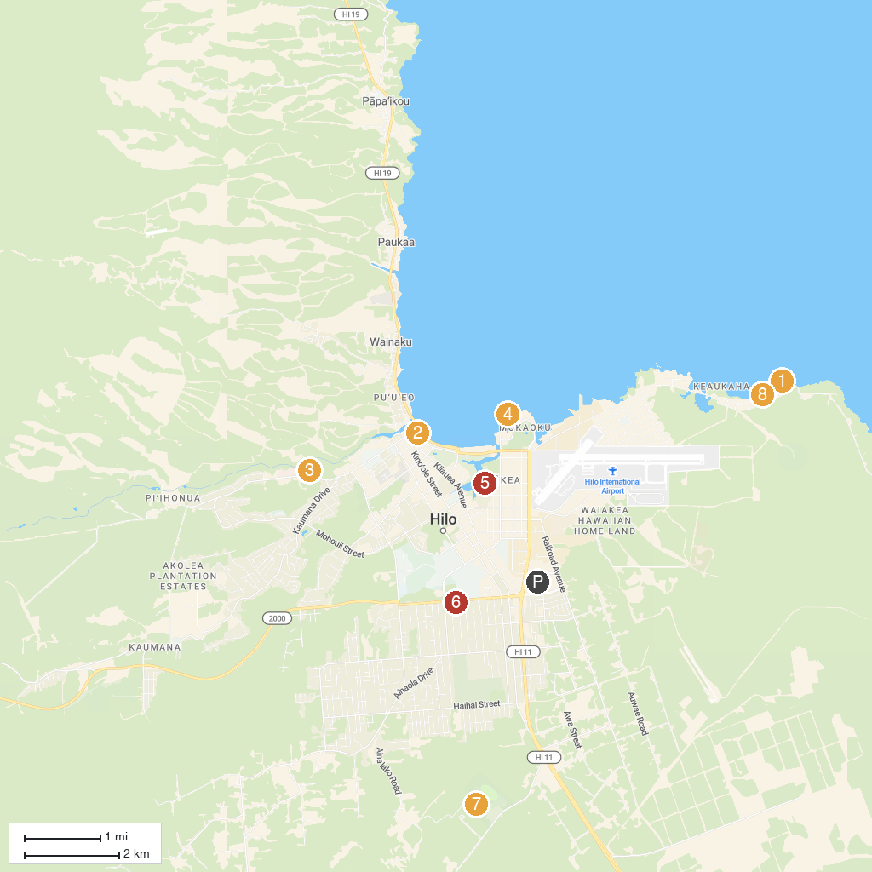
MAP KEY
1. Richardson Ocean Park | 5. Wailoa River State Recreation Area
2. Pacific Tsunami Museum | 6. Hilo Daijingu
3. Wailuku River State Park | 7. Panaewa Rainforest Zoo and Gardens
4. Moku Ola / Coconut Island | 8. Wai'olena Beach Park
P. Cruise port / terminal
Map © MapTiler © OpenStreetMap contributors · cruiseports.org

