Heringsdorf, Usedom, Germany
A 19th-century Imperial Spa resort on Germany's sunniest island, Heringsdorf dazzles with white-sand beaches, ornate Bäderarchitektur villas, and a 508-metre pier — one of Germany's longest — stretching into the Baltic Sea.
⚓ Tender (anchor offshore) · 🕒 Typical call: 7-9 hrs · 💶 Euro (€) · 🗣️ German · 🏖️ Baltic beach resort
✍️ MY DAY IN PORT (FILL IN)
Ship / Date
In port | arrive ______ · all aboard ______
Booked excursion
Notes / meeting point
GETTING ASHORE
- Docking: Tender — ships anchor in Pomeranian Bay; small ships may use Heringsdorf pier directly
- Walk to center: Pier drops passengers right at the beach promenade — 0 min to town
- Best For: Beach walks, spa culture, historic resort architecture, Baltic seafood
- Don't Miss: Fischbrötchen at the pier, Strandkorb rental, stroll to Ahlbeck's 1898 pier
GETTING AROUND
- 🚕 Taxi: €15–€20 — Larger ships dock in Świnoujście (~8 km away). A taxi to Heringsdorf town center takes 15–20 minutes. Local taxis are av
- 📱 Rideshare: ❌ not available
TOP THINGS TO DO
- Heringsdorf Pier & Promenade Walk — Walk the full 508-metre Seebrücke over the Baltic, then stroll the car-free promenade to Ahlbeck's charming 1898 wooden pier — a…
- Peenemünde Rocket Museum — At the island's northern tip, explore the WWII site where German engineers developed the V-2 rocket.
- OstseeTherme Usedom Spa — Soak in iodine-rich Baltic brine pools, indoor and outdoor, at this modern thermal spa complex.
- Baumwipfelpfad Treetop Walk — A winding wooden walkway climbs into the beech canopy above Heringsdorf, ending at a 33-metre observation tower with sweeping…
- Kaiserbäder Imperial Spa Villages — Wander through Bansin, Heringsdorf, and Ahlbeck — the three 'Imperial Spas' — admiring restored 19th-century resort villas…
BEST WALKS
- Pier to Ahlbeck Promenade Walk: 2.9 km one-way · 35 min · Flat · Free — From Heringsdorf pier, follow the paved seafront promenade east through the ornate resort villas of…
- Bäderarchitektur Villa Stroll: 1.5 km loop · 45 min · Easy · Free — Loop through the Dünenstraße and Maxim-Gorki-Straße to see the finest collection of ornate…
WEATHER · DAYLIGHT · MONEY
Month | High °F | Low °F | Rainy days
May | 59 | 49 | 11
Jul | 70 | 60 | 14
Sep | 65 | 56 | 10
Daylight: May 5:11AM–9:13PM · Jul 5:02AM–9:41PM · Sep 6:49AM–7:31PM
cruiseports.org/heringsdorf-usedom · Confirm terminal & all-aboard time with your ship

Heringsdorf, Usedom, Germany — Port Map
Red = walkable sights · Amber = excursions farther out · P = cruise terminal
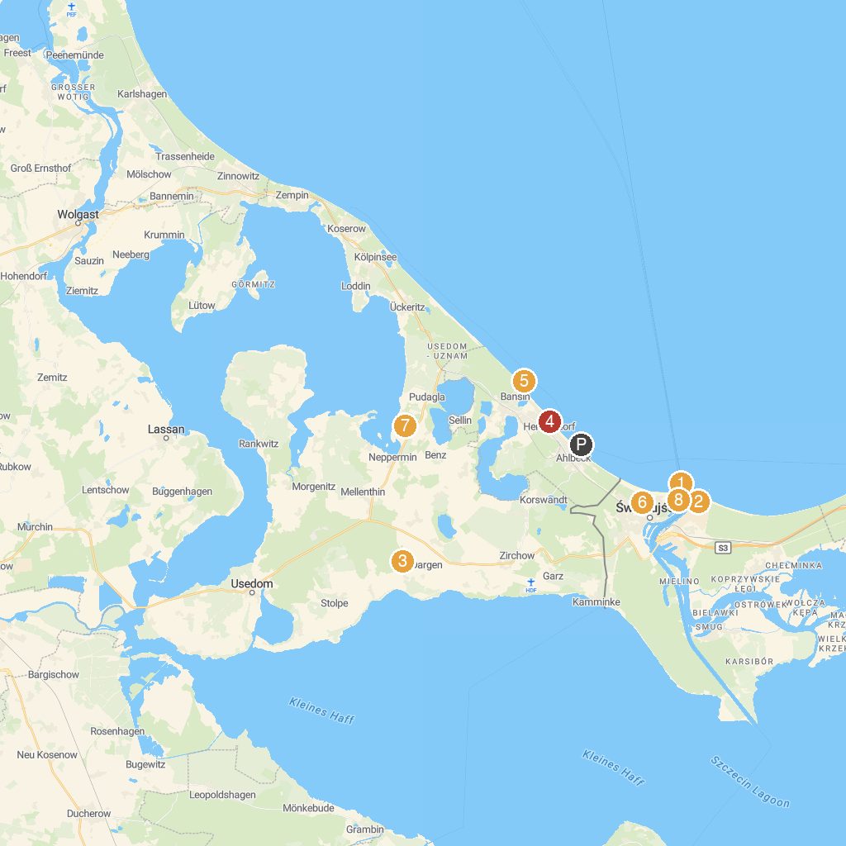
MAP KEY
1. Stawa Młyny | 5. Seebrücke Bansin
2. Bateria Brzegowa (Strandbatterie) w Świnoujściu | 6. Park Linowy Bluszcz Świnoujście
3. Wisentpark Insel Usedom | 7. Gullivers Welt
4. XXL Strandkorb | 8. Western Fort
P. Cruise port / terminal
Map © MapTiler © OpenStreetMap contributors · cruiseports.org

