Heraklion, Crete, Greece
Crete's capital packs a Minoan palace, Venetian battlements, a world-class archaeology museum, and one of Greece's most vibrant market streets into a very walkable shore day.
⚓ Docked Port · 🕒 Typical call: 8–10 hrs · 💶 Euro (EUR) · 🗣️ Greek · English widely spoken
✍️ MY DAY IN PORT (FILL IN)
Ship / Date
In port | arrive ______ · all aboard ______
Booked excursion
Notes / meeting point
GETTING ASHORE
- Docking: Berthed at commercial port
- Walk to center: ~10 min on foot
- Best For: Knossos · History · Food
- Don't Miss: Heraklion Archaeological Museum
GETTING AROUND
- 🚕 Taxi: €10–15 — Metered taxis are available just outside the port gate. Fare to the city center from the newer port is typically €10–15;
- 📱 Rideshare: ✅ Bolt, FreeNow
- 🚌 Hop-on hop-off: ✅ · from 25
TOP THINGS TO DO
- Knossos Palace — The most important Minoan site in the world — sprawling palace complex dating to 2000 BC, with Arthur Evans' famous…
- Heraklion Archaeological Museum — One of the finest museums in Greece — the full Minoan collection including the Phaistos Disc, Bull-Leaping Fresco, and Snake…
- Venetian Old Town & Koules Fortress — Walk the 16th-century Venetian harbor, climb the Koules sea fortress for views over the port and city, then explore the narrow…
- 1866 Street Market & Cretan Lunch — The covered market street running through the heart of the old town overflows with Cretan olive oil, honey, cheeses, and raki.
BEST WALKS
- Waterfront to Koules & Venetian Harbour: ~1.5 km · 30–40 min · easy — Follow the quay east from the cruise terminal to the Venetian harbor and Koules fortress.
- 1866 Street, Lion Square & Archaeological Museum: ~2 km loop · 1–1.5 hrs · easy — Head into the old town via the market street to Morosini Fountain (Lion Square), the social heart…
WEATHER · DAYLIGHT · MONEY
Month | High °F | Low °F | Rainy days
May | 76 | 60 | 6
Jul | 87 | 73 | 1
Sep | 82 | 69 | 5
Daylight: May 6:15AM–8:16PM · Jul 6:16AM–8:34PM · Sep 7:02AM–7:26PM
cruiseports.org/heraklion · Confirm terminal & all-aboard time with your ship

Heraklion, Crete, Greece — Port Map
Red = walkable sights · Amber = excursions farther out · P = cruise terminal
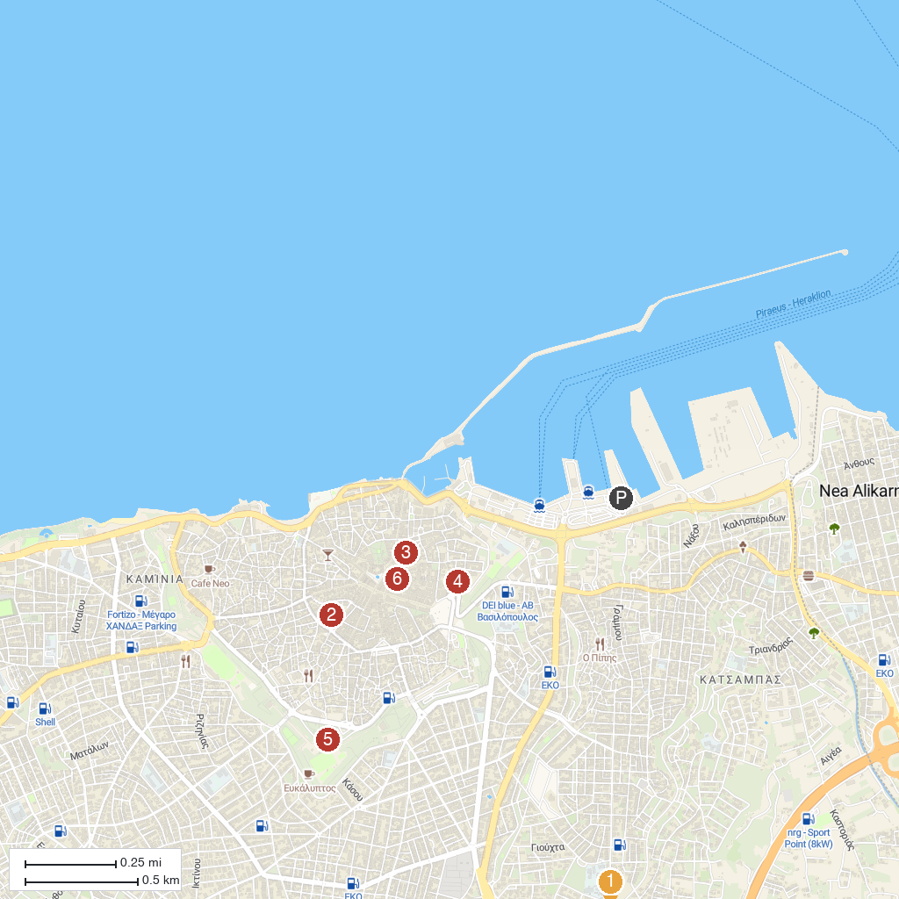
MAP KEY
1. Anemospilia | 4. Heraklion Archaeological Museum
2. Saint Minas Holy Cathedral | 5. Nikos Kazantzakis' Grave
3. Cathedral Holy Temple of Saint Titus | 6. EscapeRooms.Gr
P. Cruise port / terminal
Map © MapTiler © OpenStreetMap contributors · cruiseports.org

