Hendaye, Basque Country, France
Straddling the French-Spanish border at the mouth of the Bidasoa River, Hendaye pairs a sweeping Atlantic beach with easy cross-border escapes to Hondarribia and San Sebastián — all from a tender landing at the marina.
⚓ Tender port · 🕒 Typical call: 6–9 hrs · 💶 Currency: Euro (€) · 🗣️ Languages: French, Spanish, Basque · 🏖️ Best beach on the Basque coast
✍️ MY DAY IN PORT (FILL IN)
Ship / Date
In port | arrive ______ · all aboard ______
Booked excursion
Notes / meeting point
GETTING ASHORE
- Docking: Tender — ships anchor offshore; tenders land at Hendaye marina
- Walk to center: 5 min from tender dock to beach promenade; 15 min to town center
- Best For: Beach, Basque culture, cross-border day trips to Spain
- Don't Miss: Ferry to Hondarribia or Euskotren to San Sebastián
GETTING AROUND
- 🚕 Taxi: €15–30 — Taxis wait near the marina tender dock. Short ride to the town center; agree on fare or ensure meter is running.
- 📱 Rideshare: ✅ Uber
TOP THINGS TO DO
- Hendaye Beach — Three kilometres of fine Atlantic sand, gentle surf, and the iconic Deux Jumeaux (Twin Rocks) at the north end.
- Abbadia Castle-Observatory — A dramatic 19th-century neo-Gothic castle built on the cliffs by explorer-scientist Antoine d'Abbadie.
- Ferry to Hondarribia, Spain — A 15-minute passenger ferry crosses the Bidasoa estuary to the perfectly preserved medieval port town of Hondarribia.
- San Sebastián by Euskotren — Catch the Euskotren light rail from Hendaye station (every 30 min, ~€2.75 one-way) to world-famous San Sebastián in 35 minutes.
- Txingudi Bay & Coastal Path — The Txingudi bay nature reserve sits at the mouth of the Bidasoa, shared by France and Spain.
BEST WALKS
- Beach Promenade Stroll: 2 km · 30 min · Easy · Flat — Walk the full length of Hendaye's Atlantic beach from the marina to the Deux Jumeaux rocks at the…
- Estuary & Pheasant Island Walk: 3 km · 45 min · Easy · Flat — Follow the Bidasoa riverbank path from the marina into Txingudi Bay.
WEATHER · DAYLIGHT · MONEY
Month | High °F | Low °F | Rainy days
May | 65 | 53 | 16
Jul | 74 | 63 | 13
Sep | 73 | 60 | 13
Daylight: May 6:43AM–9:24PM · Jul 6:40AM–9:44PM · Sep 7:46AM–8:16PM
cruiseports.org/hendaye · Confirm terminal & all-aboard time with your ship

Hendaye, Basque Country, France — Port Map
Red = walkable sights · Amber = excursions farther out · P = cruise terminal
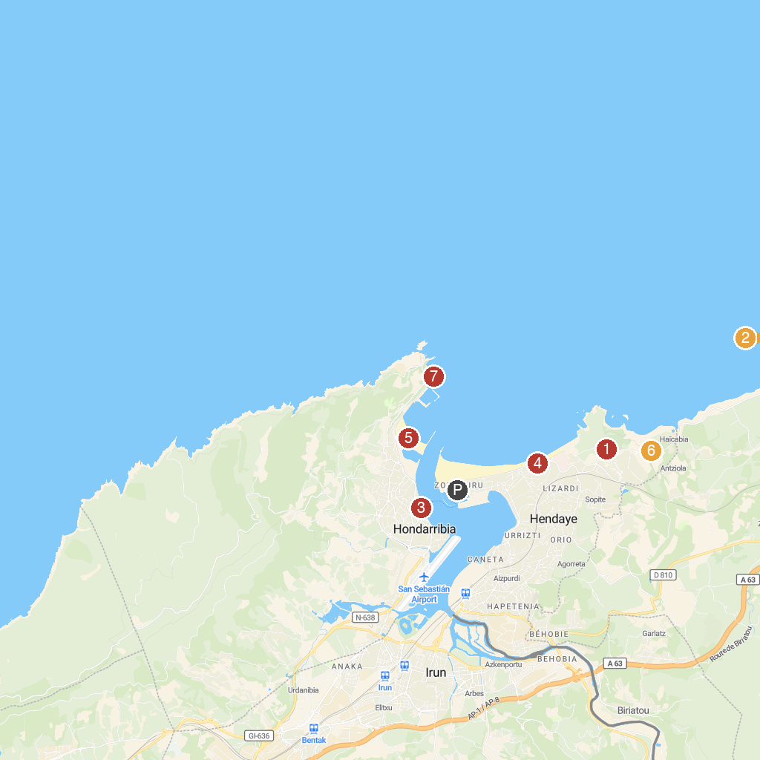
MAP KEY
1. Château d'Abbadie | 5. Banc des Berritsu
2. Le Train de La Rhune | 6. Hondarribiko hondartza
3. Socoa Fort | 7. Maison de la Corniche - Asporotsttipi
4. Mariñel ship | 8. San Telmo gaztelua
P. Cruise port / terminal
Map © MapTiler © OpenStreetMap contributors · cruiseports.org

